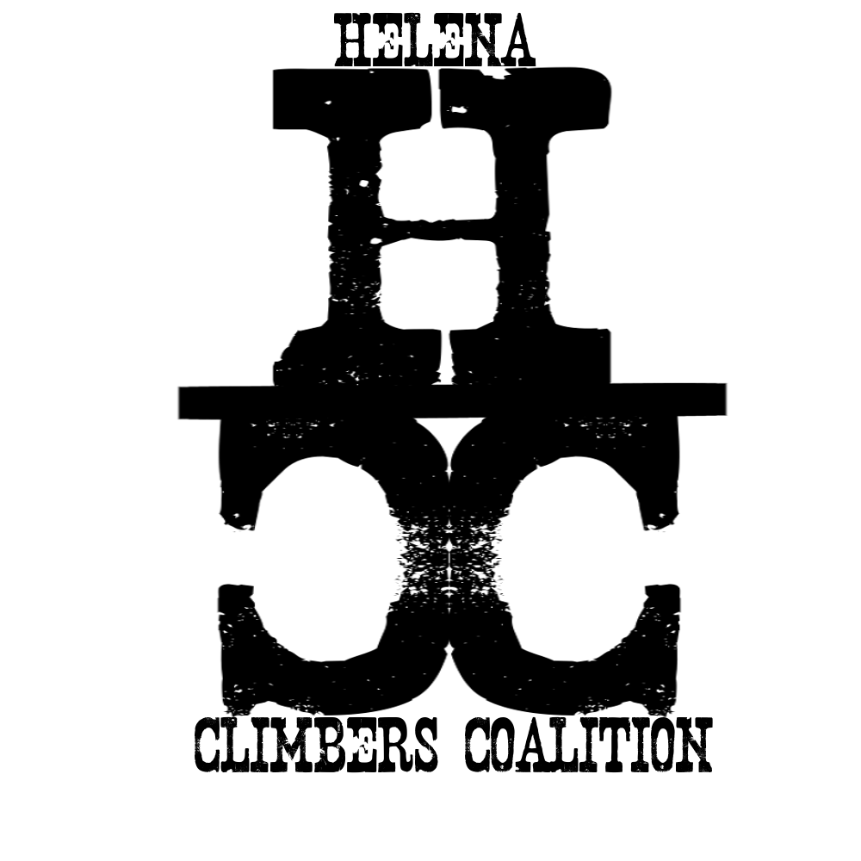
HELENA CLIMBERS COALITION

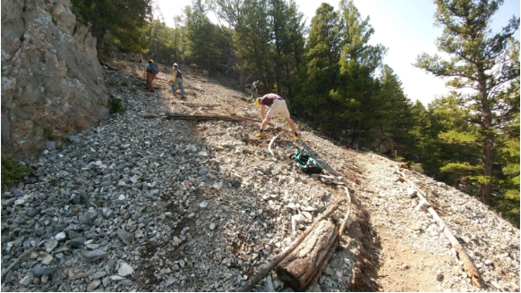
Winter 2024 Newsletter

Please comment on Mt. Helena trail work proposal!
Please help us by commenting in favor of the trailwork proposed by the HCC on Mt. Helena. This work will be mainly focused on fixing up the Sunset Slab trail that has become eroded due to heavy rain. More info about the detailed proposal and a link to comment below. Comments are Due by March 8th https://beheardhelena.com/rock-climbing-access-trail-reconstruction

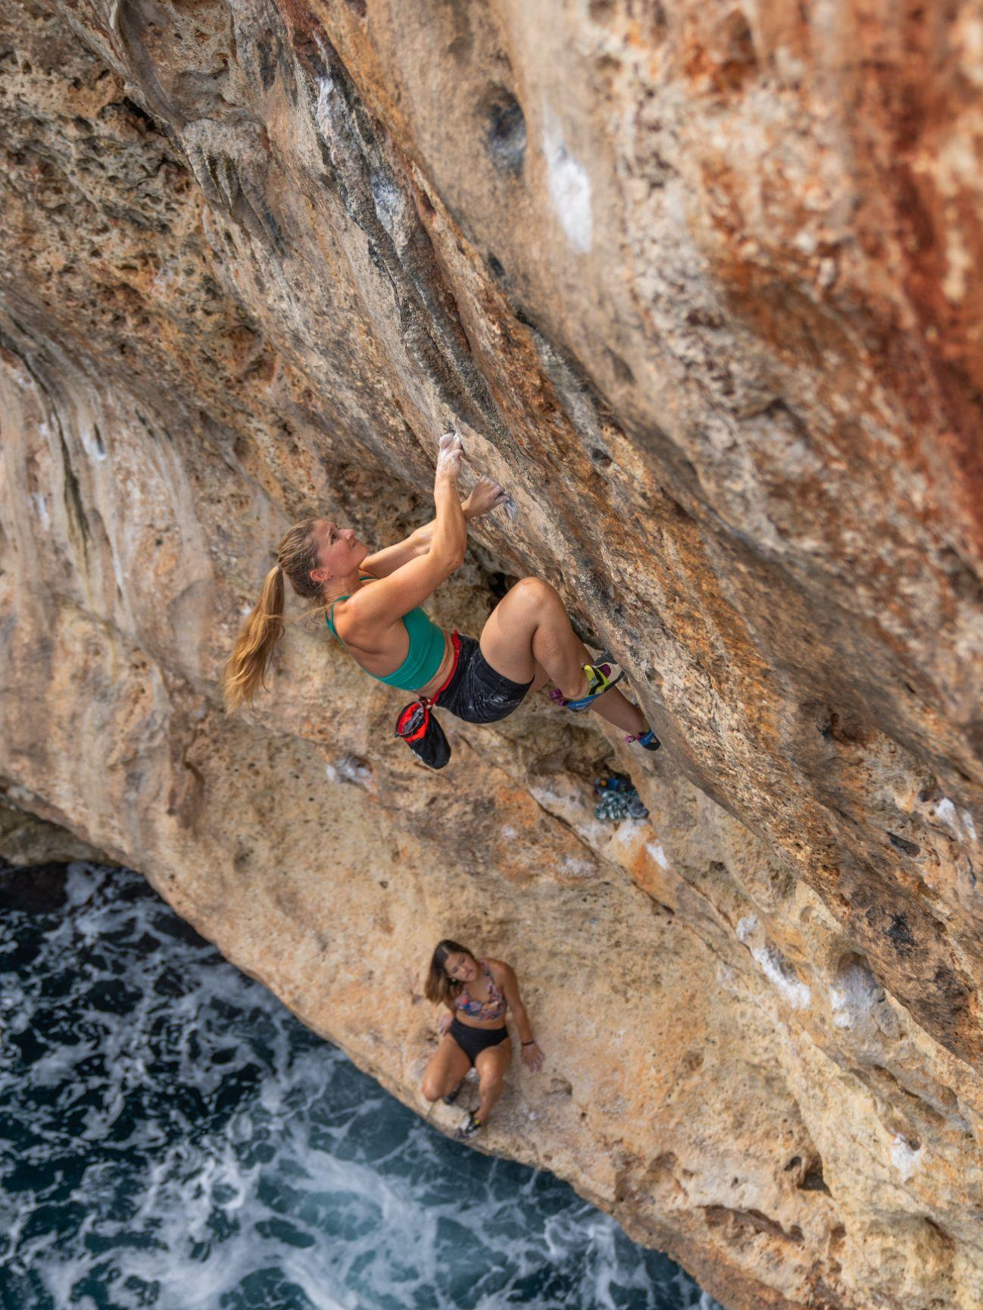
Upcoming Events
- Tues Feb 27th 5:30pm Ten Mile Creek Brewery Social
- Thursday April 11th Reel Rock 18 @ The Myrna Loy
  - Get Stoked! Watch the Teaser
  - 6:30pm Pre film social. 7:00pm Film
  - Purchase your tickets online, or at Stonetree
  - $18 presale, $28 at the door
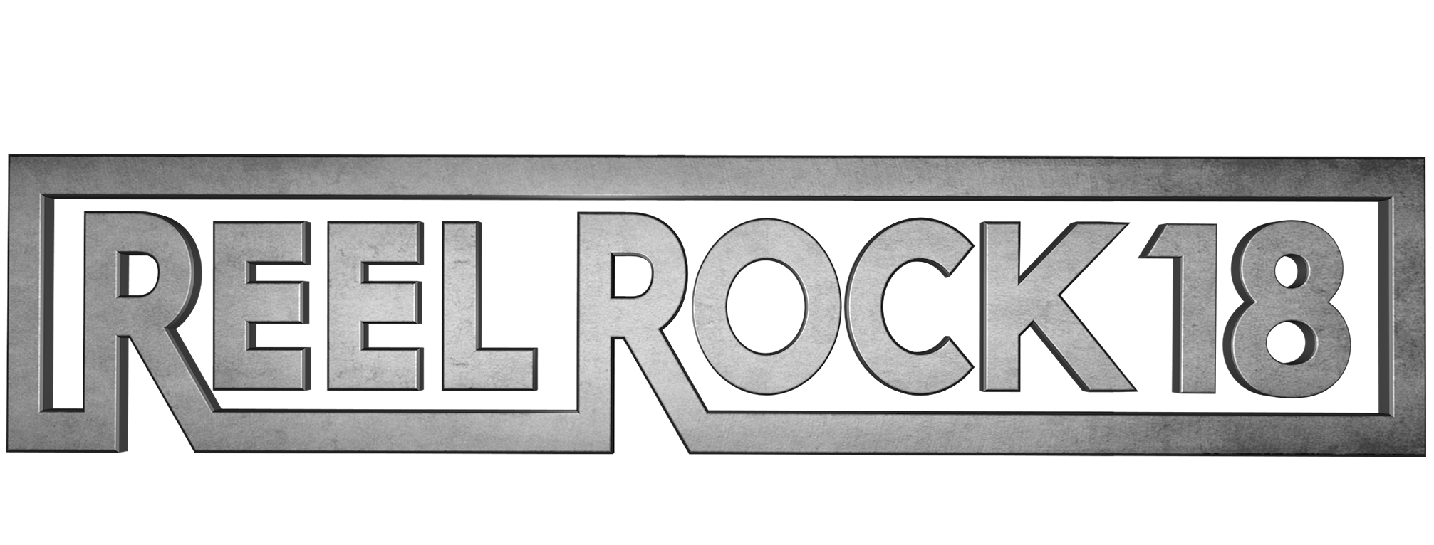
  - Proceeds from the event go to the HCC.. We will have an amazing silent auction, supported by local businesses, as well as door prizes and surprises. Anyone who purchases a ticket online is automatically entered into a raffle for a 70m 9.5mm dry treated rope!

Board Nominations
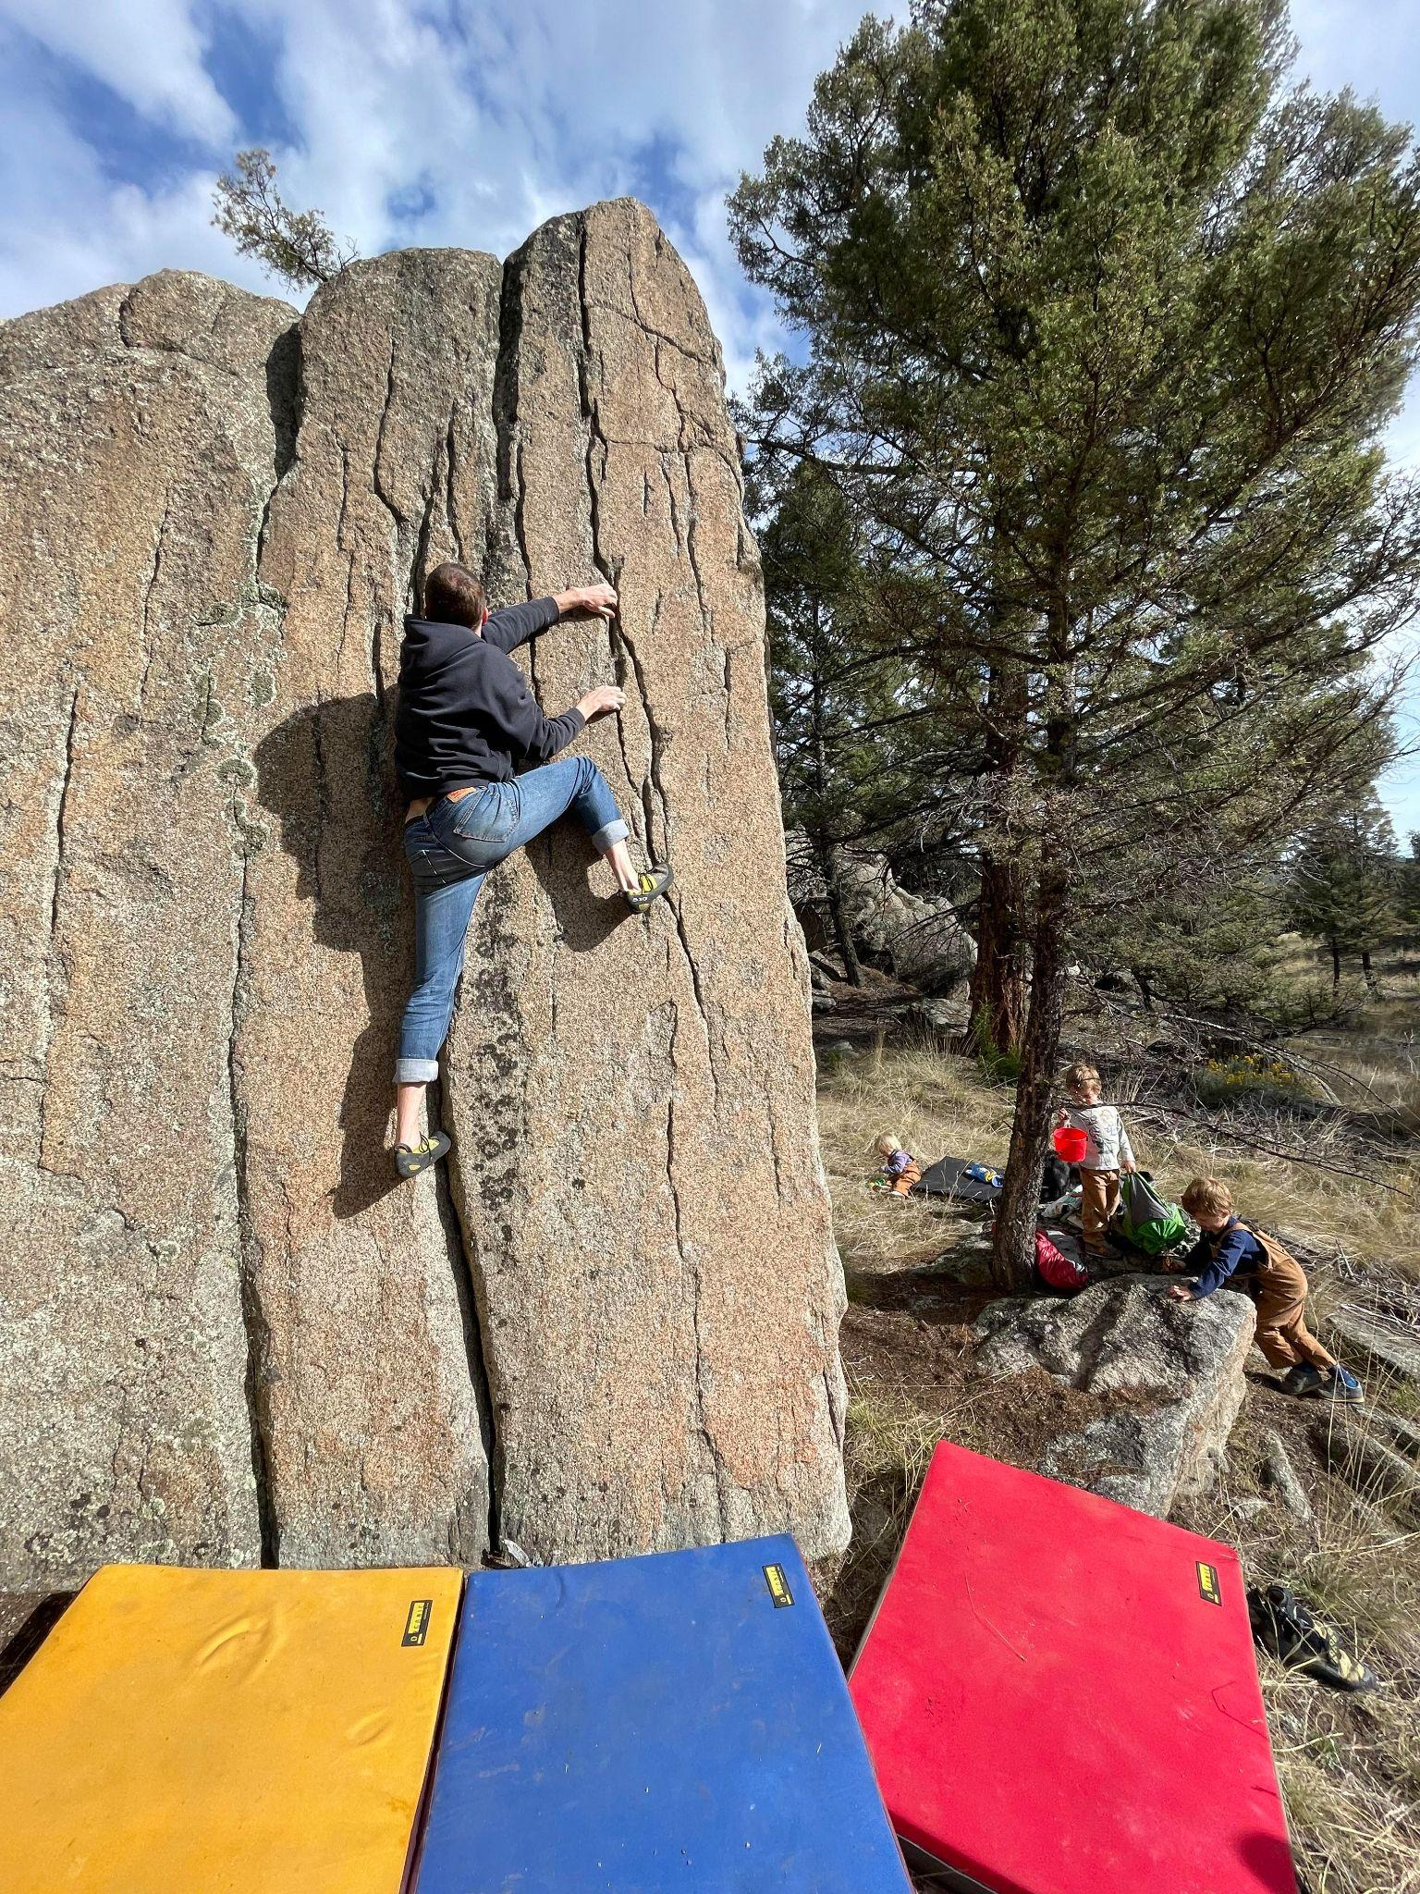
The HCC is composed of 9 board members and their terms are offset by 1 year so that 5 board members will expire at the start of odd calendar years and 4 members will expire at the start of even calendar years. The newly elected board members will serve a 2 year term.

The expiring board members that are up for re-nomination are Dan Bachen, Megan Helton, Sarah Maddock, and Steve Ahlrich.

The board members that will continue for 1 more year are Katherine Feehan, Shane Forsythe, Haven Hoffman, Brad Maddock, and Kevin Shon.

The board is open to anyone that has the time and desire to be on the board and we have made an open nominating and voting process outlined below:
- You may nominate yourself.
- Nominations do not need a second.
- You may fill out this form as many times as you would like and nominate as many people as you would like.
- Nominations are due February 26th.
- Nominee's must accept the nomination before being put on the final ballot.
- Nominee's must accept by March 3rd and write a 200 word or less blurb about why they would like to be on the board.
- If the nominee is not an HCC member they must become one before they are able to be put on the final ballot.
- Voting will begin March 4th and votes are due by March 8th
- Board members must be members of the HCC and Access Fund
Nomination Form

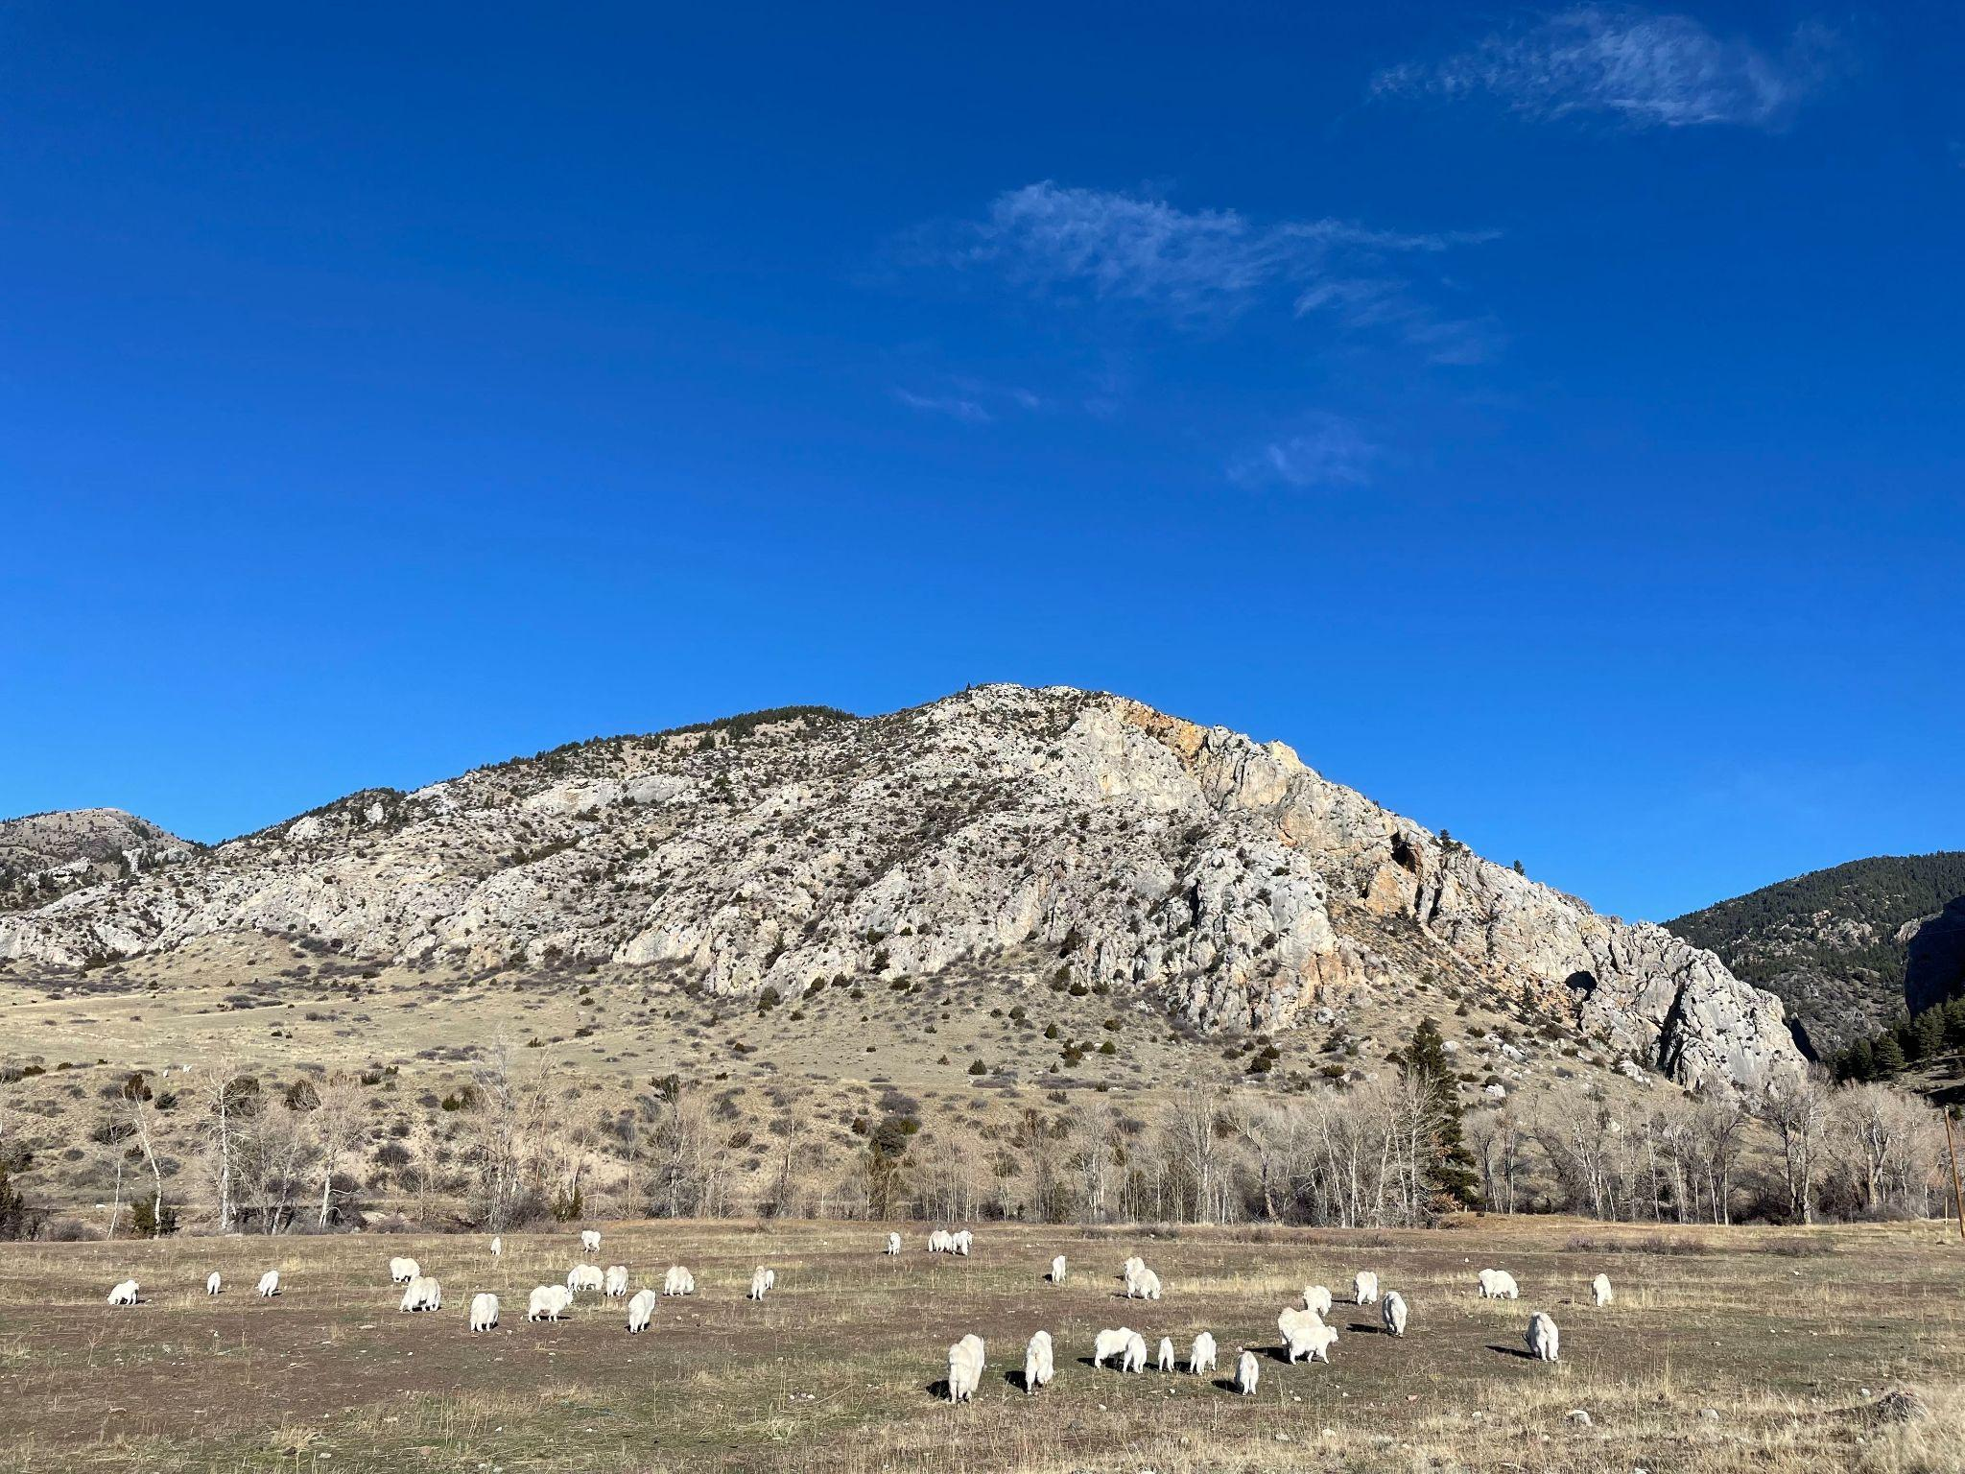
❗️Please fill out our survey
Please fill out our survey! So we can learn more about you and how you use the climbing in the Helena area! The survey can be completed in less than 5 min! Each person who fills out the survey is entered to win a Rope Tarp! SURVEY HERE

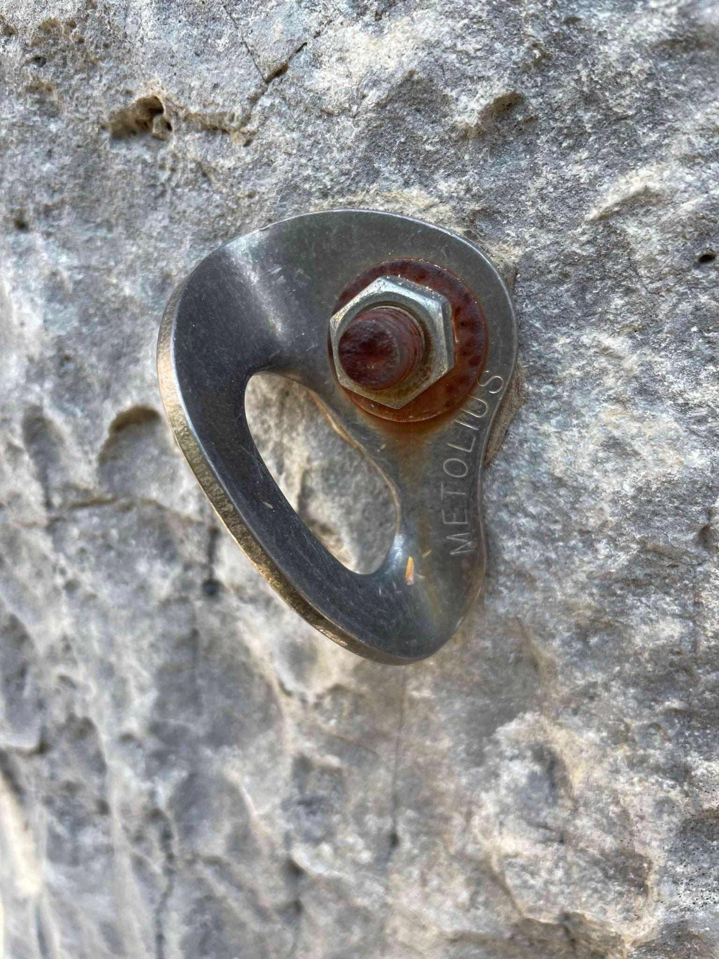
Bad bolts?
The American Safe Climbing Association has generously donated AGAIN!!!! We have 50 more sets of mussy hooks for lower off anchors on popular routes! Consider giving them a donation if you haven't already.
Thinking about those bad bolts you clipped the last time you were out? Report them here Want mussy hooks for your favorite route or want to learn how to replace bolts and anchors? Email Dan at daniel.bachen@gmail.com

Need to pay your membership dues???
https://helenaclimberscoalition.org/members/ Still only $30, what a great deal!
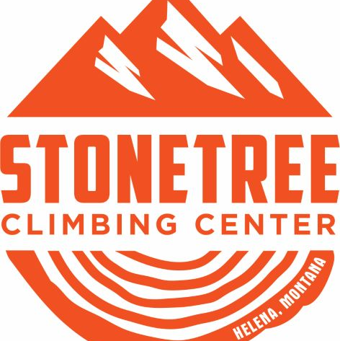
Stonetree Discounts
Thanks to the generosity of Helena’s local gym Stonetree Climbing, Contributing Member perks include:
$13 day passes on Tuesday And Student pricing on memberships
See Stonetree’s Website for further details.

https://helenaclimberscoalition.org

