HELENA CLIMBERS COALITION
Winter 2020 Newsletter



A Word From the Board
On Feb 12th 2020 we had our first ever HCC Membership Drive. TONS of Helena climbers showed up! We started a great membership base, formed subcommittees for community involvement, and had a ton of fun welcoming new climbers to our community. Little did we know that the pandemic was soon to come and would change the world we live in today. Needless to say all of our great momentum generated that evening at Stonetree was forced to a screeching halt. Although in person events have been at a minimum since that date, we have still managed to squeeze in a few great stewardship events, bolt and anchor hardware replacements, and a few fun community events. Two years later we are excited to bring back the HCC membership drive! There will be free pizza, free stickers, sweet new HCC T-Shirts for $10, beer, and we will finally have the chance to once again form our subcommittees to get to work maintaining our Helena crags and having some fun! We hope you join us whether you are a new to town climber, an old time Helena native, or living out of your van and just happen to be passing through. Save the date: March 22nd 5:30pm Stonetree Climbing Center.

Upcoming Events

- HCC Membership Drive and Community Meeting
March 22nd 5:30pm Stonetree Climbing Center
  - Join us for an update on HCC past accomplishments and future goals, free stickers, free pizza, free beer, $10 T-Shirts, great membership incentives, subcommittees, socializing, meeting new climbing partners, storytelling, and more!
- Spring social climb day TBD
  - TBD Depending on the weather. Watch social media for a last minute announcement for a group climbing day at Winter Wall.
- Tuesday Night Social Climbing
  - Mark your calendars. Starting Tuesdays in May 5:30pm at rotating crags.
- National Trails Day June 4th
  - Join HCC for a trail project at one of our local crags. Details to come.
- Event put here by YOU!
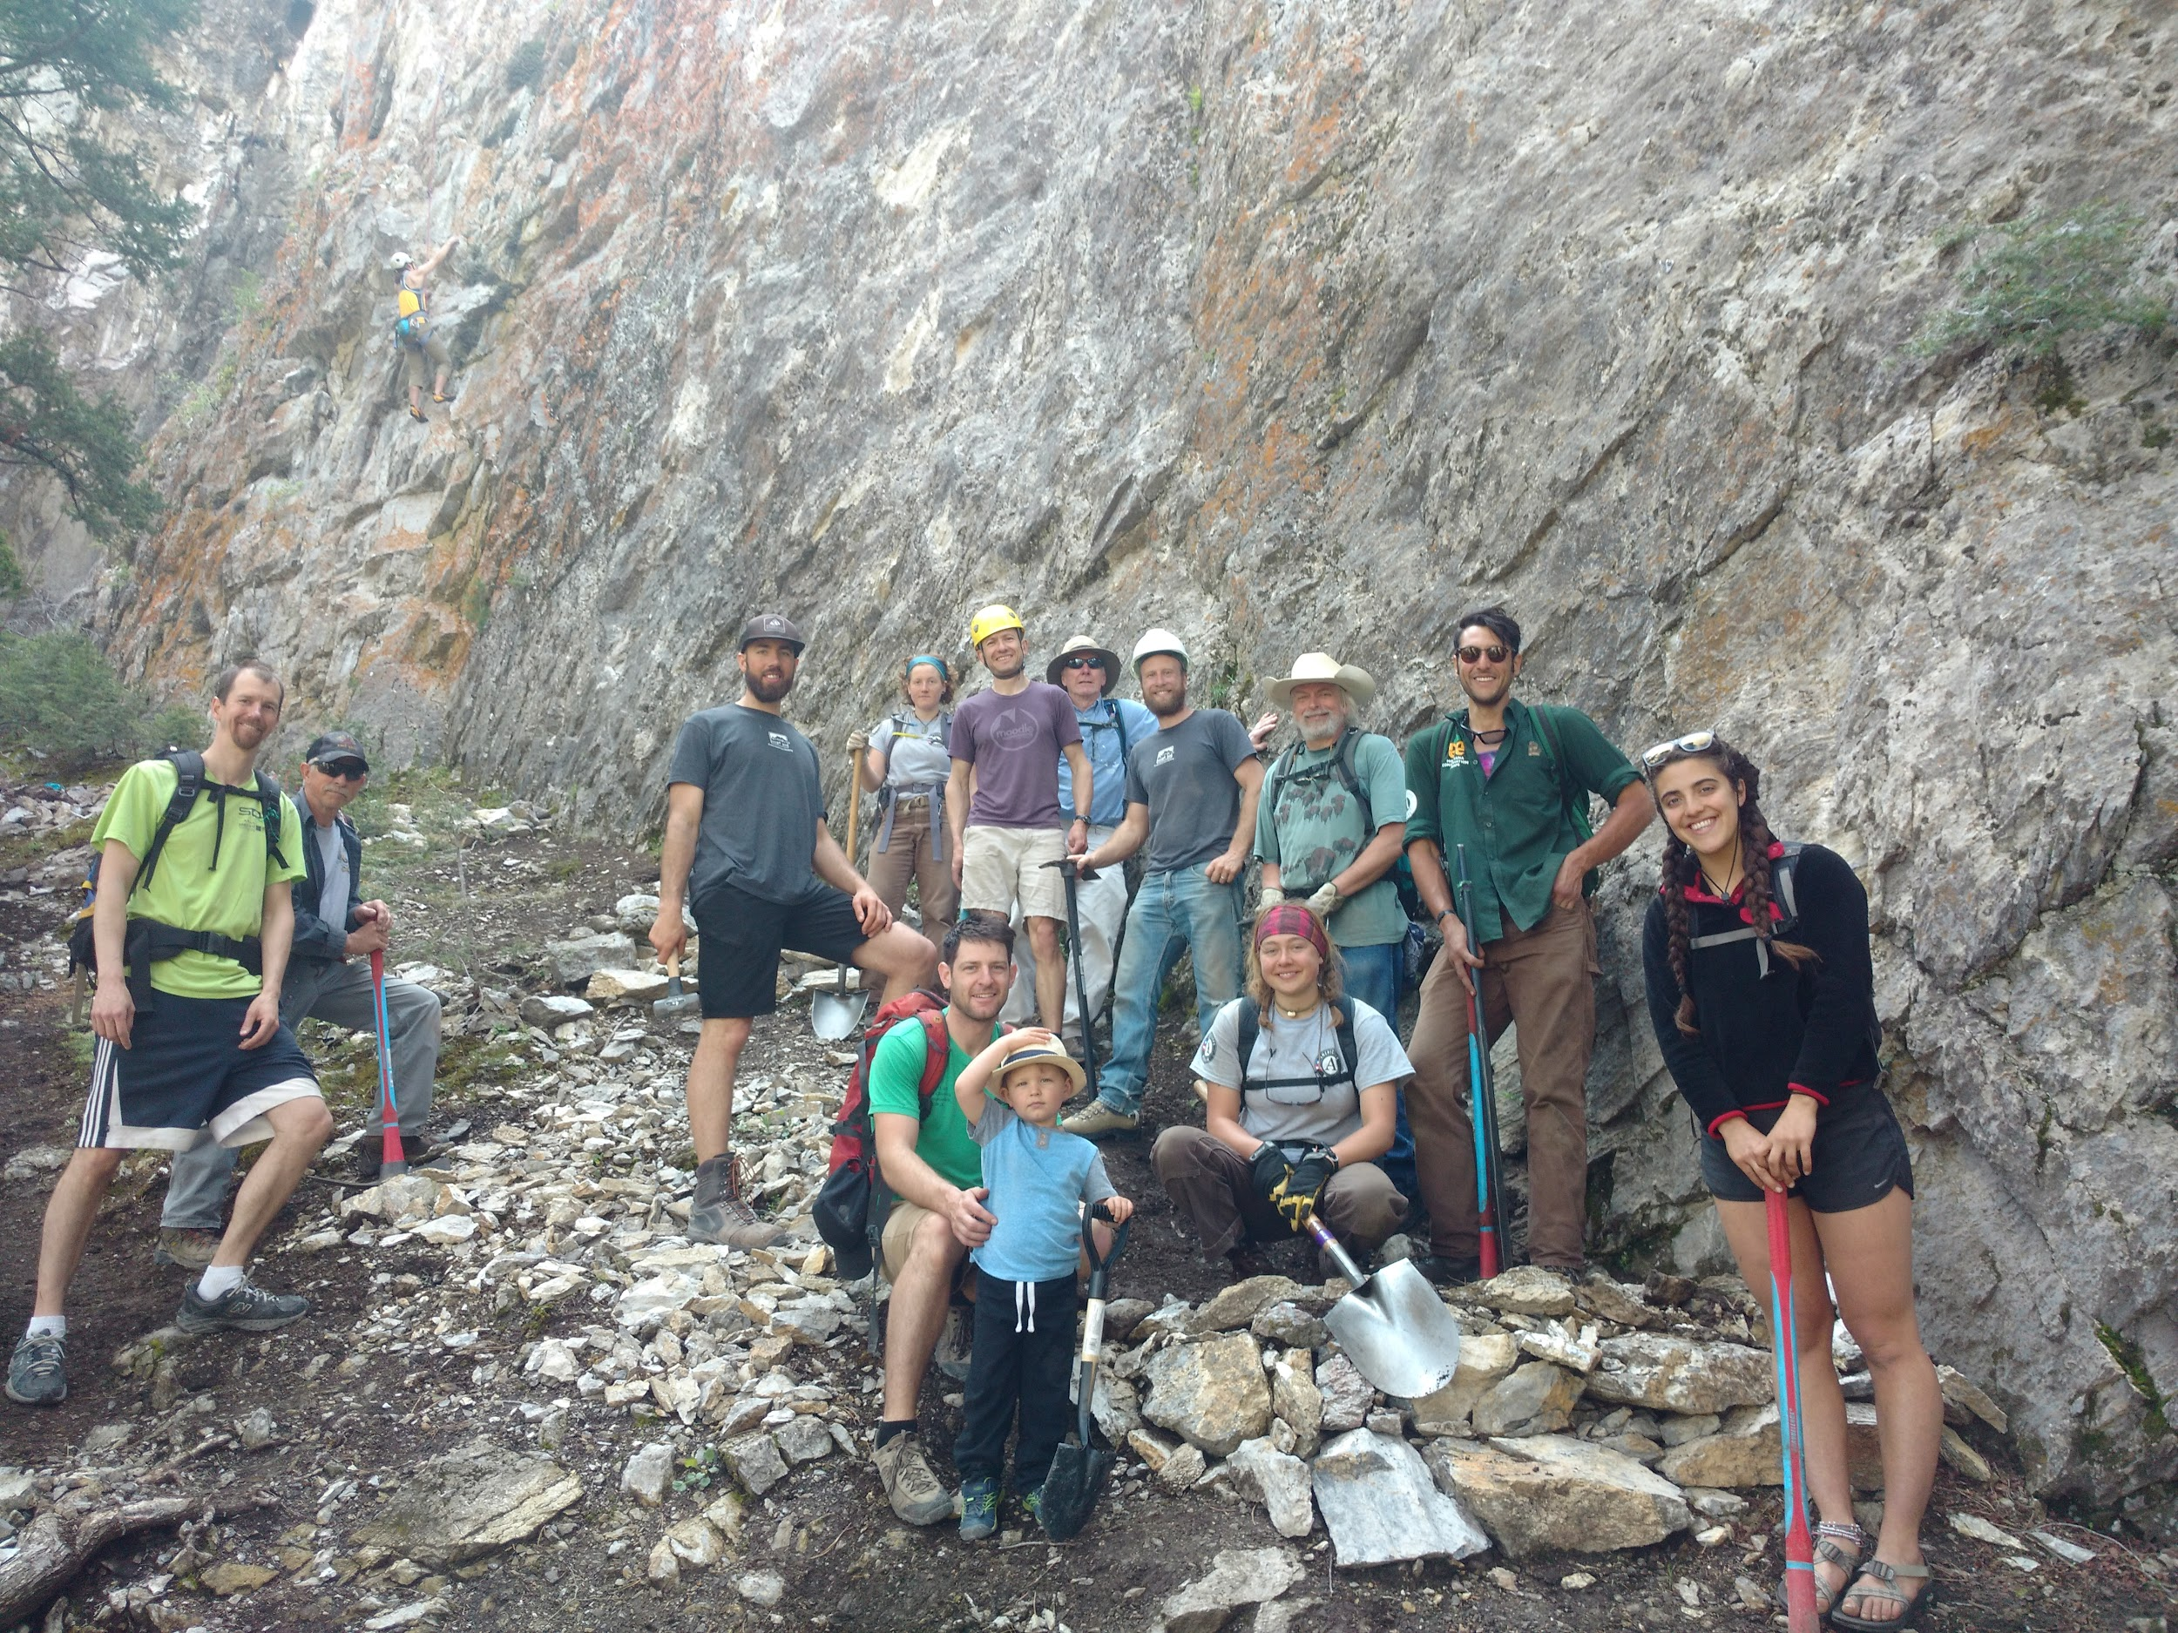
  - Part of our subcommittee work is to involve YOU reading this newsletter in helping us form stewardship and fun events for the Helena Climbing Community! Please join us and be involved!
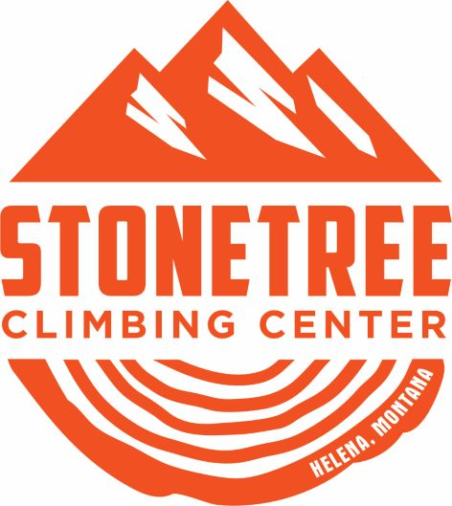Stonetree Membership Perks!
Thanks to the generosity of Helena’s local gym Stonetree Climbing, Contributing Member perks include:
- $10 discounts for all memberships (EFT, prepaid, couple, family, etc)
- $11 day pass all day Tuesday
- 10% off all retail (chalk, chalk bags, and more climbing related merch )
- Stonetree Membership rates on future classes
- See Stonetree’s Website for further details.
- Renew or Sign up for your $30 annual HCC membership HERE

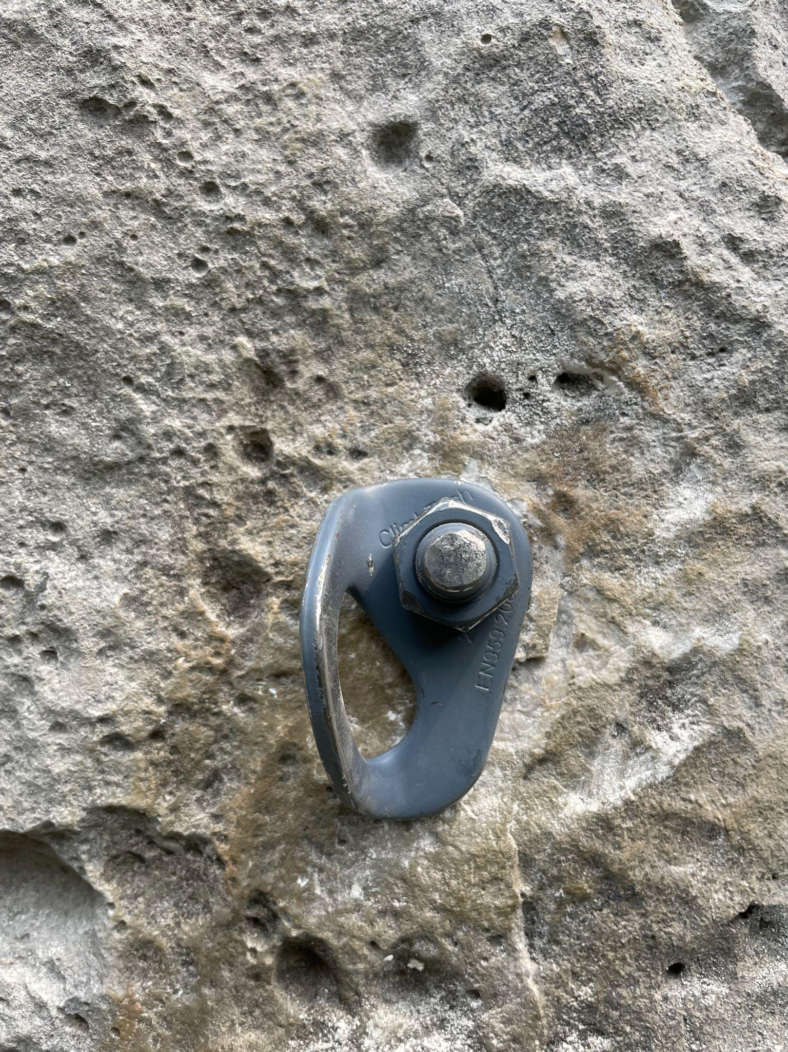

Bolt Reporting Tool
Thinking about those bad bolts you clipped the last time you were out? Report them here
Photo of one of the many bolts that HCC board members replaced this summer!


The New Guidebook Is Almost Here
The book is headed to print!!!! ETA April?!?! You can either Pre-Order via Sharp End Publishing or you can wait to buy the book locally from one of our awesome local shops: The Base Camp, Stonetree Climbing, and more!

https://helenaclimberscoalition.org

