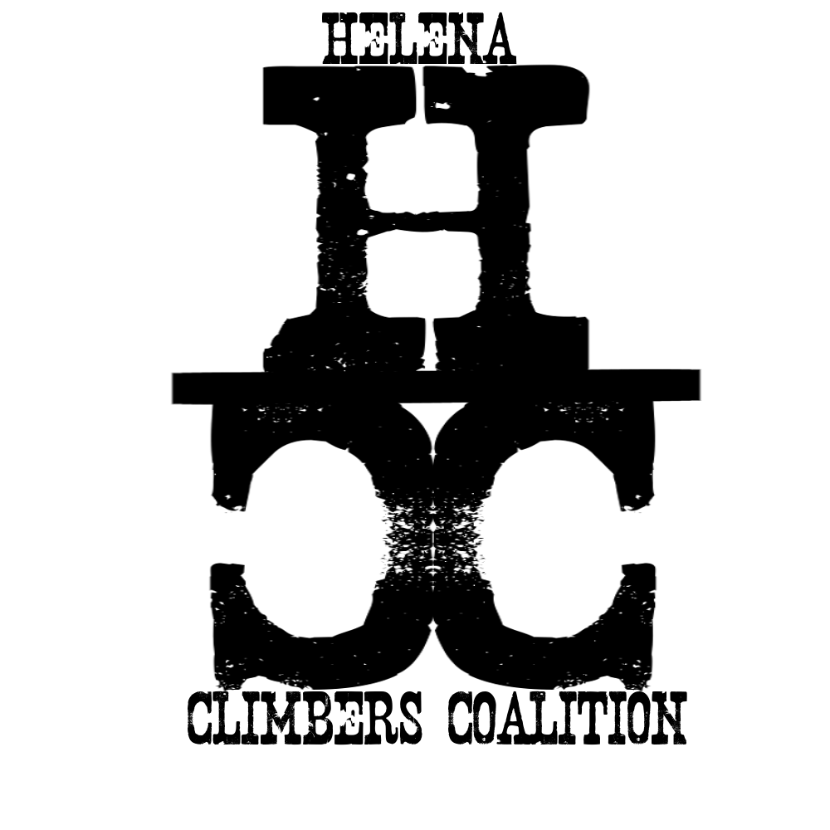
HELENA CLIMBERS COALITION
Winter 2019

A message from the Board
Hello fellow Climbers! Hope everyone had a fantastic fall and was able to get out and enjoy the crisp fall days before the snow arrived. It was another interesting fall in Montana, sunny and 70s one day to 20s and snow the next. We made the most of it and chased shade on the warm days and searched for sun on the colder ones. We were able to get out and enjoy some of the changing colors in the aspen trees at Blue Cloud, soak up some sun on Winter Wall, make the most of the limited daylight on Mt Helena, and take a few longer trips to neighboring states to explore new climbing areas.
HCC has been busy as well this late summer/fall. We have been hard at work with private landowners, the Forest Service, and the City of Helena to maintain access to all of our beloved climbing areas. Membership funds allowed us to install a stile and signage at Blue Cloud in August as well as scrub some graffiti from a particular rock in the area. Our Bolt Replacement Committee is getting their feet off the ground and did some work out at Sheep Mountain to replace some anchors and bolts that had seen significant wear. They have developed a 'Bolt and Anchor Reporting tool' for folks to use to report any suspicious or concerning hardware in the area. Please follow the link and let us know!!

Bolt and Anchor Reporting tool:
https://forms.gle/wjZsMaENPFCsQVFGA

We would love to see more involvement from our members and we invite you to our upcoming Member meeting on December 17th at 6pm at 326 Fuller Ave. There will be important information shared about committees and ways to get involved in your local climbing community. We couldn't do what we do without our members so thank you for committing to an annual membership to keep climbing in Helena safe, accessible, and fun for all.

Climb on and stay warm!
Sarah Maddock, Secretary

UPCOMING EVENTS
December 17th
Join us at 6pm at 326 Fuller Ave for our General Membership meeting. This is a great opportunity to renew your membership, or start a new year long dedication. Members pay $30 a year, which supports crag maintenance and access in the Helena area. Have questions? Ideas for a volunteer project? Want to meet other climbers? There’s plenty of room for that too.

In preparation for our meeting, look over the agenda here: HCC Winter Meeting. If you have anything to add, let us know before the meeting and you can steal the mic!

The board has proposed a change to part of our by-laws, and to do so we need input from our members. Currently, Article IV, Section 2 states:

Notice of Board Member Meetings: Notice of Board Member Meetings will be posted on the HCC website, www.helenaclimberscoalition.org at least two weeks prior to each meeting.

The board is proposing the following language as replacement:

Notice of Board Member Meetings: Notice of Board Member Meetings will be sent out to members via the quarterly newsletter and will include a request for agenda items.

You can review our by-laws at any time on our website. Remember! Only HCC contributing (paying) members may submit comments. Want to weigh in? Renew or start your dues!

CLIMBING NEWS
Bolt Replacement in Central Montana
The Helena Climbers Coalition is a community based organisation chartered to promote climbing and stewardship of climbing areas in the Helena area. Not to be modest, but the greater Helena area has some of the best sport climbing in the state and almost all sport, trad, and mixed lines utilize top anchor or other fixed hardware. As this hardware deteriorates through time, maintenance or replacement becomes increasingly necessary. Currently this work is performed by a handful of individuals at their own personal expense for the benefit of the greater community. As a community organisation, HCC seeks to facilitate the replacement of aging hardware by coordinating volunteer efforts, providing appropriate hardware, and promoting best practices and techniques.
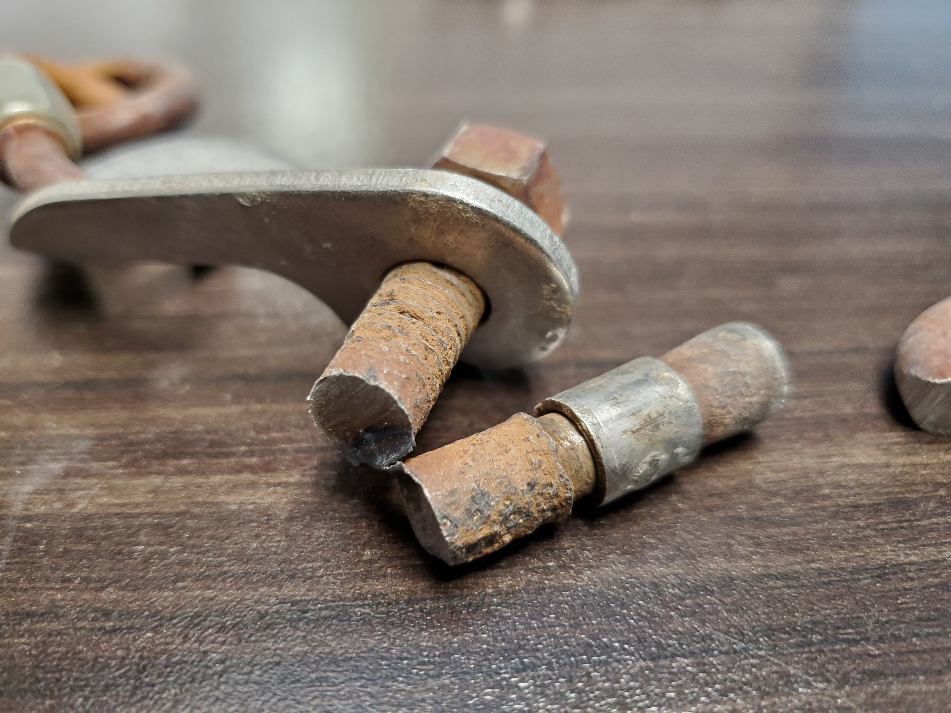
Currently we have started to acquire the tools, knowledge, and skills to tackle the monumental task of maintaining and upgrading hardware at our local crags. In 2019 we began this process at Right Rock (Sheep Mountain) using a bolt puller donated by the Access Fund and stainless steel bolts and anchor material donated by HCC board members. The 34 year old hardware used to establish rappel stations and routes had abundant surface rust and was definitely showing its age. Treasurer Board Member Andrew Schrader took a closer look and found rust and minor pitting along bolt shaft and cone and on all anchor hardware but the corrosion did not penetrate into the core of the bolt, chain, or rappel ring he looked at. That low-grade plated steel bolts managed to last over three decades without failure or apparent structural issues is encouraging. However, this longevity does little more than provide us extra time to organize and begin updating aging hardware.
Across the Helena area there are thousands of bolts and hundreds of top anchors that will need to be maintained in the coming decades. This work is not easy or quick. At Sheep Mountain we managed to replace three rappel anchors and two anchor bolts in about eight man-hours and used about $50 in hardware. If you extrapolate the time and costs across our area its easy to see that this has to be a community effort for it to be successful. At the upcoming meeting we will begin to organize this process, recruit volunteers, and explore options to fund this work. If you are interested in helping with any aspect of this -make sure to attend the meeting. If you cannot make the meeting send us an email: helenaclimberscoalition@gmail.com
The Access Fund
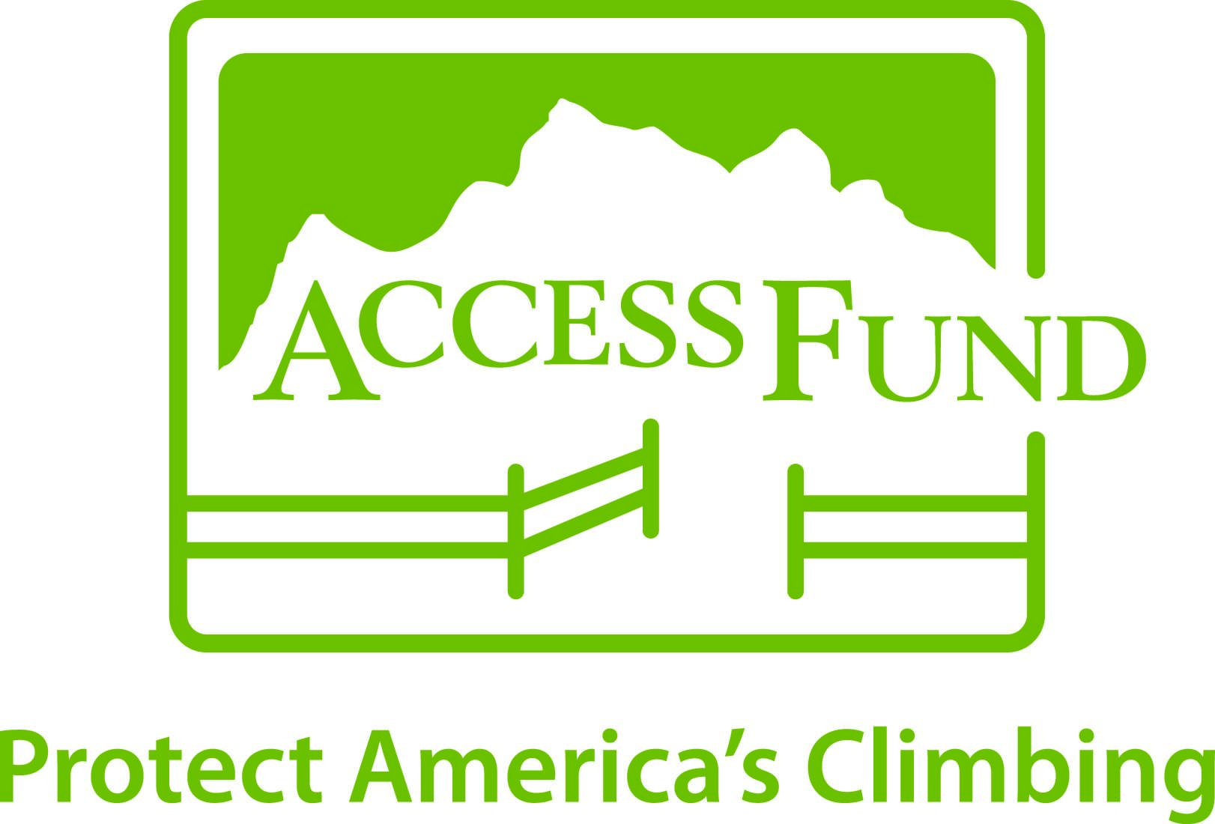
Black Diamond is currently matching all donations and memberships to Access Fund up to $80,000 to continue the fight in protecting public lands. So if you aren’t already a member, now might be the time! Poke around the news section of the Access Fund’s website to see what is going on regionally and nationally in climbing. 2019 saw some some cool access wins in in Texas and the Northeast. We are always grateful for all of our space and big sky.
STOKE
Listen to this podcast about public lands and climbing in Montana
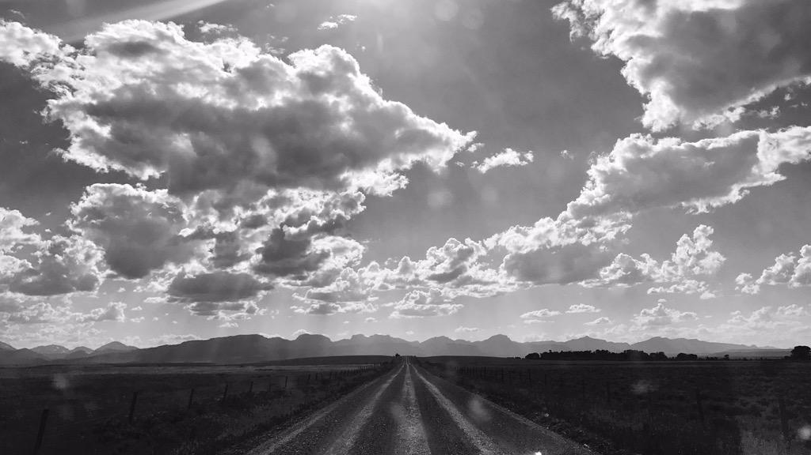

https://helenaclimberscoalition.org

