HELENA CLIMBERS COALITION
Summer 2022 Newsletter
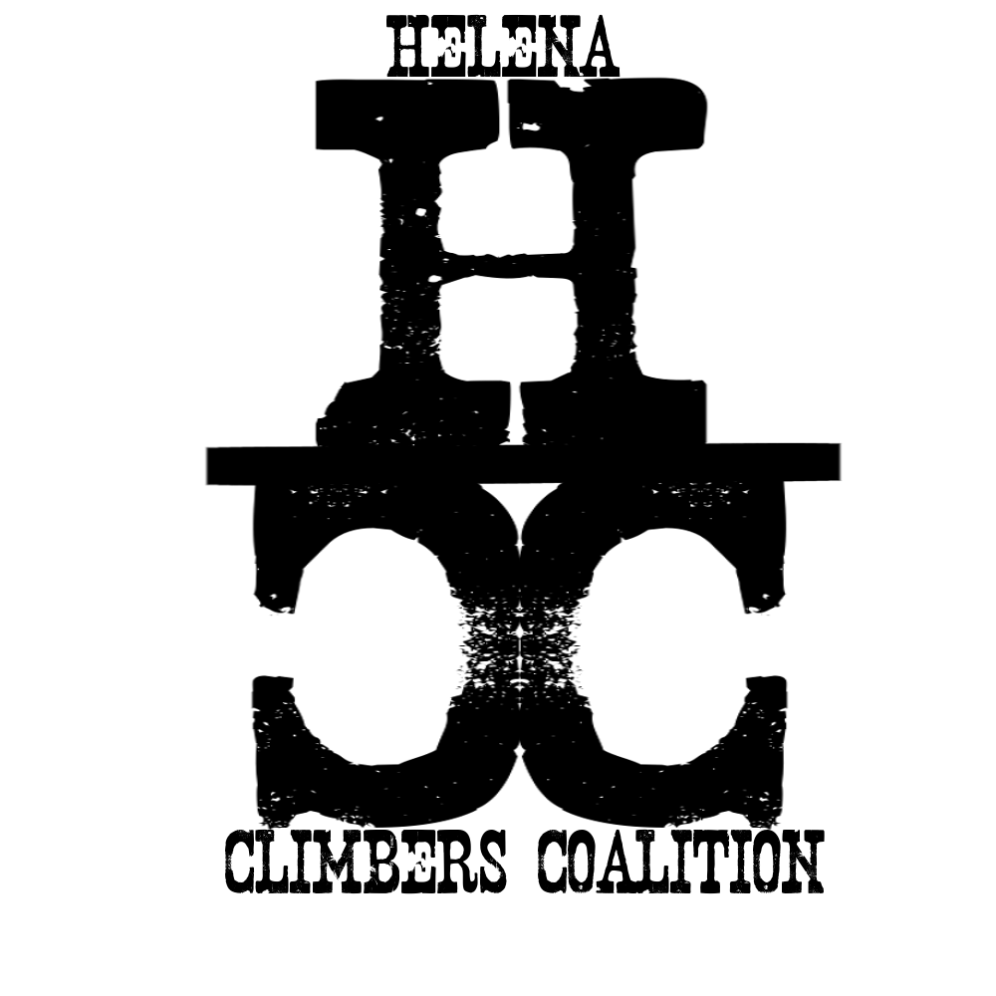


A Word From the Board

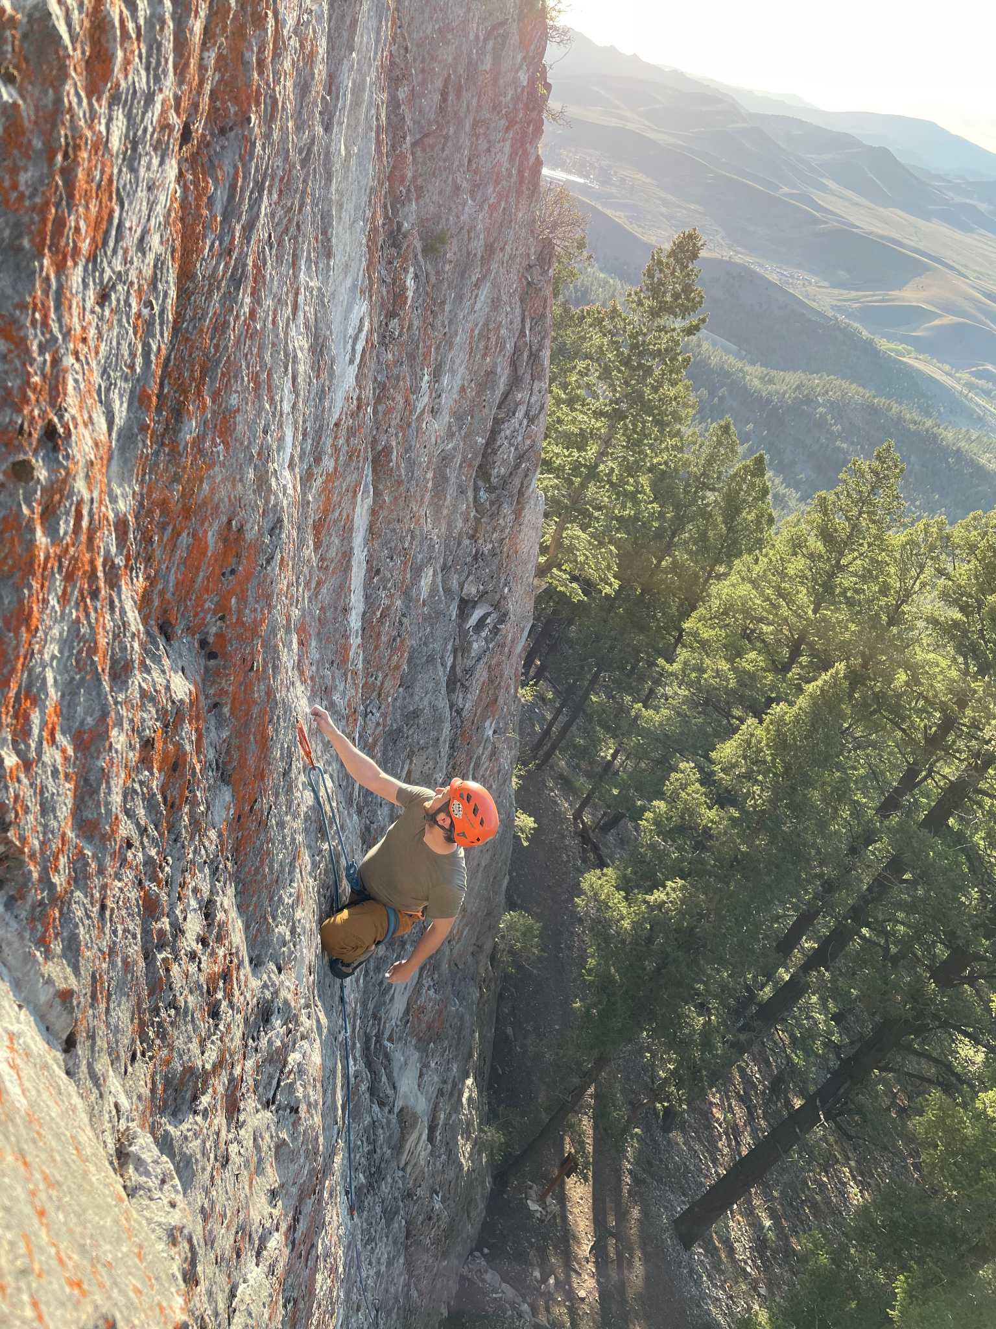
We hope everyone has been getting out and enjoying the smoke free air this spring! HCC has been busy replacing rusty hardware and putting up mussy hooks on the top of many popular climbs in the Helena area thanks to a generous donation from the ASCA. Thanks to the many climbers that have made the HCC social climbs a success this spring, we are planning on continuing them throughout the summer months. We also have a few work days coming up and would love some help sprucing up trails and belays. Please consider penciling these dates in your calendar! Work events are crucial to maintaining our crags for years to come. At one such event in September, the Access Fund is sending up one of their national work crews to help out at Winter Wall for 3 days! They need quite a few volunteers and there is a sign up link in the email below.

Get out and go climbing! 🧗‍♀️

-The HCC Board
Brad Maddock, Sarah Maddock, Dan Bachen, Megan Helton, Bob Goodwyn, Andrew Schrader, and Steve Ahlrich (the MVP).

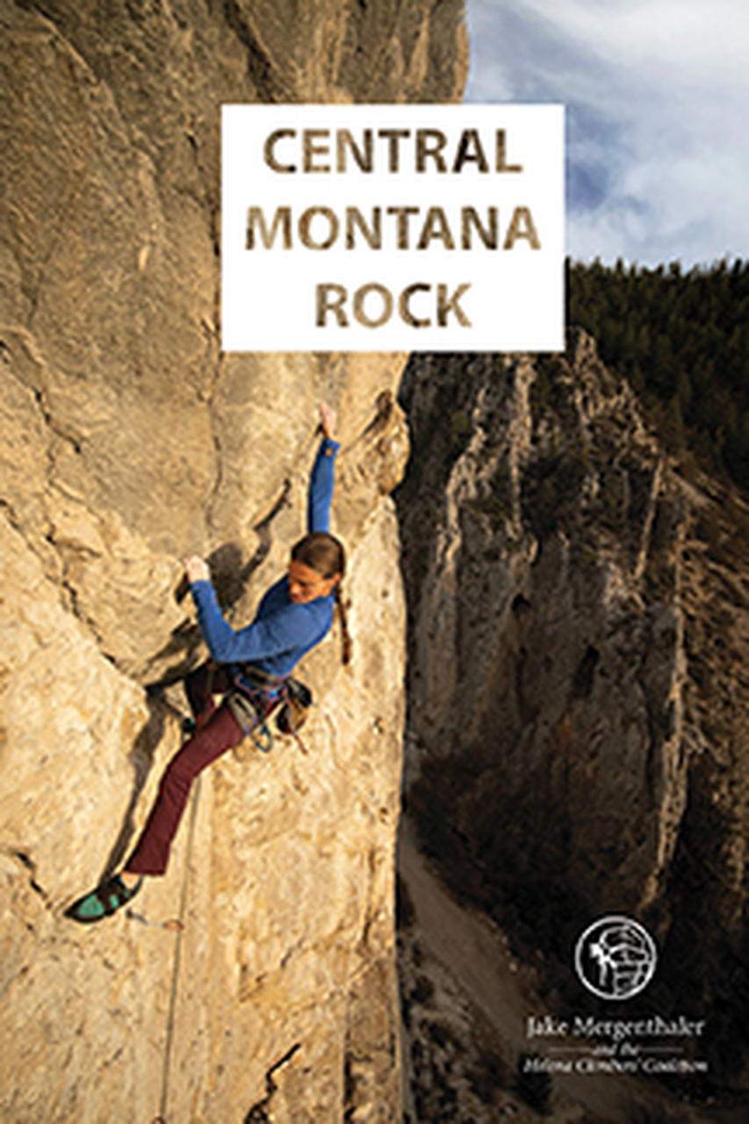
The New Guidebook Is HERE
We hope you have already picked up a copy and found a few new favorite routes! It has certainly provided us with some extra stoke to get out this spring! Many thanks to everyone that helped with the book, especially Jake and Kim Megenthaler. If you see them out at the crags, make sure to thank them!

You can now buy the book locally from one of our awesome local shops: The Base Camp or Stonetree Climbing. And the best part is, some of the proceeds for the book go back to the HCC!!!

Upcoming Events
Due to the popularity of social climb nights we are continuing them through the rest of the summer!
- Tuesday June 21st………………Social Climb: Blue Cloud 5:30pm
- Tuesday July 28th………………Social Climb: Mt. Helena 5:30pm
  - There will be a film crew present for Helena Tourism. You are not required to be filmed.
- July 4th Week………………….. No HCC Events
- Tuesday July 19th……………….Work Night: Sheep Mtn 5:30pm
  - Meet at the Devils Thumb Trailhead. Bring work gloves and a helmet.
- Saturday July 23rd………………Social Climb: Avalanche 5:30pm
- Tuesday Aug 2nd………………..Work Night: Avalanche 5:30pm
  - Meet at the Cattle Guard. Bring work gloves and a helmet.
- Saturday Aug 6th.…….………...Social Climb: Blue Cloud 9am
- Tuesday Aug 16th………………Social Climb: Mt. Helena 5:30pm
- Tuesday Aug 23rd………………Social Climb: Indian Creek 5:30pm
- Tuesday Aug 30th.……….……..Social Climb: Mt. Helena 5:30pm
- Tuesday Sept 6th.…………...….Social Climb: Hellgate 5:30pm
- Sept 16-18th Access Fund Work Days at Hellgate
  - Sign Up Here for the biggest stewardship event of the year!

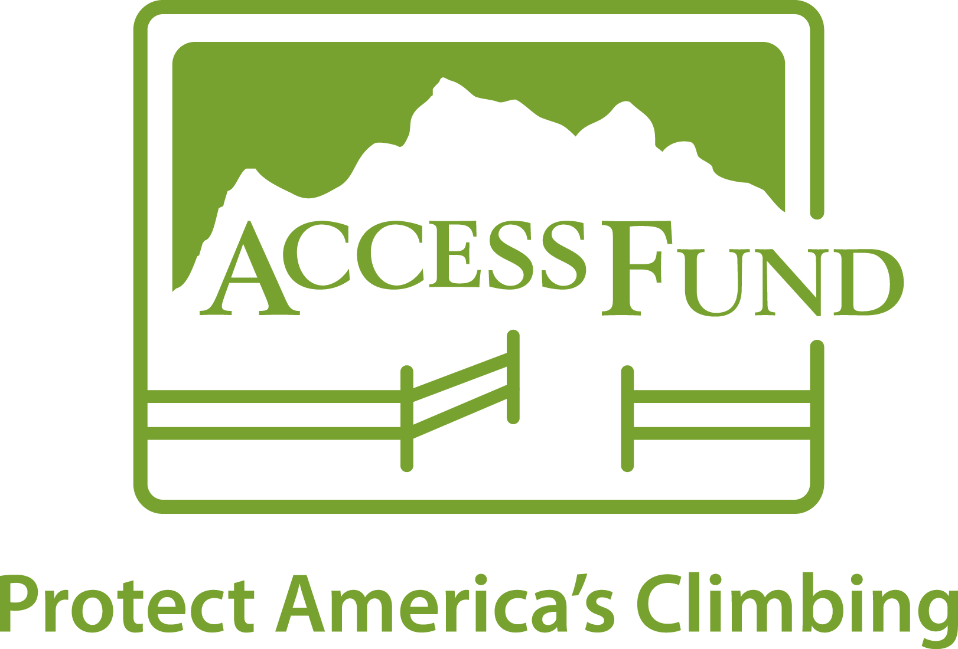
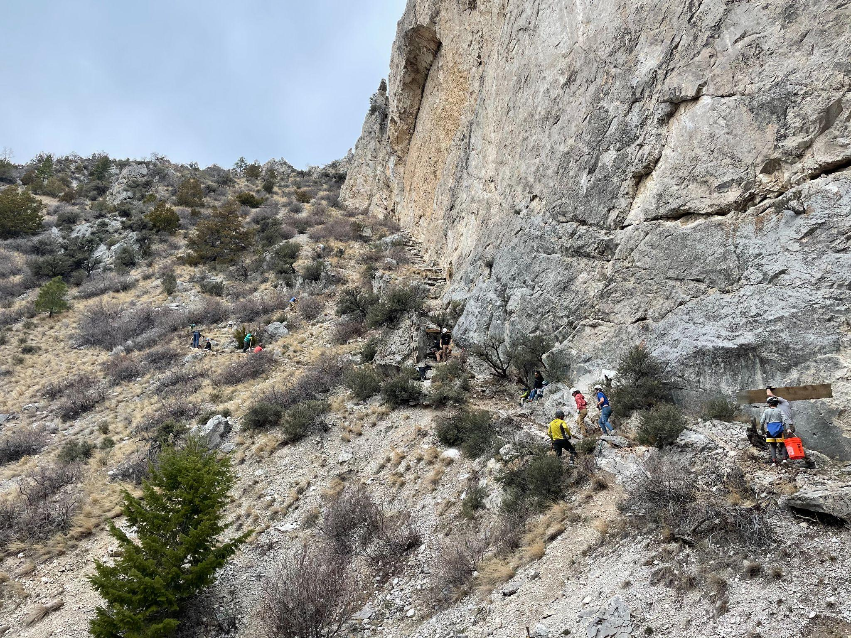

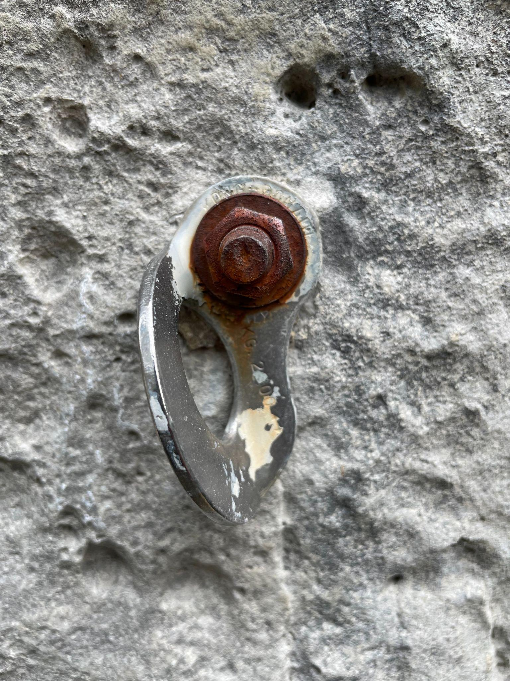
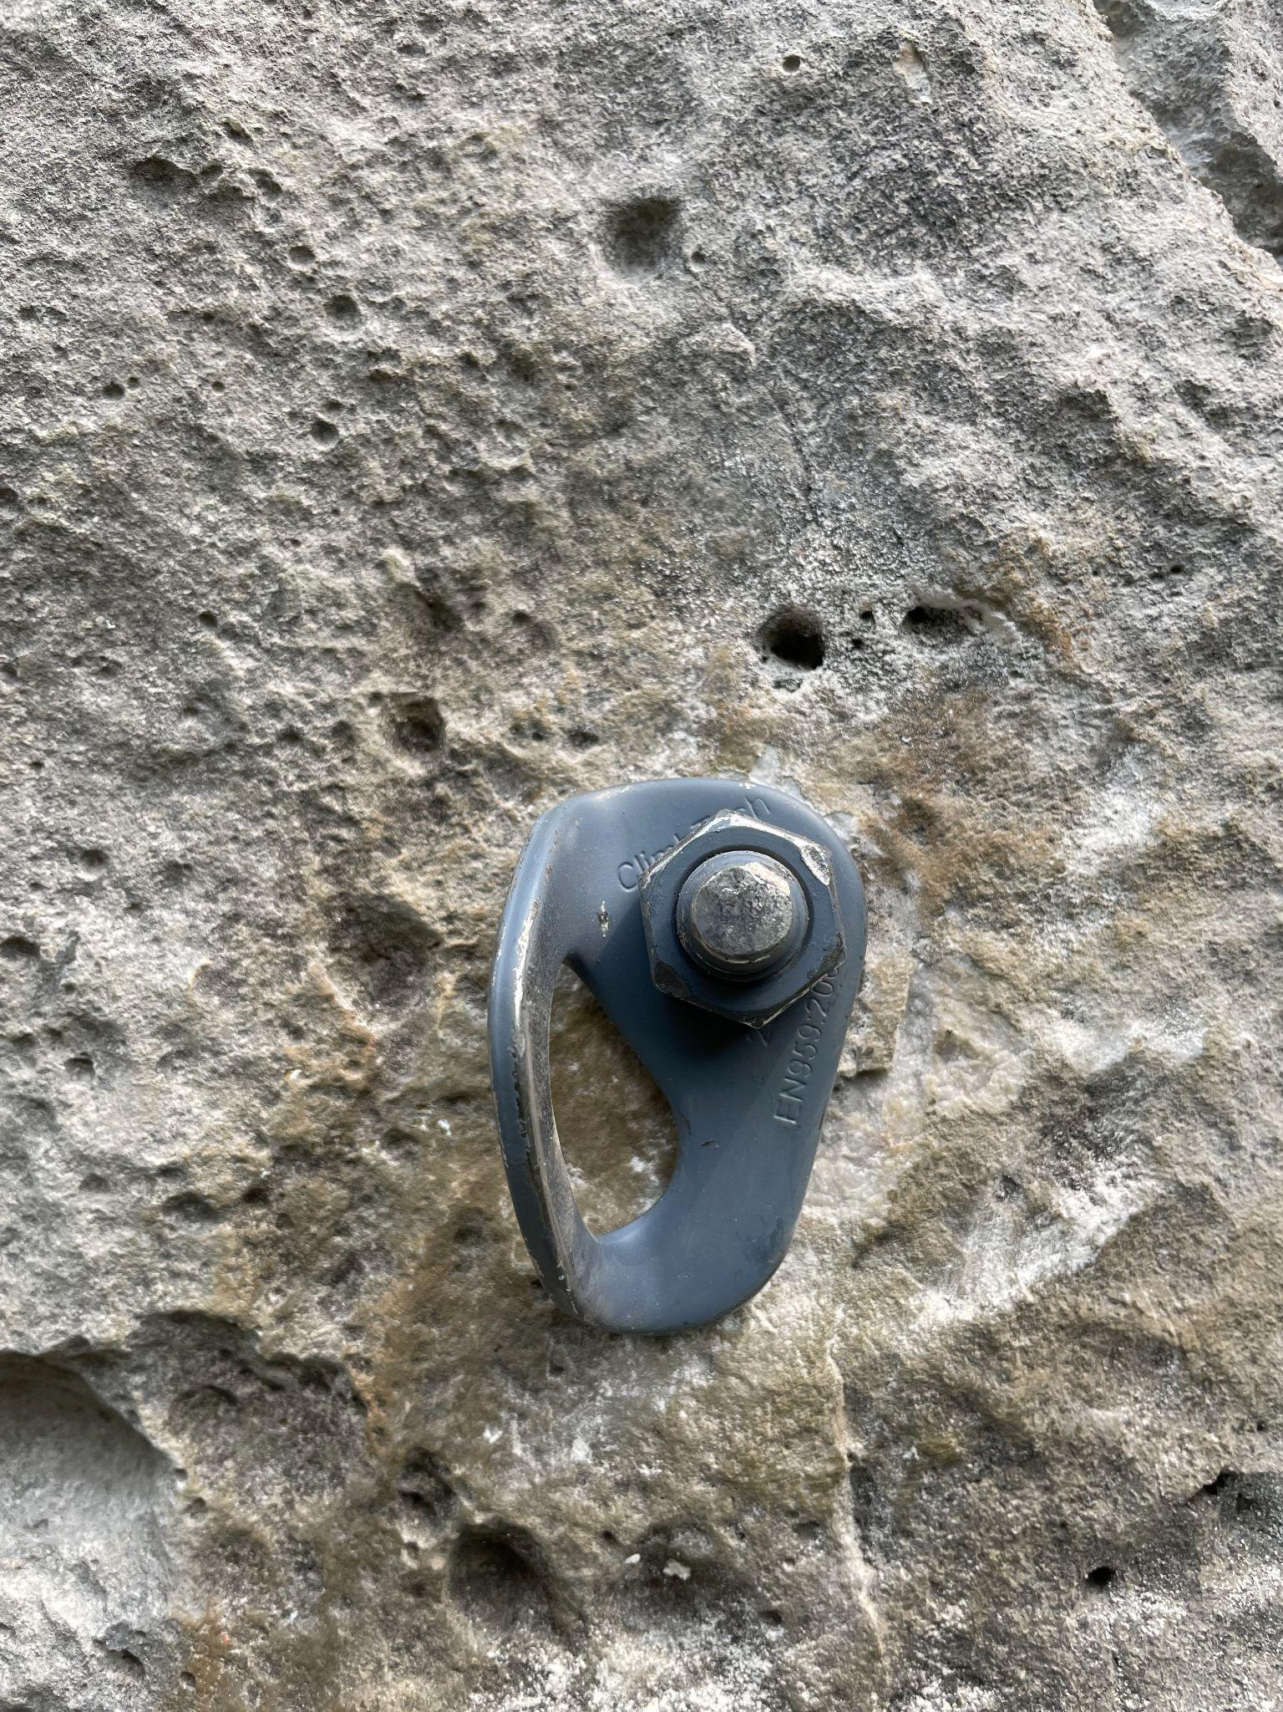
ASCA Donation and Bolt Reporting Tool
The American Safe Climbing Association has generously donated 200 bolts and hangers as well as 25 sets of mussy hooks for lower off anchors on popular routes! Thank you ASCA! Consider giving them a donation if you haven't already: https://safeclimbing.org/

Thinking about those bad bolts you clipped the last time you were out? Report them here

Since our last newsletter in February we have replaced 2 full routes, 3 anchors, and put up mussy hooks on 20 popular routes in the Helena area!
Want hooks for your favorite route or want to learn how to replace bolts and anchors? Email Dan at daniel.bachen@gmail.com

General comments? Want to be more involved? Email Brad bradly.maddock@gmail.com

https://helenaclimberscoalition.org

