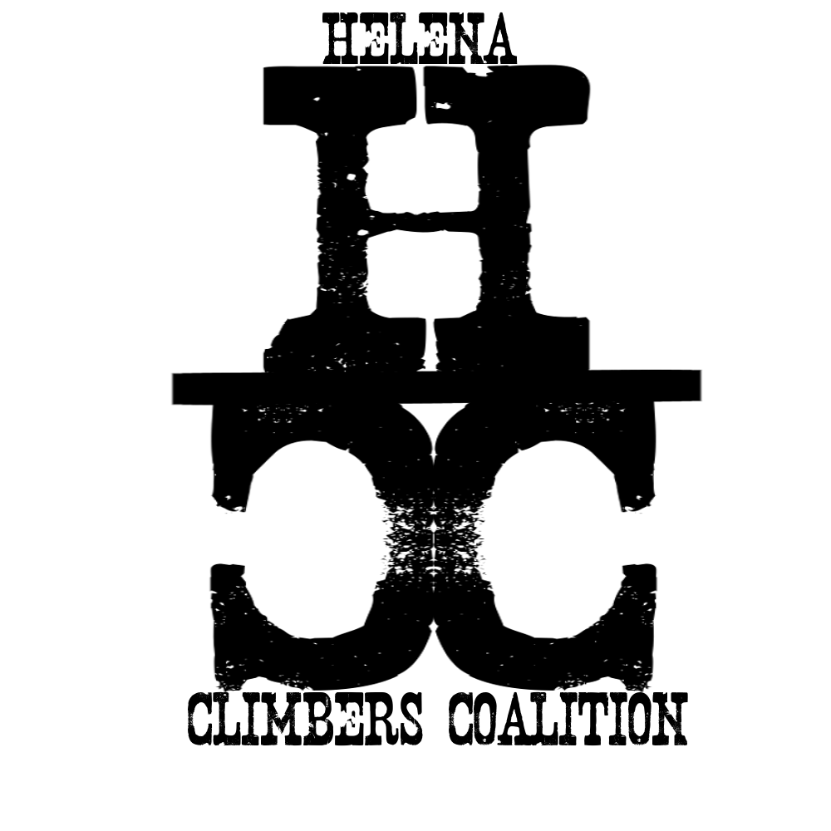
HELENA CLIMBERS COALITION
Summer 2020 Newsletter

A message from the Board

Hi folks,
Summer is in full swing and we hope that everyone has been getting out enjoying the good weather and Helena’s local climbing. In a normal year we would be highlighting the work we did over the last quarter including improving local trails during National Trails Day, announcing who won the community comp at Stone Tree, advertising social events and opportunities to get out and climb with other HCC members, and trying to rope people into committees and work days. But unless you have been living under a rock in the Batholith searching through endless boulders for that perfect project, or hand drilling runout sport routes deep in the Bob for the last few months, you have probably realized this is not a normal year.
HCC is an organization based on the interactions between members and the local community, and so the pandemic has caused an abrupt halt to much of what we do. However, the board has still been able to meet and we have been making progress on tasks like an updated guidebook, better access signs for Blue Cloud, and anchor maintenance and hardware replacement. We are remaining cautious about getting folks together in large groups as we are still in the middle of the pandemic. Currently we plan on holding a few events in the fall that facilitate social distancing and other protective measures that reduce the probability of spreading the virus. Hopefully, these include trail maintenance work at Sheep Mountain, a community evening/ camping trip at Avalanche, and a work day at one of the local crags in September.
Like all Local Climbing Organizations, the HCC is only as strong as its members and the community it represents and supports. It is our hope that despite this year’s challenges we continue to build momentum and facilitate community.
-HCC Board Member Dan Bachen

Thank you for your continued support! We have continued to have new members join even during this time of uncertainty. We are so lucky to have a community like this and we can’t wait until we can all be back together.

UPCOMING EVENTS
All events are tentative pending the duration of the COVID-19 outbreak
Summer events are cancelled until further notice. However, you and your (safely) quarantine climbing buddy should still be getting after it! Tag @HelenaClimbers on instagram and Facebook to stay connected and keep us stoked on your sends!
We will collect photos and vote for the winner at our next community meeting! Prizes for 1st, 2nd, 3rd place and best outtake. Photos can be of climbing, preparing for climbing, places you climb, your Jerry of the day moment, or that approach that made you yell “Ronnie B!!!!!!!!!!*” again.

*We are forever grateful for all the beta Ron Brunckhorst has put out into the world. If this line doesn’t make sense to you, put “The Big Empty,” “Select Alpine Climbs to Montana,” or “Big Sky Ice” on your next birthday wishlist and lose yourself climbing and attempting to climb in this great state.

October 5th
Blackfoot River Brewing Company Community Monday! From 2-8pm $1.00 from every glass of beer sold goes to the HCC! Come out and support the HCC and enjoy some “Real good beer made by real good people.”

Other events?
As soon as we can, we will be back to hanging out and climbing together. To stay up to date on changes and events, see our calendar here

BOLT REPORTING TOOL
Finding yourself stuck on the couch and thinking about those bad bolts you clipped the last time you were out? Report them here!

CLIMBING NEWS
Call for climbing photos!
Looking for an artistic outlet? Meticulous about documenting all of your great sends? HCC is looking for high quality photos and action shots of you and your friends on your favorite routes. We will include your photos (with credits) in the new guidebook. Please submit photos to bradly.maddock@gmail.com with location, route name, climber name, and photographer name. Please not butt shots or TR shots (sorry Top Rope Ninja - you’re insta famous only). New guidebook anticipated Spring 2021!

Did you buy a rad HCC t-shirt?
We still have some unclaimed, but purchased HCC shirts. Skip laundry day and email Bob at ragoodwyn@gmail.com to pick up your shirt. If you want a shirt and didn’t order one in the spring, let us know!

The Access Fund & COVID-19
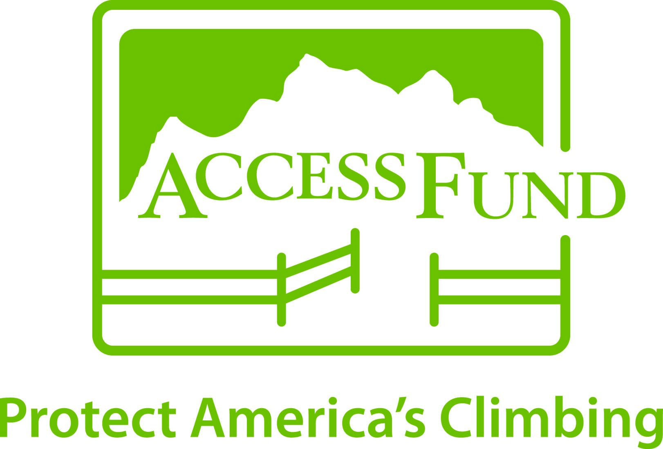
We are sure you are sick of reading more news about the COVID-19 pandemic. Here is the “COVID-19 Resource for Climbers” that the Access Fund has created. It is worth a read if you haven’t stumbled upon it already.

STOKE DURING SHELTER IN PLACE
- Alpinists at Large

Steph Davis - Choices
- Sabrina Chapman

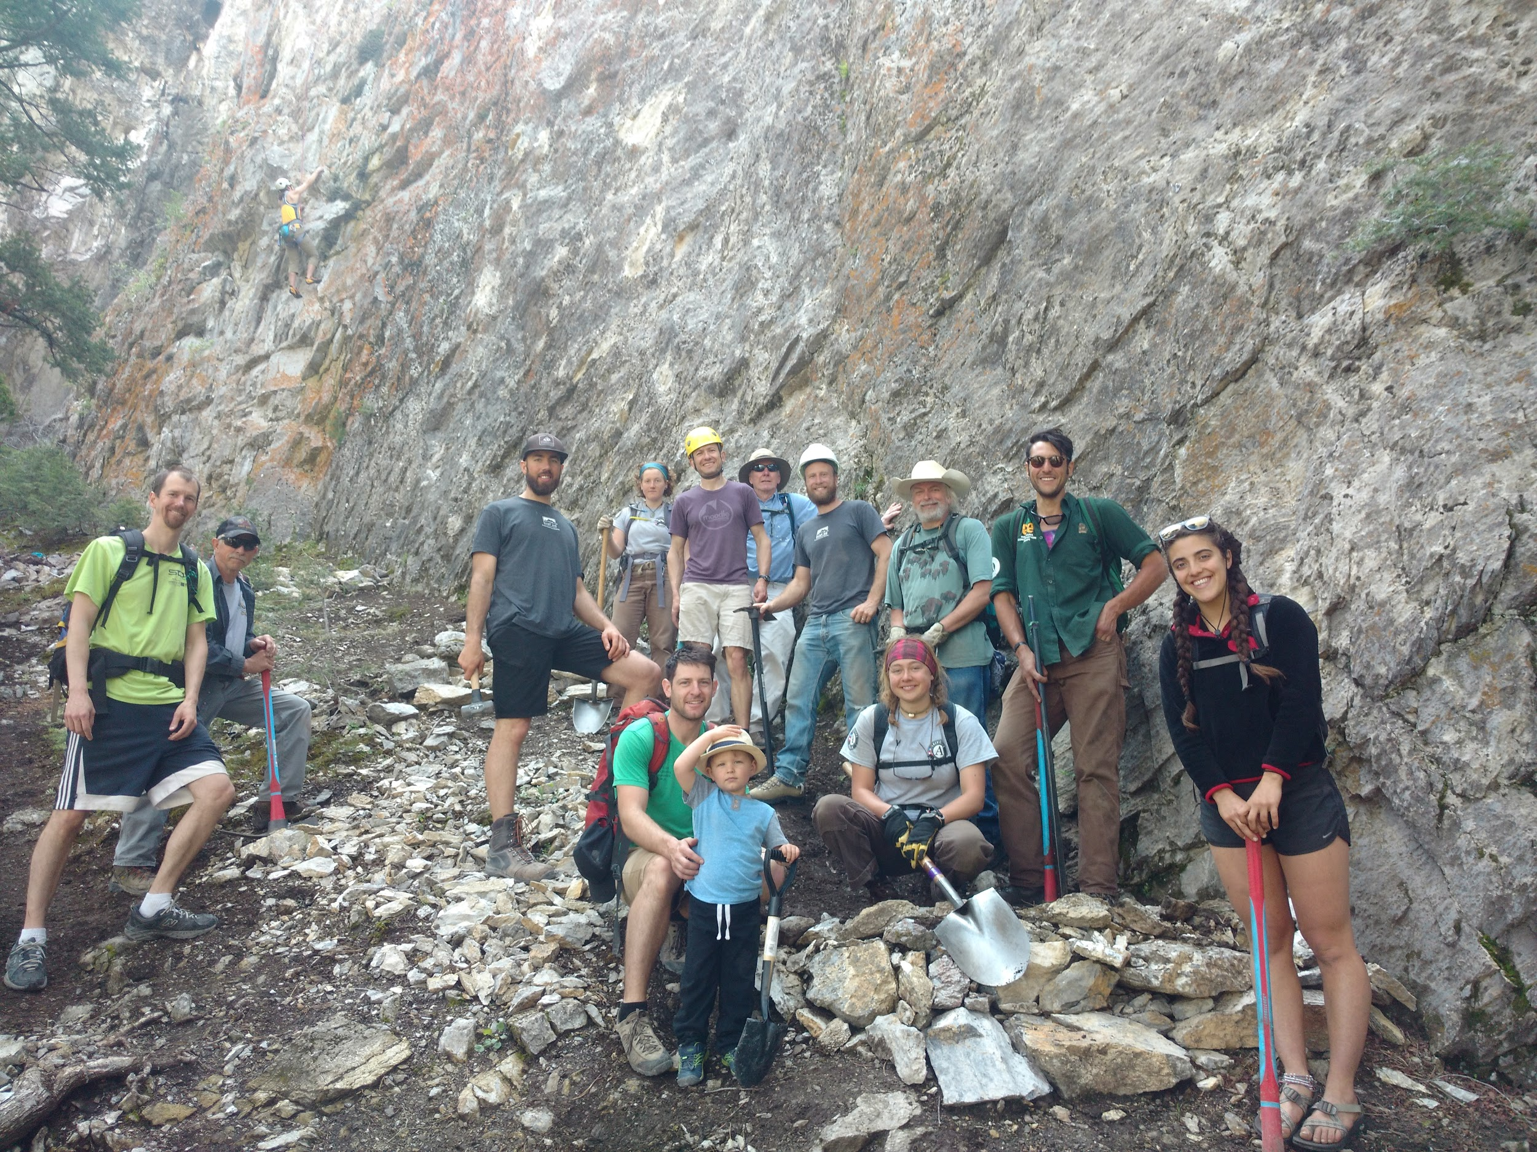

https://helenaclimberscoalition.org

