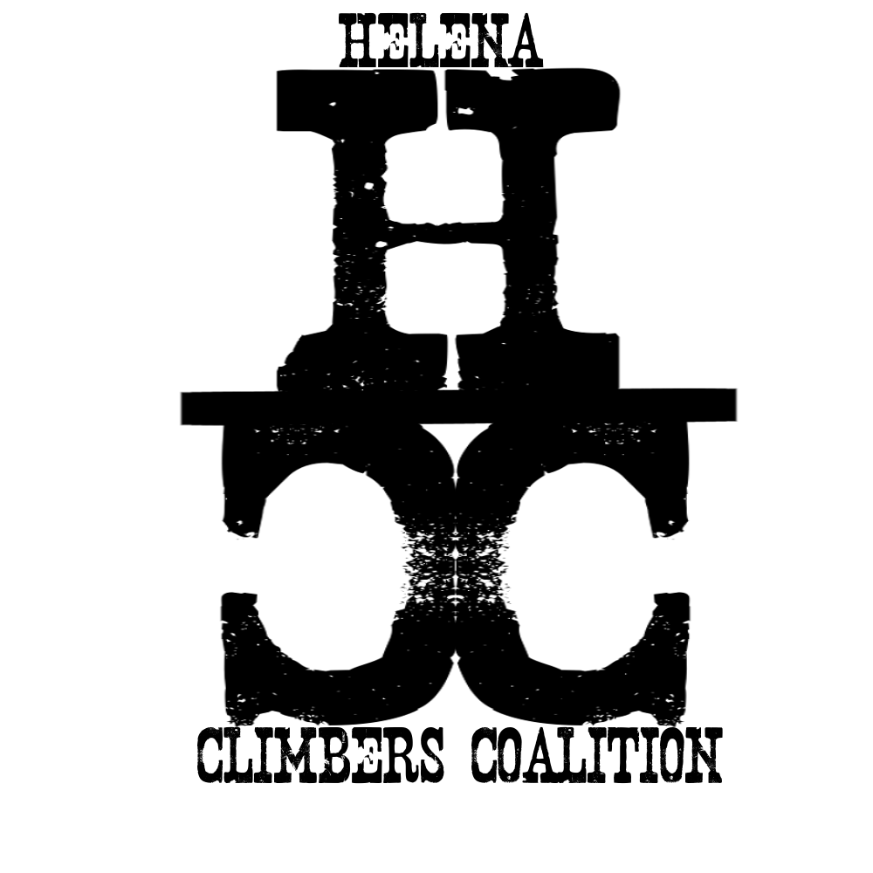
HELENA CLIMBERS COALITION

Spring 2023 Newsletter

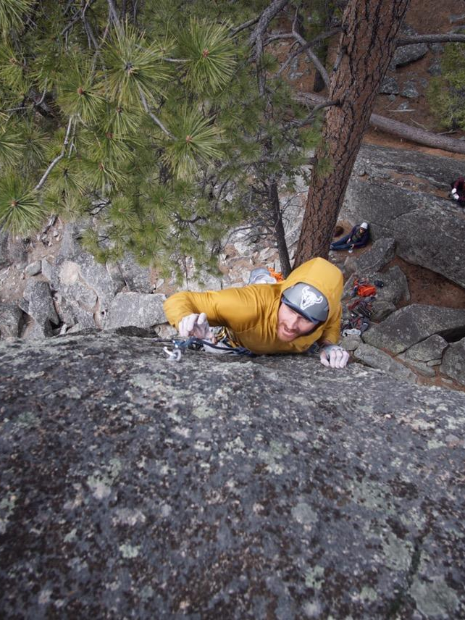
A word from the board
Friends and crushers! Winter has finally released its icy grasp from the hearts of those pining for warmer weather, flippy floppies, drinks with little umbrellas, and… oh yeah, ROCK CLIMBING! We have a lot planned for the spring/summer, and we are excited to share what is sure to be another great season with all our community members. Now, to get our psych levels high; how many times can we say "stoke" in a single sentence? (A little bird told me Bob Goodwyn holds the record). The stoked folks at HCC are stoked to bring all you other stoked folks a stack of stoke for what’s going on in and around our stoked climbing community, including social climbs, crag maintenance days, and new board members for all you stoke-soaked stokers out there!
– Haven Hoffman - Board member

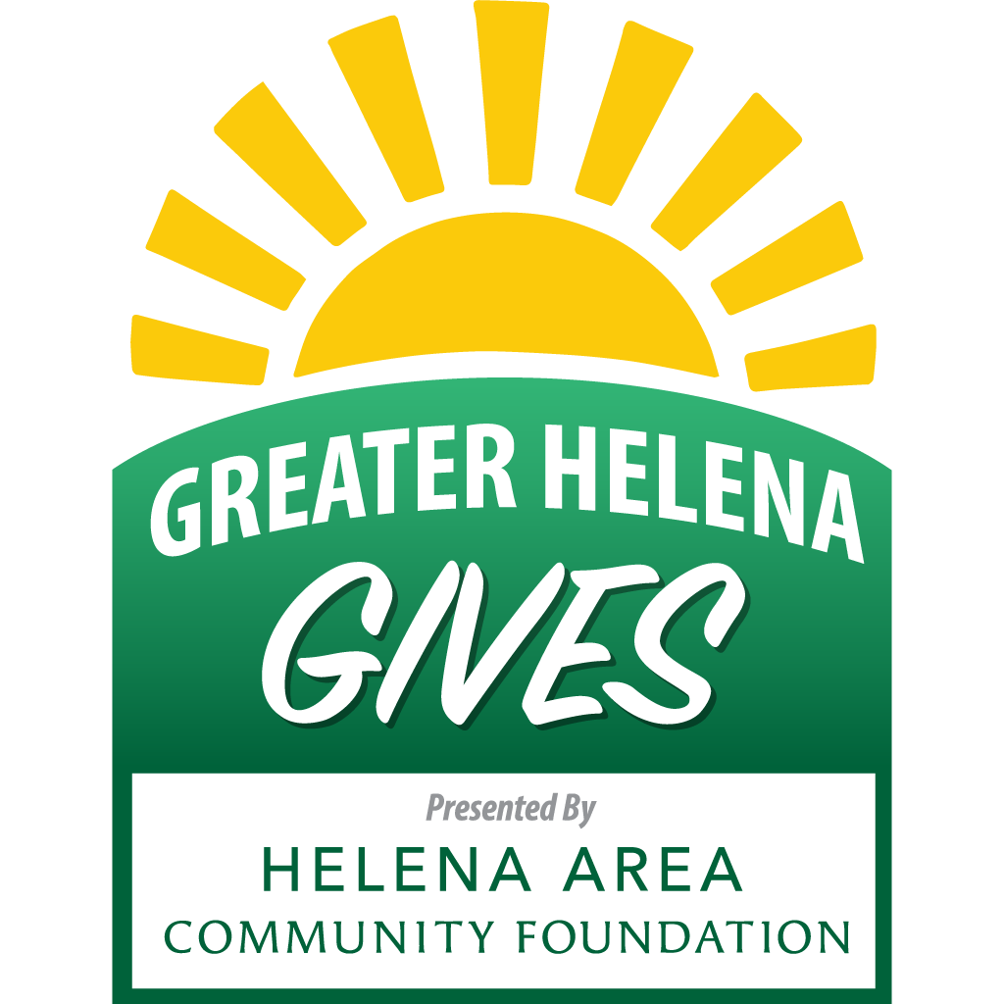
Have you dreamed of making history?
Of course, we all have. And now we have a chance to be a part of Greater Helena Area's day of giving - an opportunity to unite our community around causes in which we truly believe and help nonprofit organizations connect to the larger community.
We need your help! Please join our campaign. We need you to tell your friends and family members about the important work we do and ask them to join us in helping to make a difference.
Get ready to give! On May 3 at 8PM to May 4 at 8PM, visit greaterhelenagives.org and make a donation to us and/or to any of the great participating nonprofit organizations in the Greater Helena Area. All giving will end at 8:00PM on May 4, so make sure to get your gift in on time!

Upcoming Events
- Tuesday May 2nd 5:30pm First Social Climb of the Season
- Wednesday May 3rd-Thursday May 4th! Greater Helena Gives
- Tuesday May 9th, 5:30pm Sheep Mountain Graffiti Scrub and Social Climb
  - Come help us scrub off the graffiti on the rocks out at Sheep Mountain and climb afterward! Meet at the Middle/Right Rock Climbers Parking Lot.
- Saturday May 20th 9am-5pm, Avalanche Gulch Workday
  - Join the HCC in stabilizing some access paths to the crags in Avalanche Gulch
  - Bring gloves, a helmet, safety glasses, water, food, and stoke!
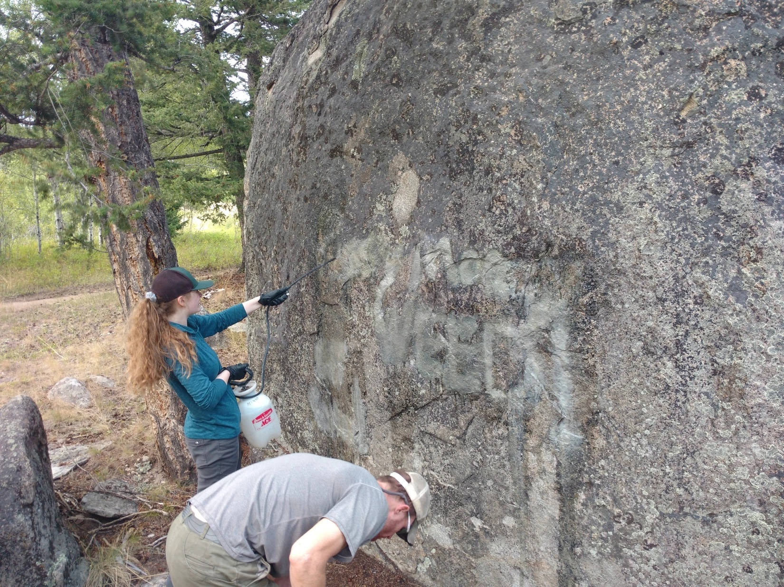
  - Sign Up Here
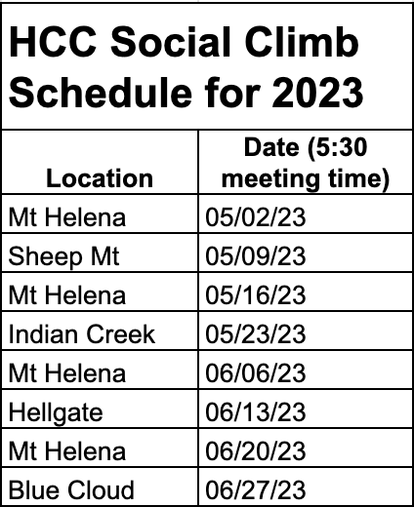

"The Helena Climber's Coalition (HCC) facilitates the weekly social climbs to bring local climbers together. HCC does not organize, sponsor or guide these events. Climbing of any kind is dangerous and should only be attempted after undertaking professional training. Failure to do this may result in serious injury or death. Participants in social climbs do so at their own risk."

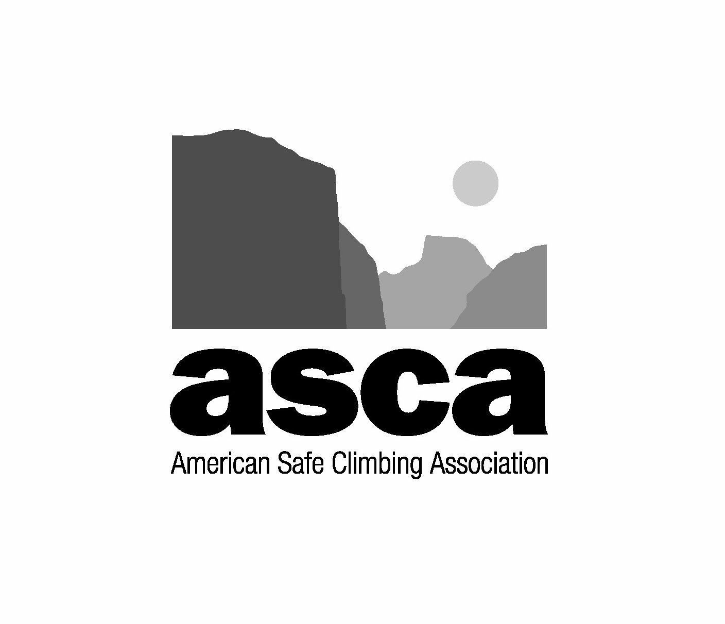
ASCA Donation
The American Safe Climbing Association has generously donated AGAIN!!!! We have 50 more sets of mussy hooks for lower off anchors on popular routes! Thank you ASCA! Consider giving them a donation if you haven't already: https://safeclimbing.org/

Thinking about those bad bolts you clipped the last time you were out? Report them here Want hooks for your favorite route or want to learn how to replace bolts and anchors? Email Dan at daniel.bachen@gmail.com

With all the new hooks going in on popular routes we thought it might be good to have an educational piece about how to use them and lower off climbs safely. Please see below from board member and HCC hardwear expert Dan Bachen.

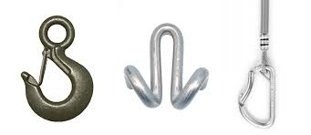
Lower Offs 101
By Dan Bachen
What are lower-offs?
Lower-offs are a class of hardware placed at the top of routes that allows a climber to lower to the ground without having to untie. Common types of hardware can include mussy hooks, rams horns/pig tails, and fixed carabiners (pictured from left to right)
Lower instead of rappel? Isn’t that bad for the hardware?
In a bygone era it was frowned upon to lower from climbs in some circles as this will eventually wear the anchor points faster than rappelling and pulling an unweighted rope. While rappelling is certainly a necessary skill and useful in many circumstances, lowering off climbs, particularly when the climber can remain tied into the rope, reduces some potential failure mechanisms and simplifies single pitch climbing. Given this, recent initiatives such as the American Safe Climbing Associations lower-off initiative have sought to make lower off hardware more common at crags across the country. If you are concerned about causing wear on hardware, a donation to HCC will fund anchor maintenance. And if you're interested we will even teach you how to do that maintenance yourself and give you the tools to make it happen!
So I can just top rope through the hooks right?
While we want you to use the hooks to lower, top-roping through them will wear them out faster. Please use your own draws or preferred anchor and have the last climber use the hooks to lower off. Same goes for running a bunch of lead laps. While we don’t mind replacing worn hardware, it's still a lot of work and takes time that could be better spent replacing bolts, putting in new routes, or just climbing!
This sounds great! How do I get Mussys on my favorite route?
We recently received 50 routes worth of hooks that need to be placed on local routes from the ASCA! If you know of a route that would benefit from having hooks installed, let us know. If your interested in helping hang hooks or keeping our local hardware in good shape we are actively seeking volunteers to do this work and would be happy to train you on best practices for hardware maintenance.
For more information on the ASCA’s Lower Off Initiative: https://safeclimbing.org/lower-off-initiative
For a good overview of how to use mussys: https://youtu.be/Y-pLP9dRWPc
How to use rams horns: https://www.thebmc.co.uk/how-to-thread-a-rams-head-lower-off

Need to pay your membership dues???
https://helenaclimberscoalition.org/members/ Still only $30, what a great deal!
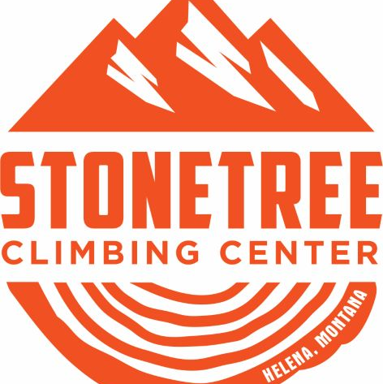
Stonetree Discounts
Thanks to the generosity of Helena’s local gym Stonetree Climbing, Contributing Member perks include:
$12 day passes on Tuesday And Student pricing on memberships
See Stonetree’s Website for further details. https://www.stonetreeclimbing.com/

https://helenaclimberscoalition.org

