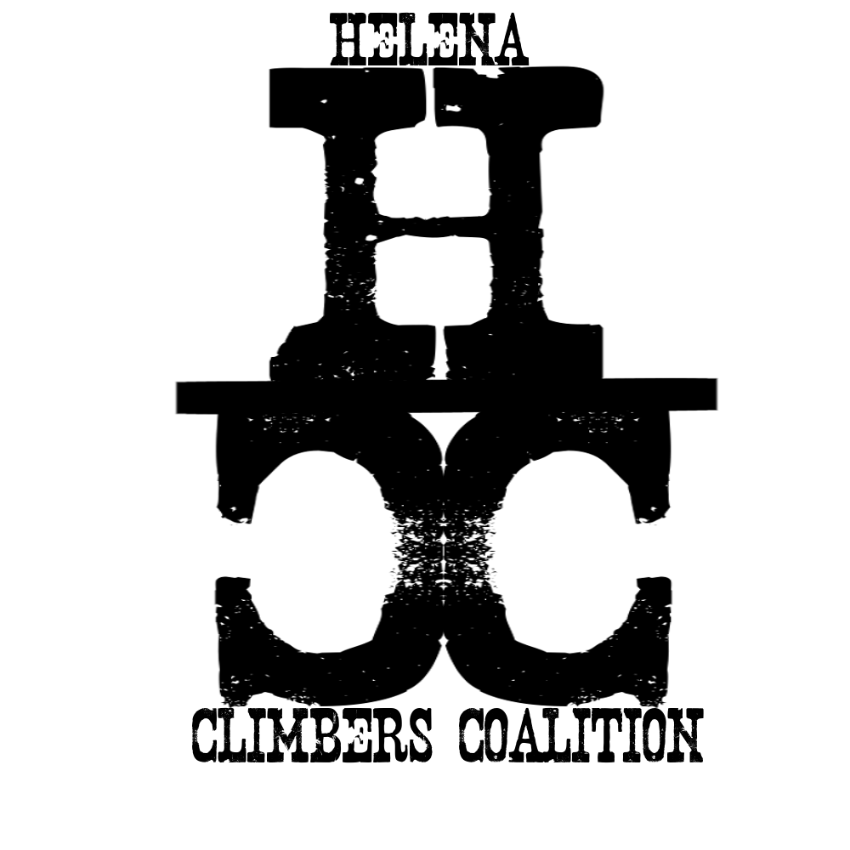
HELENA CLIMBERS COALITION
Spring 2021 Newsletter

A message from the Board

Happy Springtime HCC!
It’s that time of year when some of us might stare blankly into gear rooms and garages wondering what outdoor opportunity will best fit the next 6 hour weather window. Or maybe birding and bitterroot budding has captured your attention. Perhaps you monitor daily your favorite section of trail with crossed fingers, knowing it will be dry any day now. No matter what your interests are we can all agree: winter is loosening its grasp on our landscape.
For me, it feels like spring in more ways than one: the longer days and sunshine brighten my mood and strengthen my patience, and the increasingly good news around the pandemic mean that people are cautiously emerging from a year of social hibernation. It feels refreshing to once again linger in conversation with casual acquaintances and to start to think about future plans. And that is what this newsletter is about: the future.
A little over a year ago we halted projects and climbing events that we had worked hard to organize. We had seen a large growth in our membership and felt a strong passion for connecting climbers across the community. And that momentum has been impacted by COVID-19, like all aspects of life. It’s been hard to stay motivated and connected this past year, and we’ve tried as a board to be transparent and communicative. Who knows how we did, but we tried and we kept working, hoping that this spring would come. We are hopeful that you will reengage with us and bring ideas, stoke, and the love of climbing to our upcoming meetings and volunteer days.
Please take the time to read through these next short pages. We have included information about how to vote in the new board, an upcoming volunteer day, and the new area guidebook. If you haven’t already re-upped or started your membership, please do so and help us keep building an engaged and open community of climbers.
Enjoy your season of new beginnings!
Megan Helton, HCC Board Member
Thank you for your continued support! We have continued to have new members join even during this time of uncertainty. We are so lucky to have a community like this and we are looking forward to reconnecting this year.

BOARD MEMBER VOTING

The current board served its 2 year commitment and we have received nominations for a new board. These new folks will serve 2021 and 2022. We do not have term limits and board members vote among themselves for officer positions. We have 7 open positions and 8 nominees; do not vote for all 8 or else your vote will be discounted. Please use this form to vote. We will close voting on 4/15/2021. You can read the descriptions below, and on the google form linked above.
Nominees:
Dan Bachen
Since coming to Montana 18 years ago I’ve managed to climb at most of the areas across the state and sample some of the best sport, trad, and bouldering our region has to offer. Through time I have begun to realize how much strain the rapidly growing climbing community is putting on our local areas, and how we should not take for granted the access to or privilege to climb at any crag. I strongly believe that the Local Climbing Organization model is among the best ways to address land owner and manager concerns about the impacts climbers have on the areas they love and maintain access to these climbing areas. I have served on the board since 2019. Over this last term I am most proud of the work done with our other board members to begin to address aging hardware across the Helena area. If elected for another term I look forward to continuing this work and assisting with the board’s other efforts to maintain access and conserve our local climbing areas.

Bob Goodwyn
Since moving to Helena, I can't get enough of the Helena climbing community. I do my best to be as active a climber as I can: whether it be inside bouldering, cragging around Helena, or chasing ice and alpine lines in the greater Montana area. Through those activities I feel like I’ve come to know a great number of people, experienced many different crags, and seen good and not-so-good usership. I've seen what's at stake if we don't treasure these places, but also a culture that I would like to see persist amongst Helena climbers. As a part of the Helena Climber’s Coalition, I would really like to share that knowledge, adding to our user’s experience, making Helena climbing safe and fun for all. I’m open minded, detail oriented and most of all, passionate about our climbing community.

Megan Helton
I would like to be on the HCC board to continue to grow the climbing community and to preserve our crags! I have a background in non-profit management, land management, orchestrating large scale volunteer events, and I've been a member of the Access Fund for the past 5 years. As part of the board since 2018, I designed the HCC website and finalized the by-laws and would like to provide continuity to the good work HCC has already begun! I regularly lead events for new climbers both at Stonetree and outside and feel passionate about being a people connector and a stoke generator.

Sarah Maddock
I have been on the HCC board for the past 2 years and would love the opportunity to continue serving the Helena Climbing Community in the future. My family and I are avid climbers and I have a strong desire to protect our climbing areas for future generations as well as instill a love for climbing in our younger generations. I have served as Treasurer and Secretary on the board and have helped grow and develop HCC from its inception. I hope to continue to serve on the HCC board and continue to support our local climbing community.

Andrew Schrader
Thank you for the nomination to be on the HCC board again. I am interested in staying on the HCC Board to continue progress on the projects and initiatives we’ve been working on. 2020 has been an off year for all of us, including HCC, and there is a lot of work to continue. It was exciting to see the growth in community involvement before COVID and we have the potential to gain that momentum back. Our board has consisted of a close group of friends that I enjoy climbing with and working with. I feel that I can provide input, work, and experience to the HCC board. This organization, climbing lifestyle, and the members of HCC are a major component of my life.

Brad Maddock
I would love the opportunity to continue to be on the board of the HCC. As more and more people begin to discover Helena and our local crags, we need to make sure we are maintaining the access to our climbing areas, the hardwear we trust our lives with, and are good stewards to the land our crags exist on. I have served as the HCC Chair for the past 2 years and have a very good working relationship with the City of Helena Open Lands Dept, the US Forest Service, and the BLM. If elected as part of the board, I will continue my dedication to preserving our local climbing areas so that not only the climbers of today but also the future can enjoy them.

Steve Ahlrich
I moved to Helena in 2015 and in that time have done a lot of rock climbing in the area. I've been climbing since I was 16 years old. Think gold line ropes, racks of chocks, and EB footwear. Yes, it was brutal, but we didn't know any better. I'm recently retired and would be happy to help with growth, maintenance and management of Helena's fine climbing areas. I'd also enjoy working and climbing with more of the local climbers. I own a nice set of newer cams and love a good clip-up. I'll warn you that I won't support the bolting of cracks, but I won't stop you either.😐

Peri Turk
I am a recent college graduate from Ohio State and moved here for a job in the middle of the pandemic. As weird as the world has been since then, climbing is one of the things that has remained a constant for me. It has given me the opportunity to meet my friends out here and has provided a great time for mental breaks. I am 3 years new to climbing and a group similar to this was how I first experienced climbing outside. There is still a ton I would like to learn and try. I would love to be on the board to meet more like minded people and to continue to get new climbers climbing outside. Creating and gaining new experiences is one of the best things about the outdoor community.

UPCOMING EVENTS
All events are tentative pending the duration of the COVID-19 outbreak

WE ARE GOING TO HOST A VOLUNTEER DAY! And yes, I did electronically shout it. We are very excited to provide the opportunity for our climbing community to reconnect and spruce up one of our most beloved springtime crags. On Sunday April 18th, we will host a small volunteer day at Hellgate to improve the trail and belay pads at Winter Wall. Tools will be provided and you can bring your own, if you have a favorite pickmatic laying around feeling neglected. Please bring your own gloves, helmet, safety googles, food, and water. We should have time to climb in the day, so bring your gear too!
We know that people have varying levels of comfort with gathering right now, so please check with yourself, your family, and your roommates and decide what is right for you. Trail work necessitates pretty wide spacing between people and we think we can communicate safety concerns among members who attend. There is no rain date for this event.
Sign up to volunteer at Hellgate on April 18th here!
For those of you who can’t make the event in April, please mark your calendars for National Trails Day on 6/6/2021 and National Public Lands Day on 9/25/2021. We will host volunteer work days on both of those days, and potentially a couple more throughout the climbing season. We will be sure to share detailed information and how to sign up for those events in the future.
Dan Bachen is reaching out to HCC members that would be interested in joining an informal anchor workshop. He’d like to work with people to go over the basics of anchor replacements and is willing to host a demo and help direct a work session. If this is something you are interested in, you can contact Dan at: daniel.bachen@gmail.com
Other events?
Soon, we will be back to hanging out and climbing together. To stay up to date on changes and events, see our calendar here.

BOLT REPORTING TOOL
Starting to emerge from your couch cocoon and thinking about those bad bolts you clipped the last time you were out? Report them here!

CLIMBING NEWS
This is a great article about Conrad Anker in the Washington Post that is worth a read.
And this is an interesting read regarding growth, conservation, and recreation in Bozeman.

The Access Fund & COVID-19
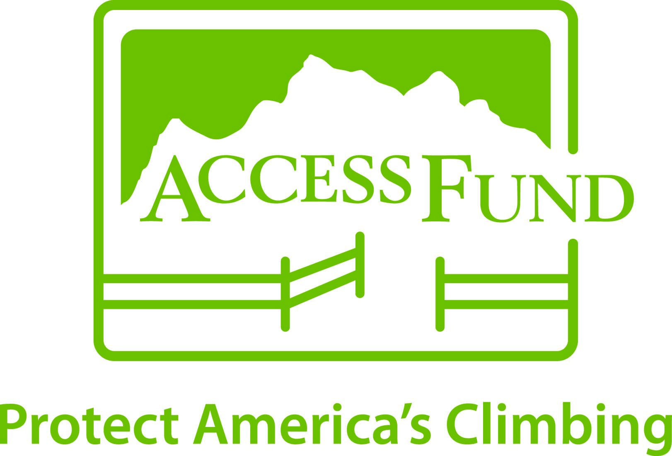
Here are some tips from the Access Fund on returning to the crags and avoiding the crowds.

SPRING TIME STOKE MACHINE

Review of Black Ice from Reel Rock 15
Brush off Failure
And for anyone battling injury or recovering from an accident, here’s a great podcast from Mark Twight, Bozemanite Blair Speed, and Sky Runner Hilary Allen

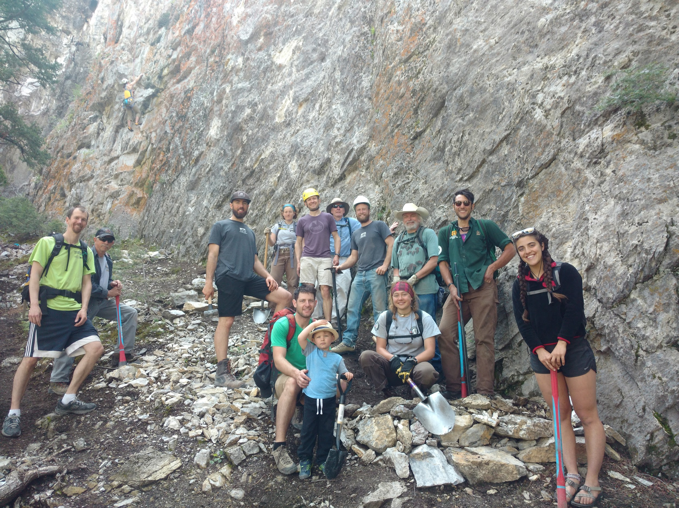

https://helenaclimberscoalition.org

