
HELENA CLIMBERS COALITION
Late Spring 2021 Newsletter

Thank you for your continued support! We are stoked to be able to safely hold in person community events again this year!

MEET HCC’S NEWEST BOARD MEMBER

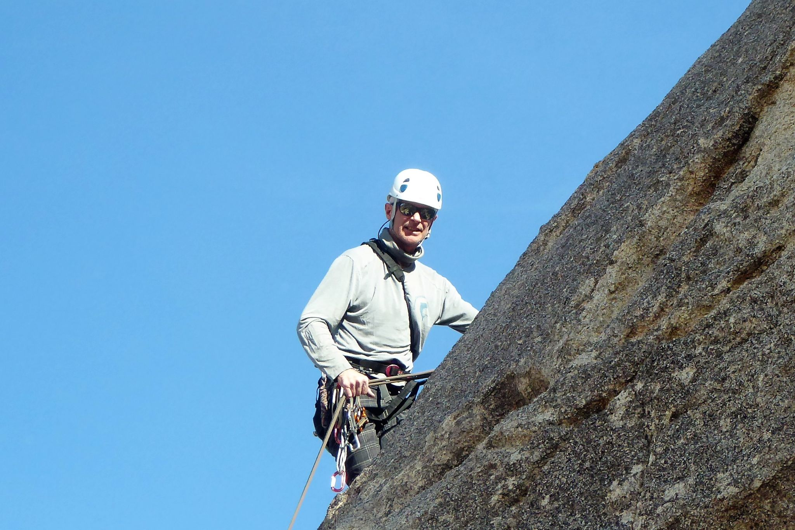
Steve Ahlrich
Born a westerner, I have lived in Arizona, Oregon, Washington and Montana. I lived in Missoula and Bozeman “back in the day” (MSU class of ‘86), and found myself in Helena in 2015. I love the lack of crowds and easy pace and don’t know of a better place to be. I’m primarily a cragger these days and love a good multi-pitch climb. I thoroughly enjoy climbing at our local crags as well as reaching a bit further out in neighboring states like Idaho and Wyoming. When not climbing I enjoy fly fishing, back-country skiing, and local and international travel. After the day’s adventures there is nothing better than sipping a cold beer with friends at a local brewery. I look forward to working with HCC to promote Helena area climbing, and advocate for climbing ethics and environmental stewardship.

UPCOMING EVENTS

Every other Tuesday Starting June 1st
- June 1st 5:30pm Mount Helena Social Climb!
  - Meet at the main parking lot and look for the people with climbing gear ;) No work, just climbing! This is a great way to meet new climbing partners for the summer!
  - If you are late, meet up at the Sunset Slab.
- June 15th 5:30pm Sheep Mountain Work and Climb
  - This is a work event and we will climb afterward if we end up with time. Please sign up if you plan on attending. HCC will provide food and drinks. A more detailed information email will be sent out before the event to those who have signed up.
- June 29th 5:00pm Indian Creek Work and Climb
  - This is a work event and we will climb afterward if we end up with time. Please sign up if you plan on attending. HCC will provide food and drinks. A more detailed information email will be sent out before the event to those who have signed up.
- July locations TBD follow us on Social Media for updates! Instagram or Facebook

BOLT REPORTING TOOL
Thinking about those bad bolts you clipped the last time you were out? Report them here

Guidebook Update
The book is taking longer than expected but it is still in progress! We will update you when we know the print date, but for now, stay stoked for all the new routes and to hold a COLOR guidebook!
Stonetree Climbing Center Deals!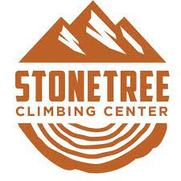
HCC members climb for $7 on Wednesday nights!
AND
HCC members get $10 off their monthly membership! Thanks Stonetree!

Thanks to the Montana Bicycle Guild
Big thanks to the Montana Bicycle Guild for lending us their tools for trail days. If you REALLY want to say thank you, you can use the same tools and help them out at one of their trail days in Lincoln, MT June 12th at 9:30am. For more info Email info@montanabicycleguild.org

SPRING TIME STOKE MACHINE
#throwbackthursday time for some classics!
Chris Sharma: Es Pontas

Dan Osman Masters of Stone IV Waterfall Climbing

Hazel Findlay First Female E9
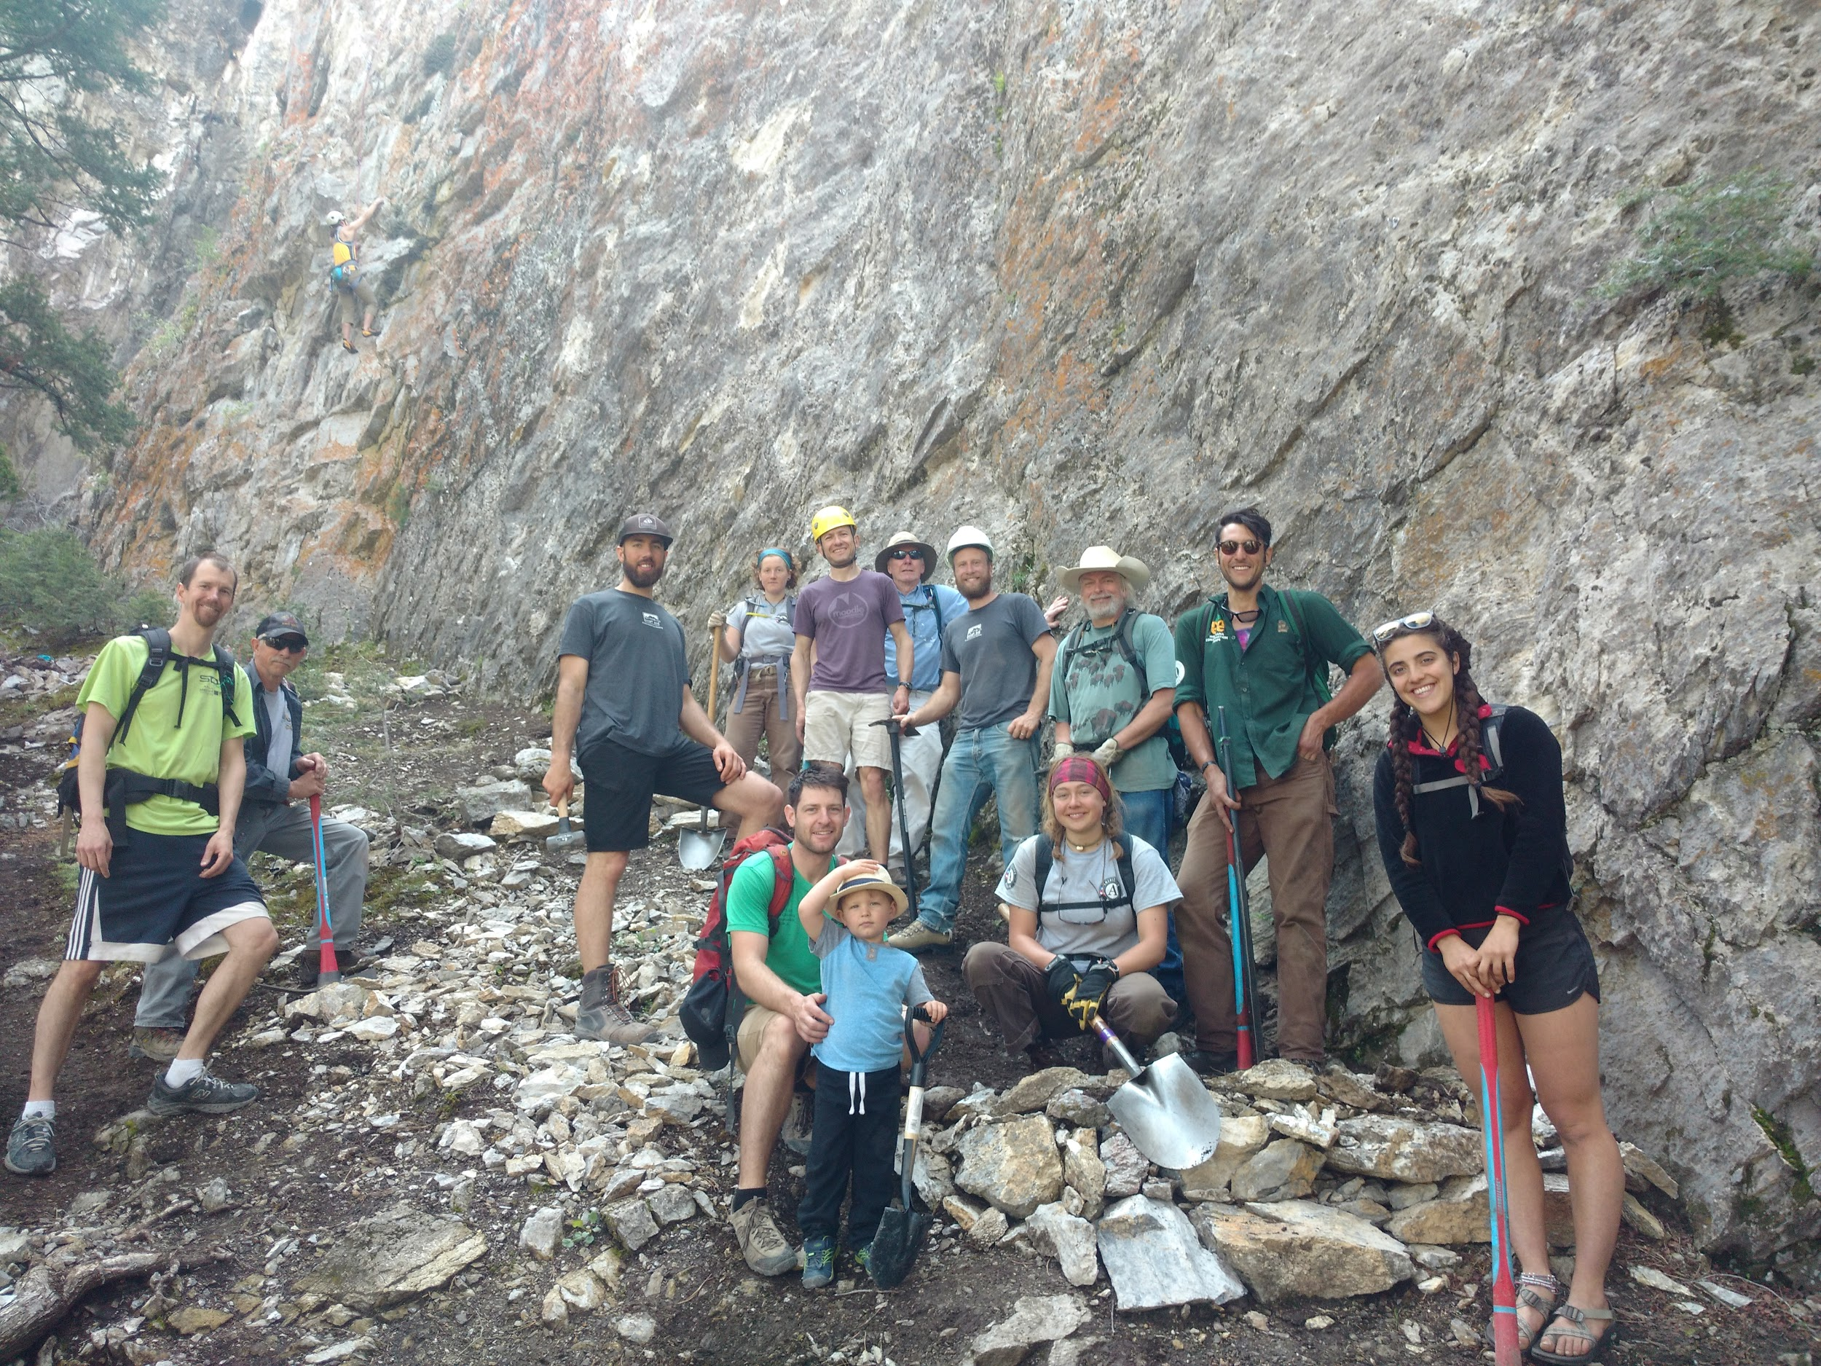

https://helenaclimberscoalition.org

