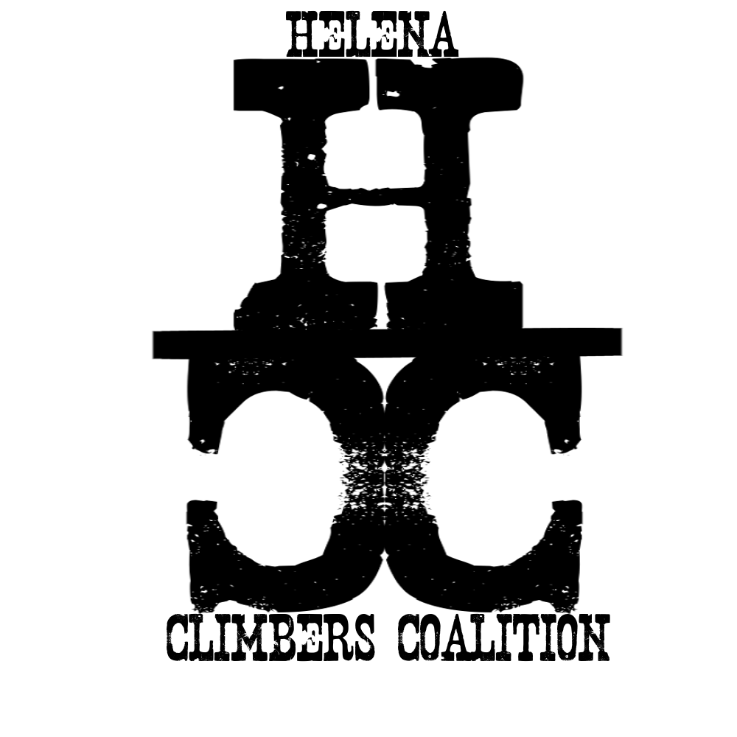
HELENA CLIMBERS COALITION

Fall/Winter 2023 Newsletter

Randall Green

April 25, 1953- Sept 29, 2023
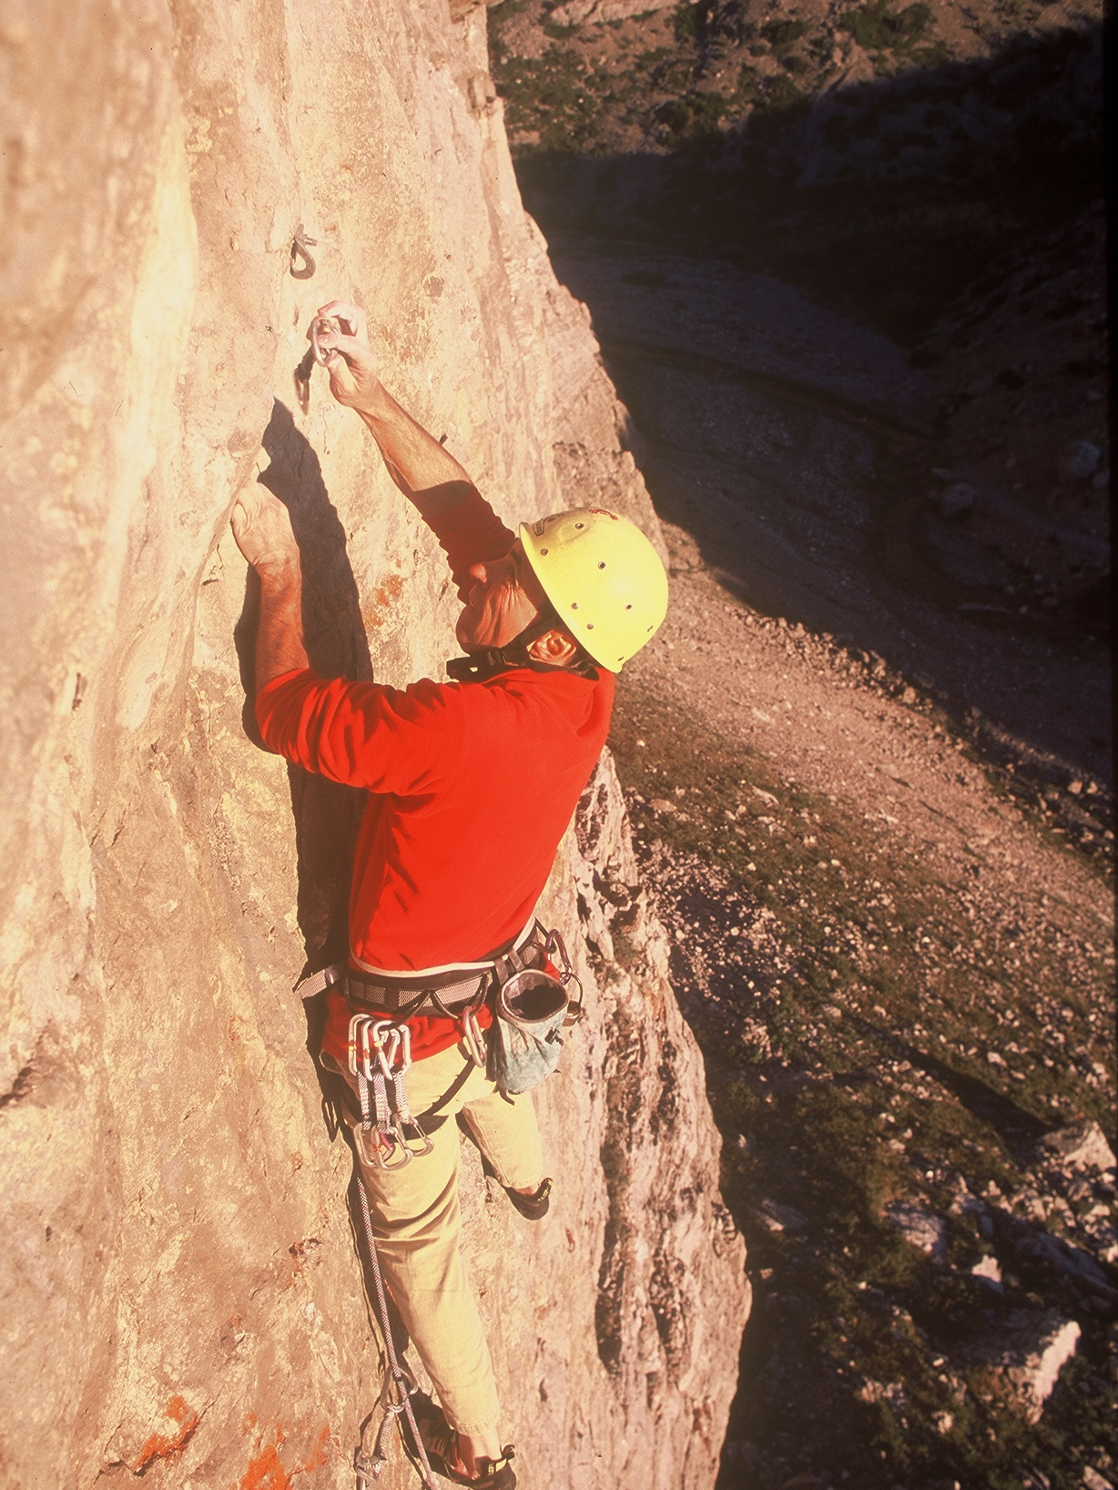
By Jake Megenthaler:
The Helena climbing area lost a valuable member of our community. Chances are if you’ve climbed anywhere around Helena you’ve climbed a route Randall Green equipped. Not only was he a valued bolter and developer of crags, he was a guidebook author, land steward, mentor and all around good guy.
Randall came to Helena in the early nineties and soon after that started bolting classic climbs; “Benevolence” and “Thin Fine Line” are two great ones on the “West Wall” in Hellgate Gulch. He also opened up new crags like the “Winter Wall” at Hellgate. A wall that took vision and hours of brutal work to clean. He also put new climbing areas like Blackleaf and Beaver Creek on the map.
When I first met him he was climbing regularly with his strong wife Teresa but also roped up with Bill Dockins quite a bit. While he had steady climbing partners Randall would climb with anyone who had enough energy to keep up with him. He helped countless people learn to climb on the slabby crags of Sheep Mountain and beyond.
Randall was also a great book editor and guidebook author. He meticulously made notes on Helena climbs and then penned the description in a way that got you to the right climb but still let you have an adventure. Randall had a great mind for remembering every move on every route he ever did so he was a shoe-in for writing the first Montana specific guidebook.
At a celebration of life held at Stonetree Climbing Center, friends and colleagues shared stories about their lives with Randall, a few attributes resonated through us all. Many talked of his willingness to mentor new climbers, writers, or even real estate agents. He just loved to teach positive people new things. He had the ability to lead people right to the edge of what was possible for them.
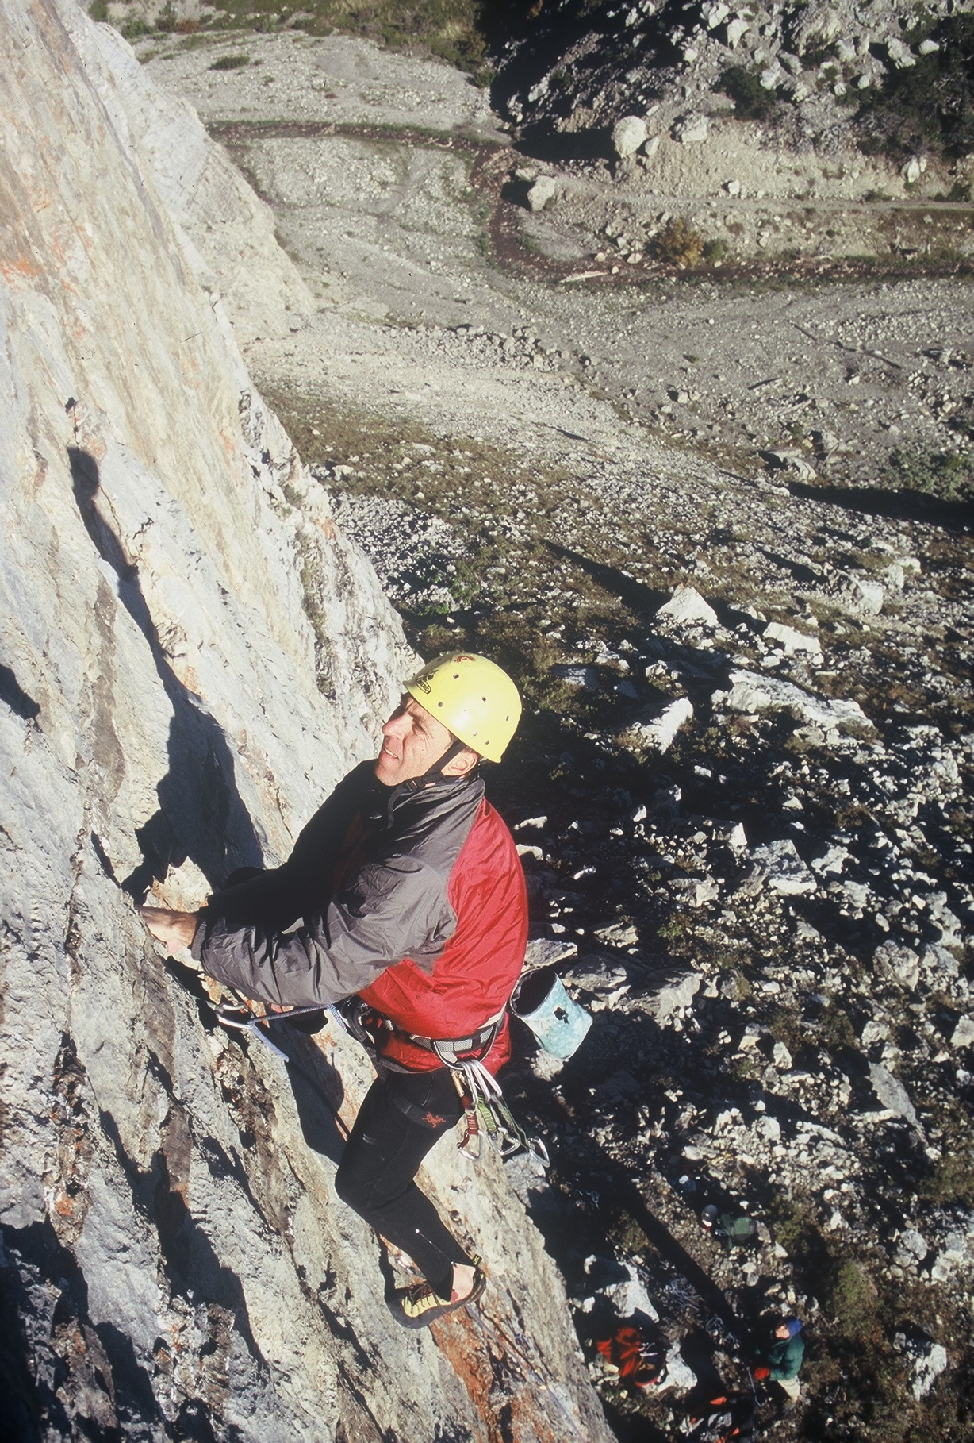
Others spoke of his work ethic. Whatever Randall did he was not going to be on the sidelines. In addition to bolting, he made trails, picked up litter, and even would provide a little positive peer pressure so that we all acted like stewards to the crags.
We enjoyed the benevolent way he led his life, but what we also admire is his drive to be the best that he could be whatever adventure he was having. Whether it was climbing or some other passions that he picked up later in life, he had the passion and the discipline to do it well.
What can we learn from the way Randall lived his life? Don’t just be a climber, be a steward. Treat the crag with respect and kindly adjust others' views to protect our valuable climbing areas. Find the joy that comes with ownership. Act like our rocks are your backyard, work to protect them. Whether that means rolling up your sleeves on work days, or contributing monetarily, we can all foster a healthy “work ethic”.
When Randall smiled his entire face lit up. He was always welcoming to climbers who came to visit Helena. By doing that we can combat some of the negativity many feel, and leave our rocks a positive haven for fun. Randall will be missed, but he left a great legacy both in the rocks he developed and the attitude he displayed.

Obituary: https://www.legacy.com/us/obituaries/helenair/name/randall-green-obituary?id=53268885

❗️PLEASE FILL OUT OUR SURVEY
Please fill out our survey! So we can learn more about you and how you use the climbing in the Helena area! The survey can be completed in less than 5 min! https://docs.google.com/forms/d/e/1FAIpQLSeUF2U1fSktT8XlTFsdWZGN--coC3AskhZTtyzF1KzPRQL2HQ/viewform?usp=sf_link

Upcoming Events
- Mt. Ascension Brewery Happy Hour Nov 7th 5:30pm
  - Come out from under your rock to join us
- Tuesday night Social Climbs!!!
  - Let's keep the fun going, indoors! HCC Members get $13 day passes or student pricing on your monthly membership!

Spring/Summer Wrap Up
The HCC was hard at work this summer maintaining trails, scrubbing graffiti, replacing bolts, and creating community! Our biggest project by far was rebuilding the approach to the upper climbs at the Blue Collar Wall in Avalanche Gulch. Thanks to all our volunteers for helping make this project possible! We look forward to finishing the last few stairs and starting on some other projects next year.
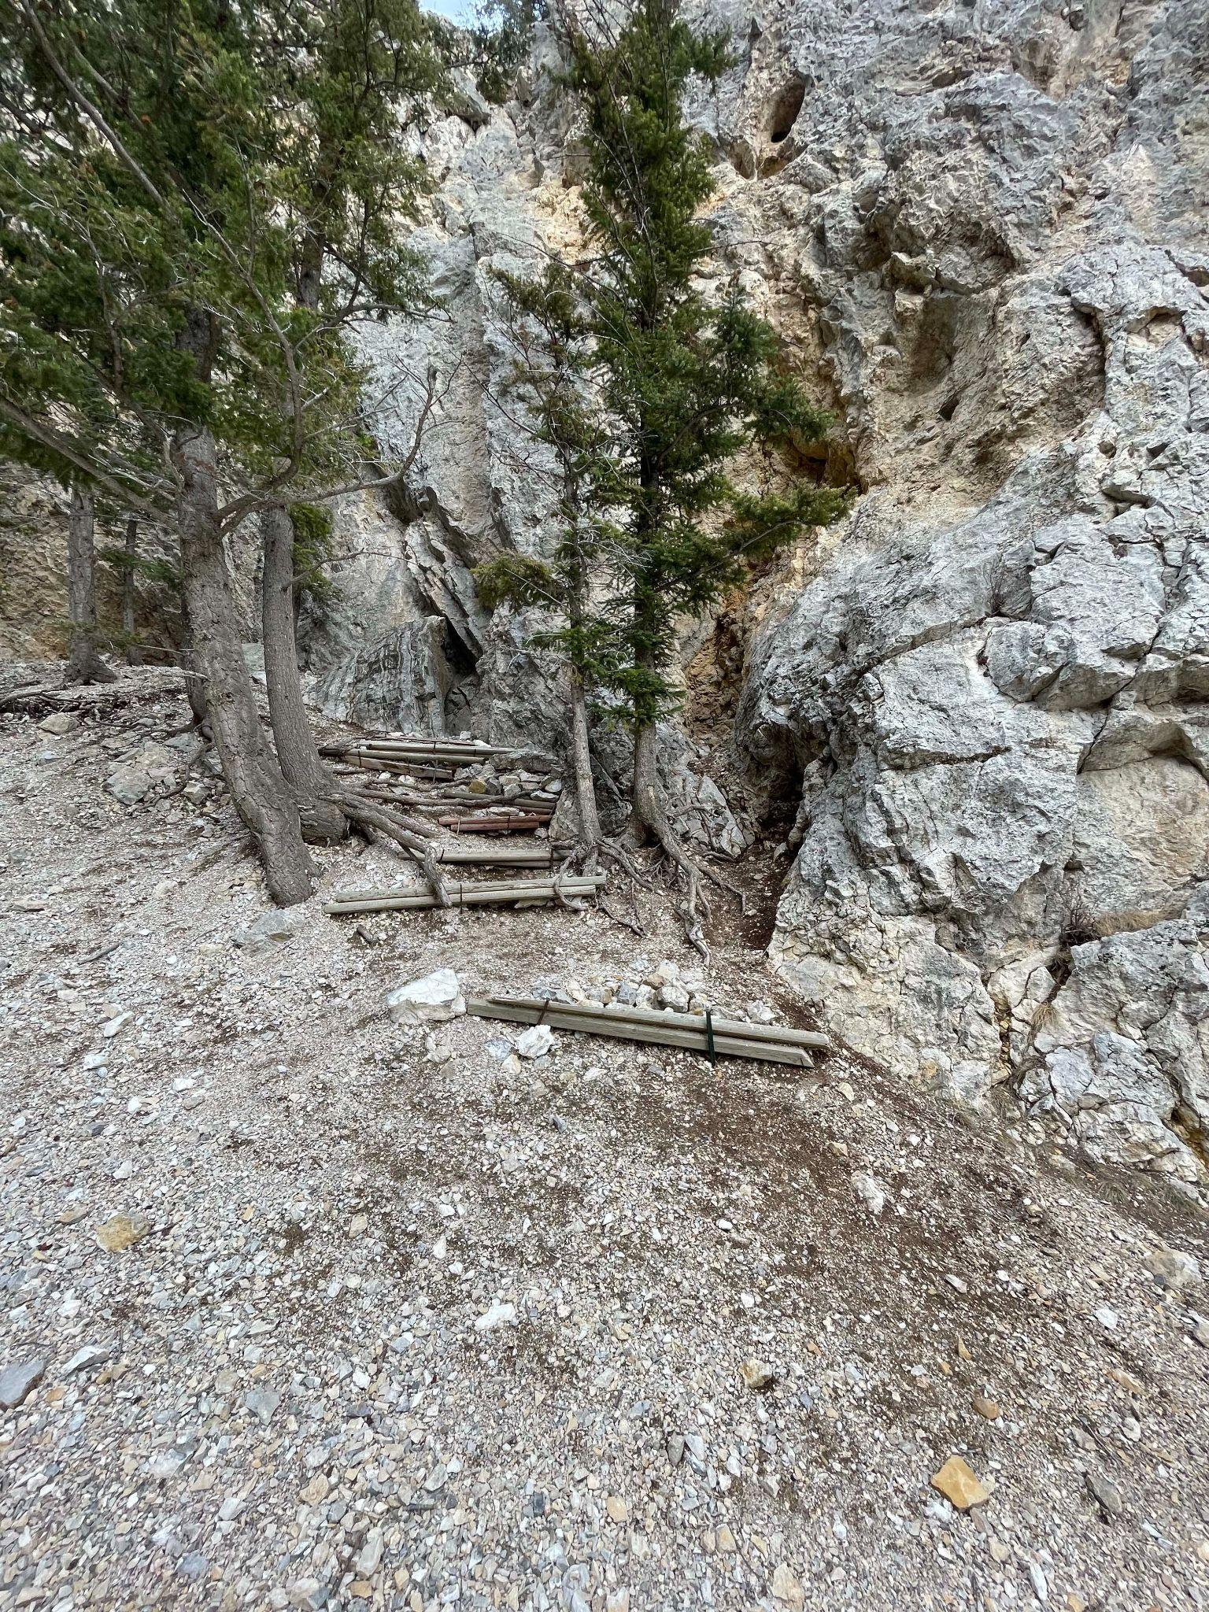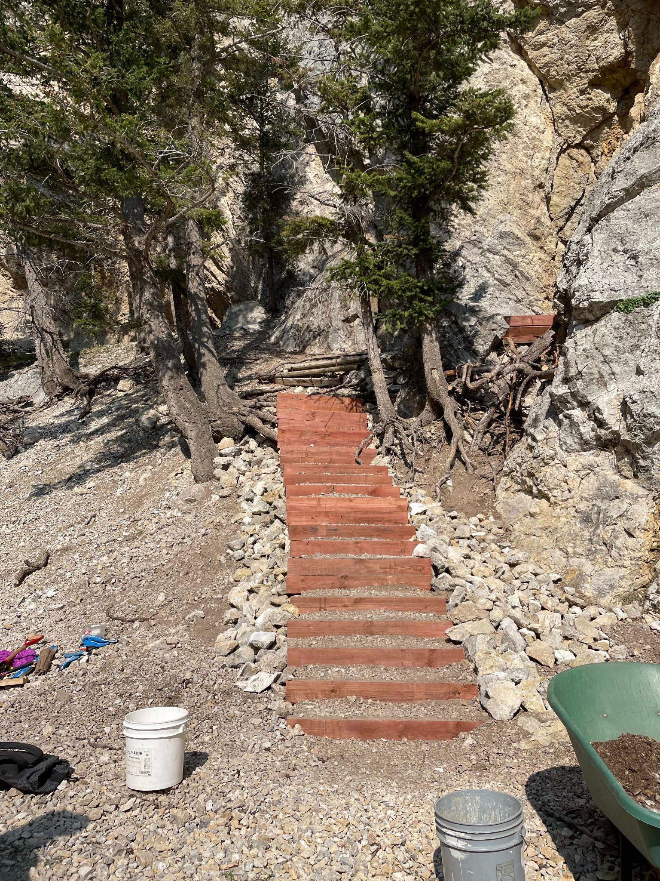

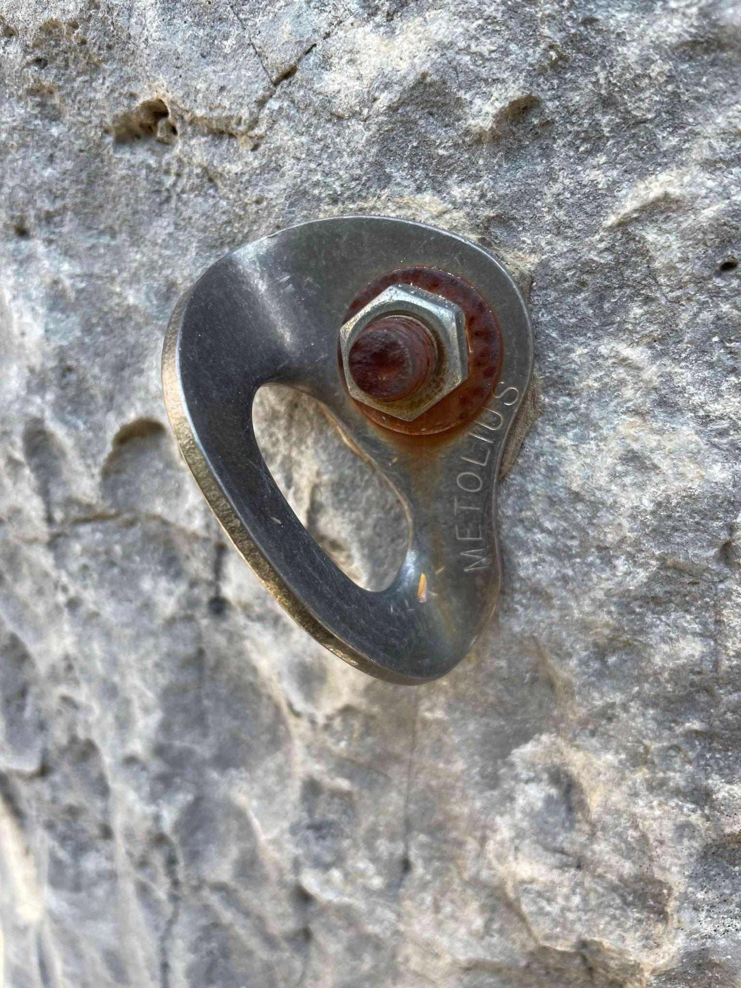
BAD BOLTS?
The American Safe Climbing Association has generously donated AGAIN!!!! We have 50 more sets of mussy hooks for lower off anchors on popular routes! Thank you ASCA! Consider giving them a donation if you haven't already: https://safeclimbing.org/
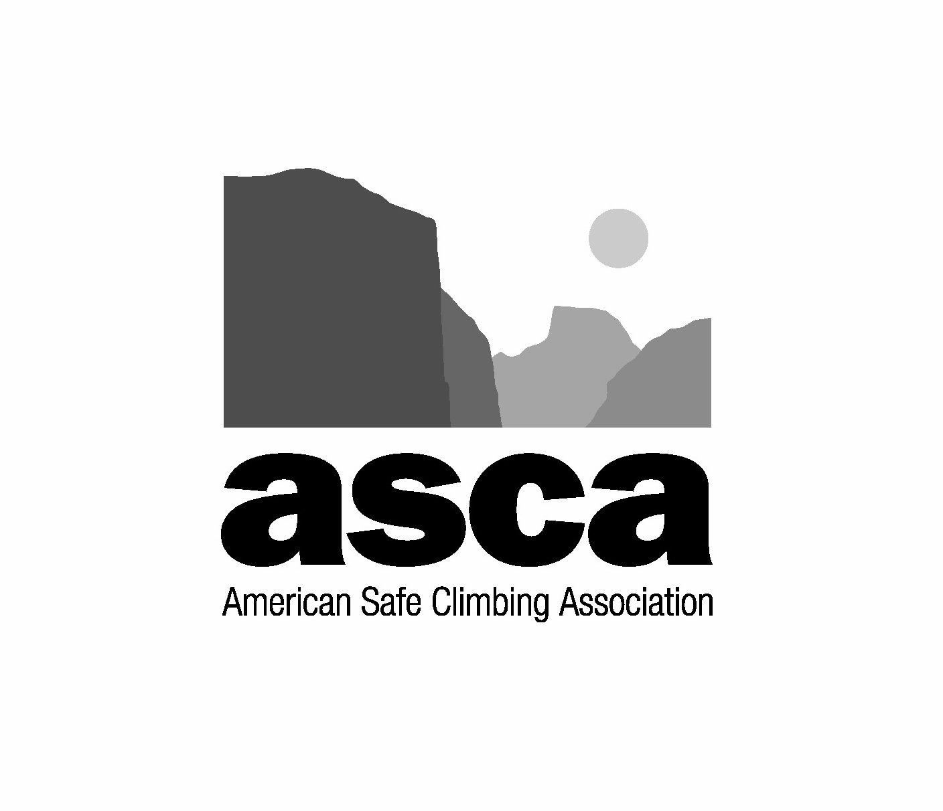
Thinking about those bad bolts you clipped the last time you were out? Report them here Want hooks for your favorite route or want to learn how to replace bolts and anchors? Email Dan at daniel.bachen@gmail.com

Need to pay your membership dues???
https://helenaclimberscoalition.org/members/ Still only $30, what a great deal!
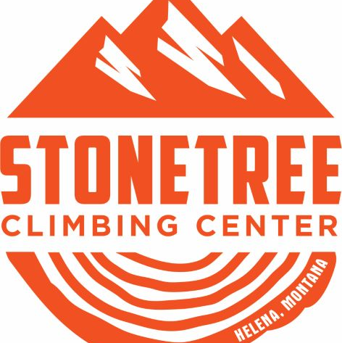
Stonetree Discounts
Thanks to the generosity of Helena’s local gym Stonetree Climbing, Contributing Member perks include:
$13 day passes on Tuesday And Student pricing on memberships
See Stonetree’s Website for further details. https://www.stonetreeclimbing.com/

https://helenaclimberscoalition.org

