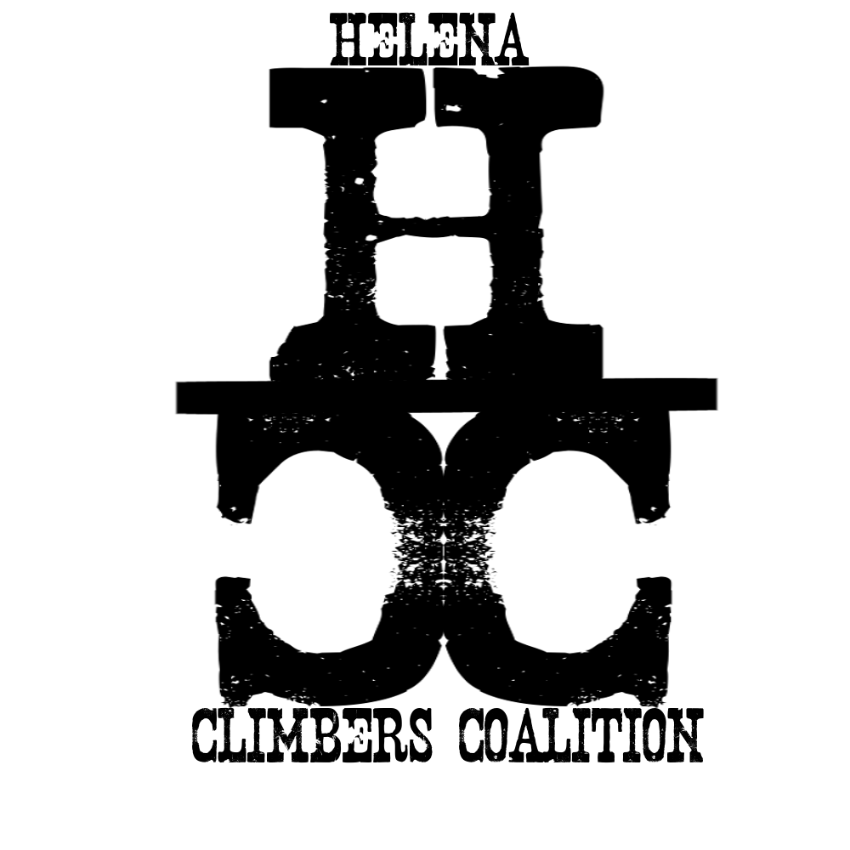
HELENA CLIMBERS COALITION
Fall 2021 Newsletter

ITS ROCK-TOBER

Stonetree Has New Owners
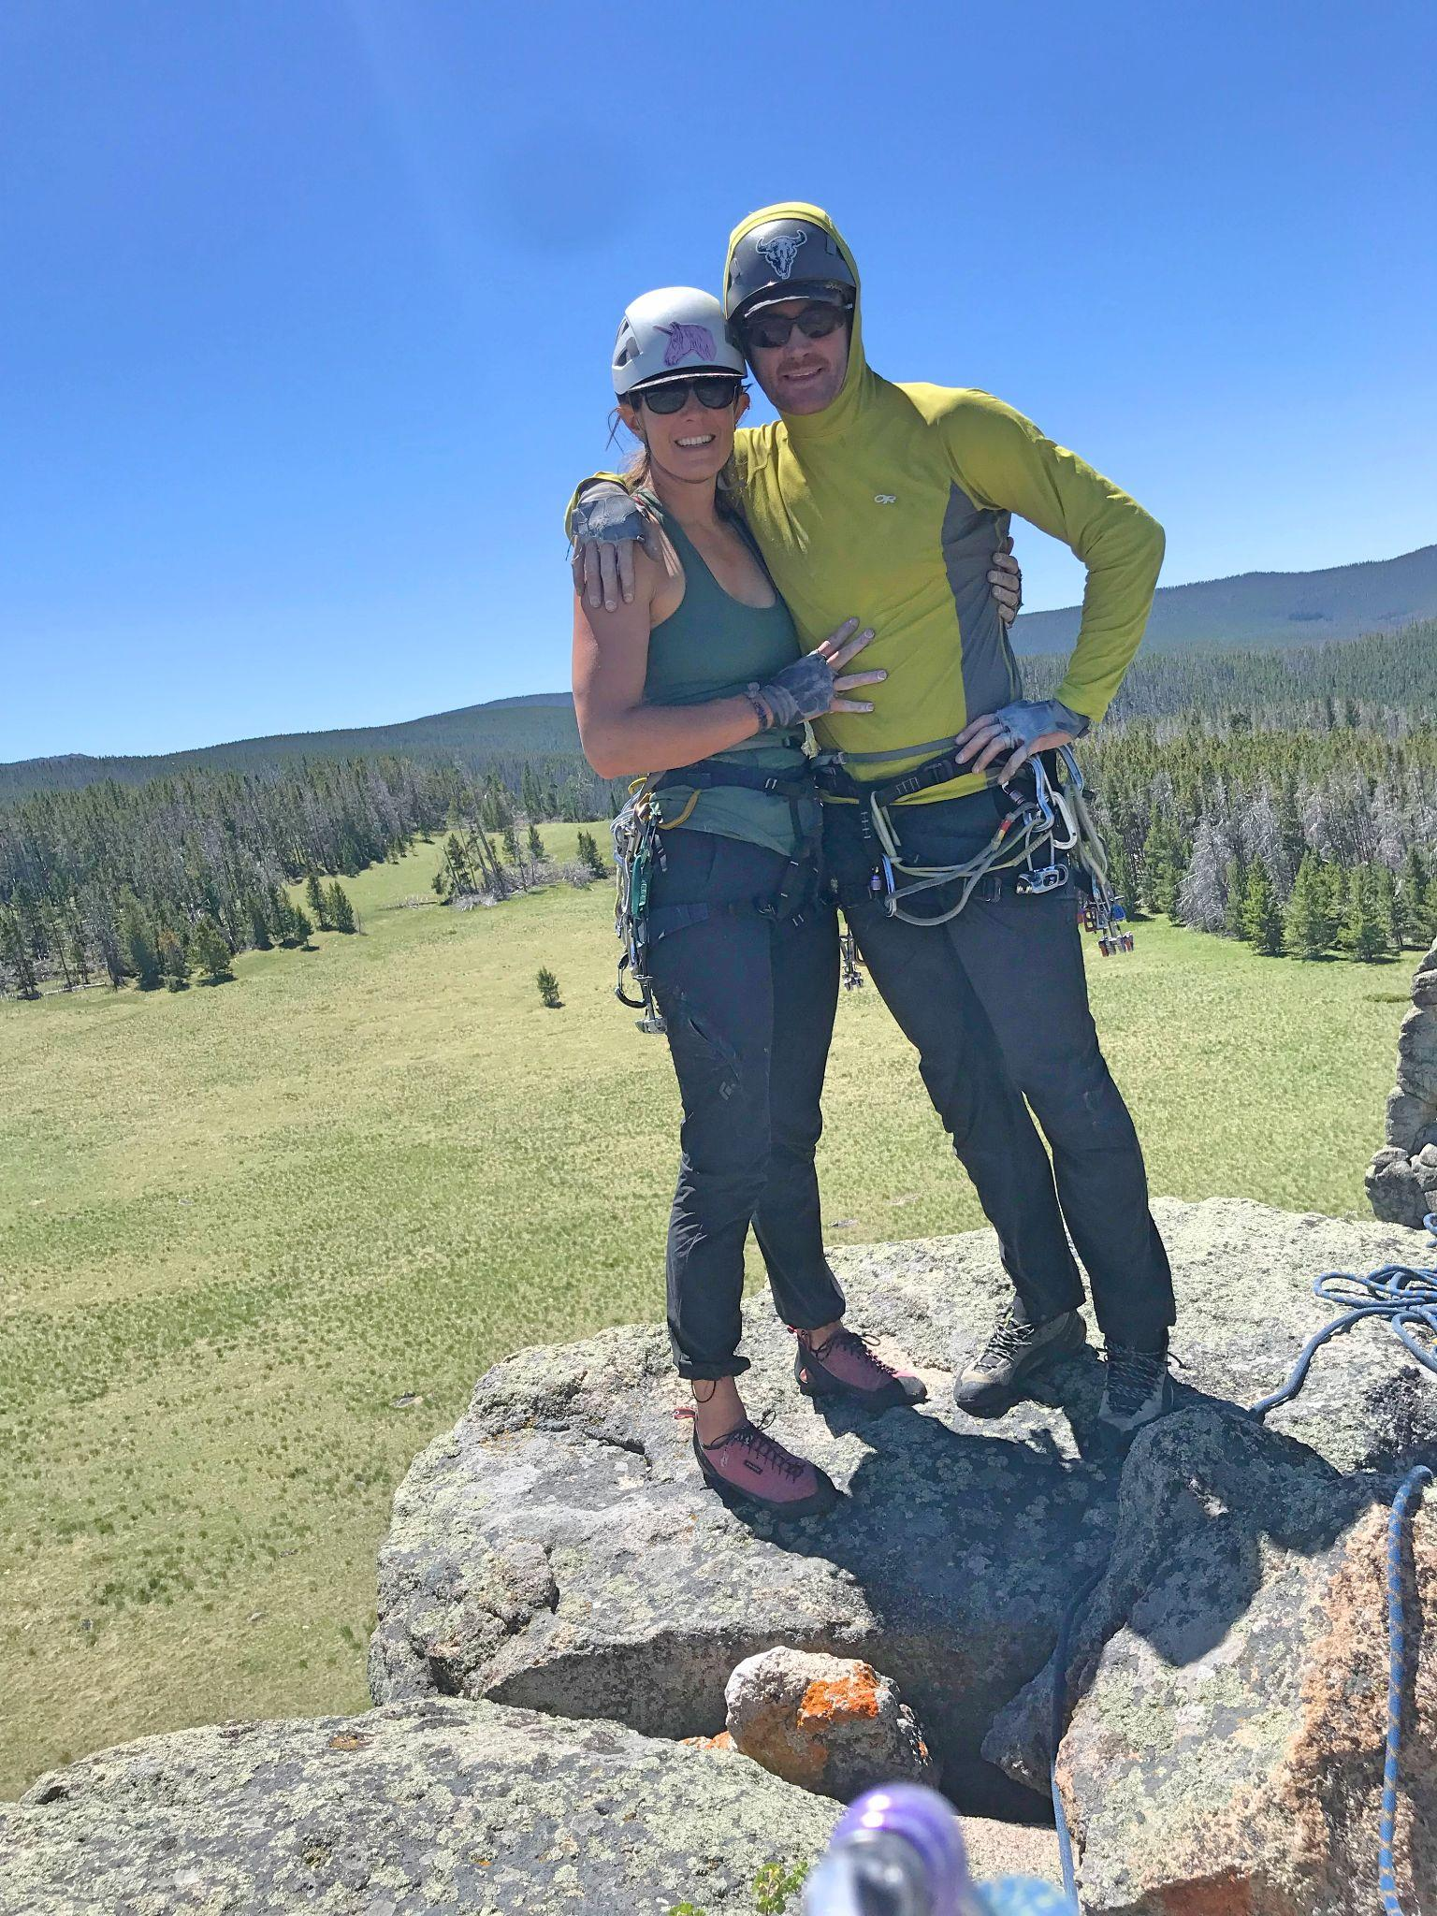
Our local climbing gym and community center has new ownership! Bob Goodwyn and Megan Helton (also HCC Board Members) took over the gym on August 21st, “We are thrilled to have the opportunity to build upon the foundation of the last 6 years and to be a center for the growing Helena community.” Keep your eye out for happenings at the gym including new classes like Intro to Climbing Outside by following them on Instagram or checking their webpage. Stonetree is continuing to offer great deals for paying HCC members with $7 climbing on Wednesday nights AND $10 off your monthly membership! Thanks Stonetree!

HCC In The News!

- HCC Board Member Dan Bachen held an anchor replacement clinic on September 25th. Boulder Monitor Newspaper Editor Joshua Murdock was in attendance and did a write up on the event. You can read the article here.
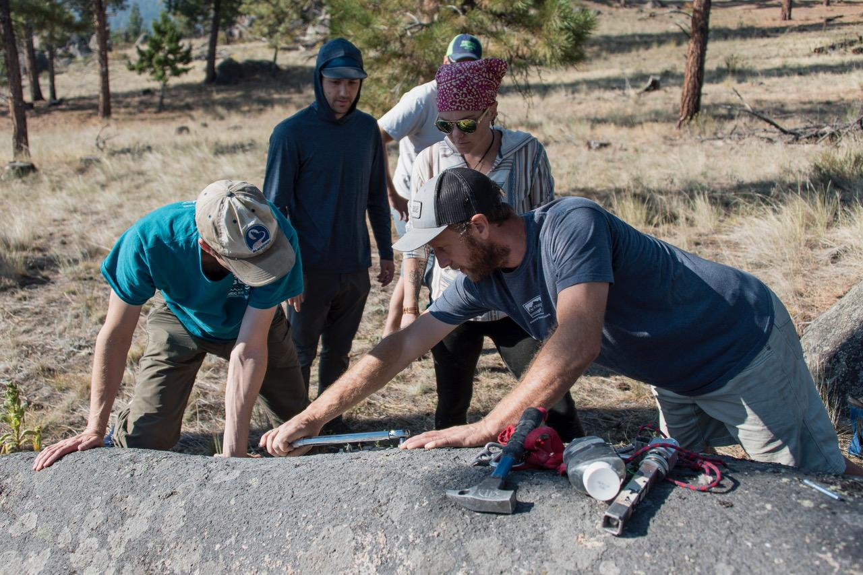

Photo: Joshua Murdock/The Boulder Monitor

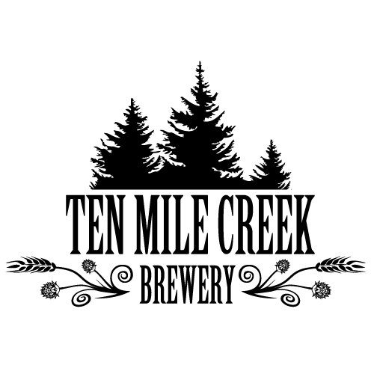
Upcoming Events
- HCC Social Night at Ten Mile Creek Brewing October 27th 6-8pm
  - Join HCC for a night of socializing, meeting new climbing partners, storytelling, and fall stoke!
- Fall social climb day TBD
  - TBD Depending on the weather. Watch social media for a last minute announcement.

- MOVIE NIGHT Friday November 19th, 7pm @ Stonetree
  - We will be showing The Sharp End by Sender Films
  - Trailer Here! Get Stoked!
  - Sponsored by Carroll College CAMP, Stonetree Climbing Center, and the HCC.

Social Media Changes
- The HCC Facebook “Group” is now the “Helena Area Climbing Community” where you can post about needing partners, lost gear, photos for stoke, beta, etc.
- The HCC now has a “Page” that you can follow for events and updates and we will cross post to the “group” as well.
- Our Instagram is still the same!

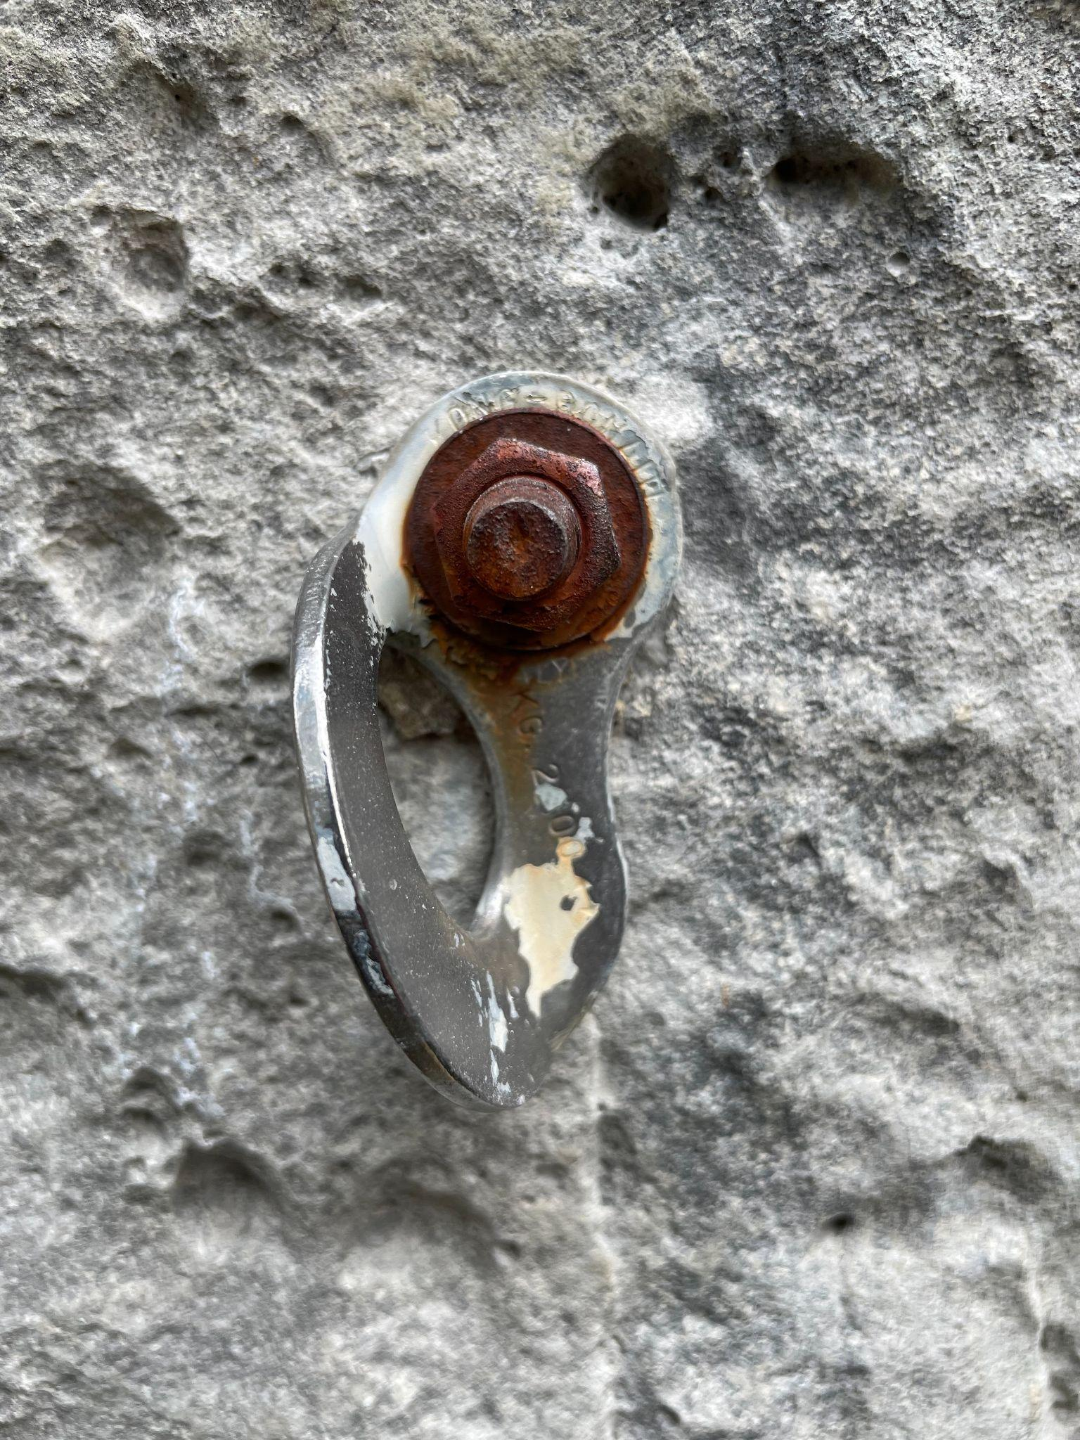
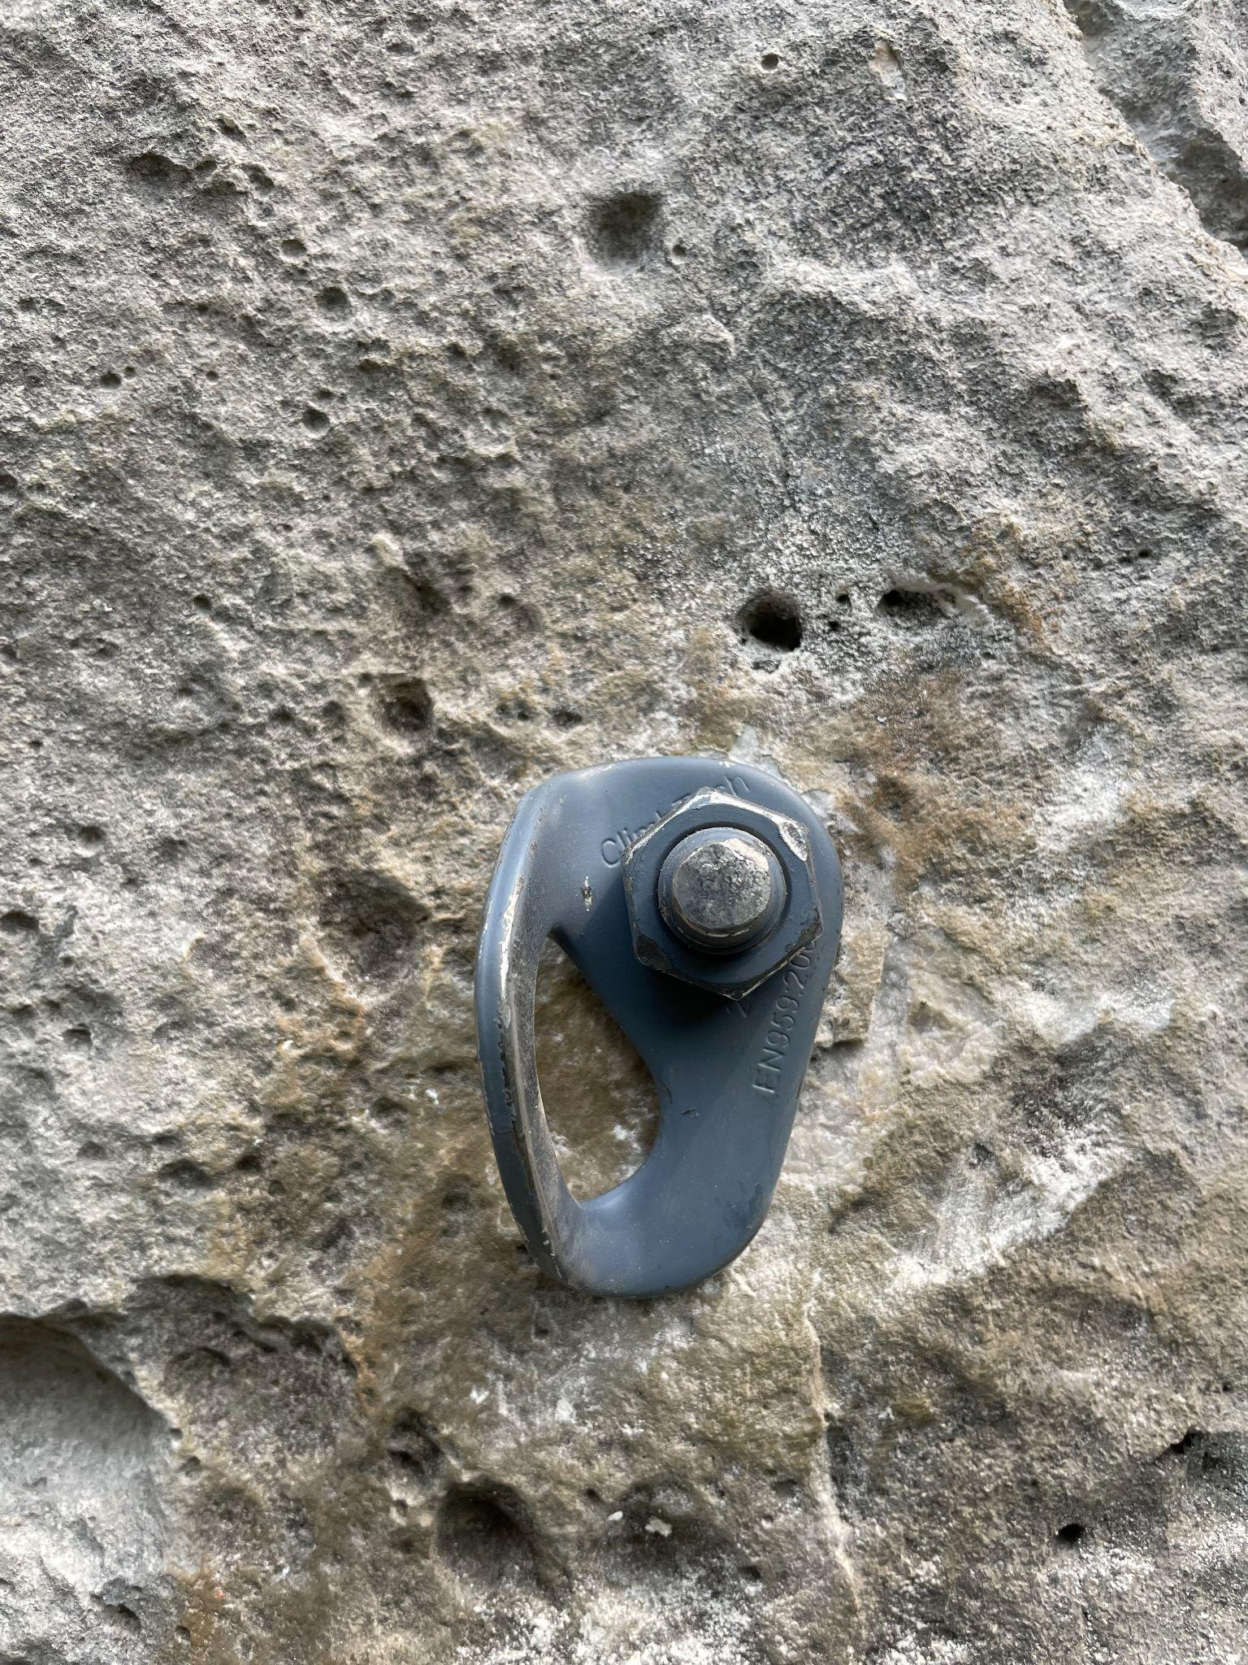
Bolt Reporting Tool
Thinking about those bad bolts you clipped the last time you were out? Report them here
Photo of one of the many bolts that HCC board members replaced this summer!

Guidebook Update
The book is taking longer than expected but it is still in progress. We are hoping it will be ready for purchase after the new year sometime! We will update you when we know the print date, but for now, stay stoked for all the new routes and to hold a COLOR guidebook!

FALL STOKE MACHINE

Patagonia: They/Them

Gold Medalist Janja Garnbret - What's Her Secret?

Arc'teryx Presents: On The Verge

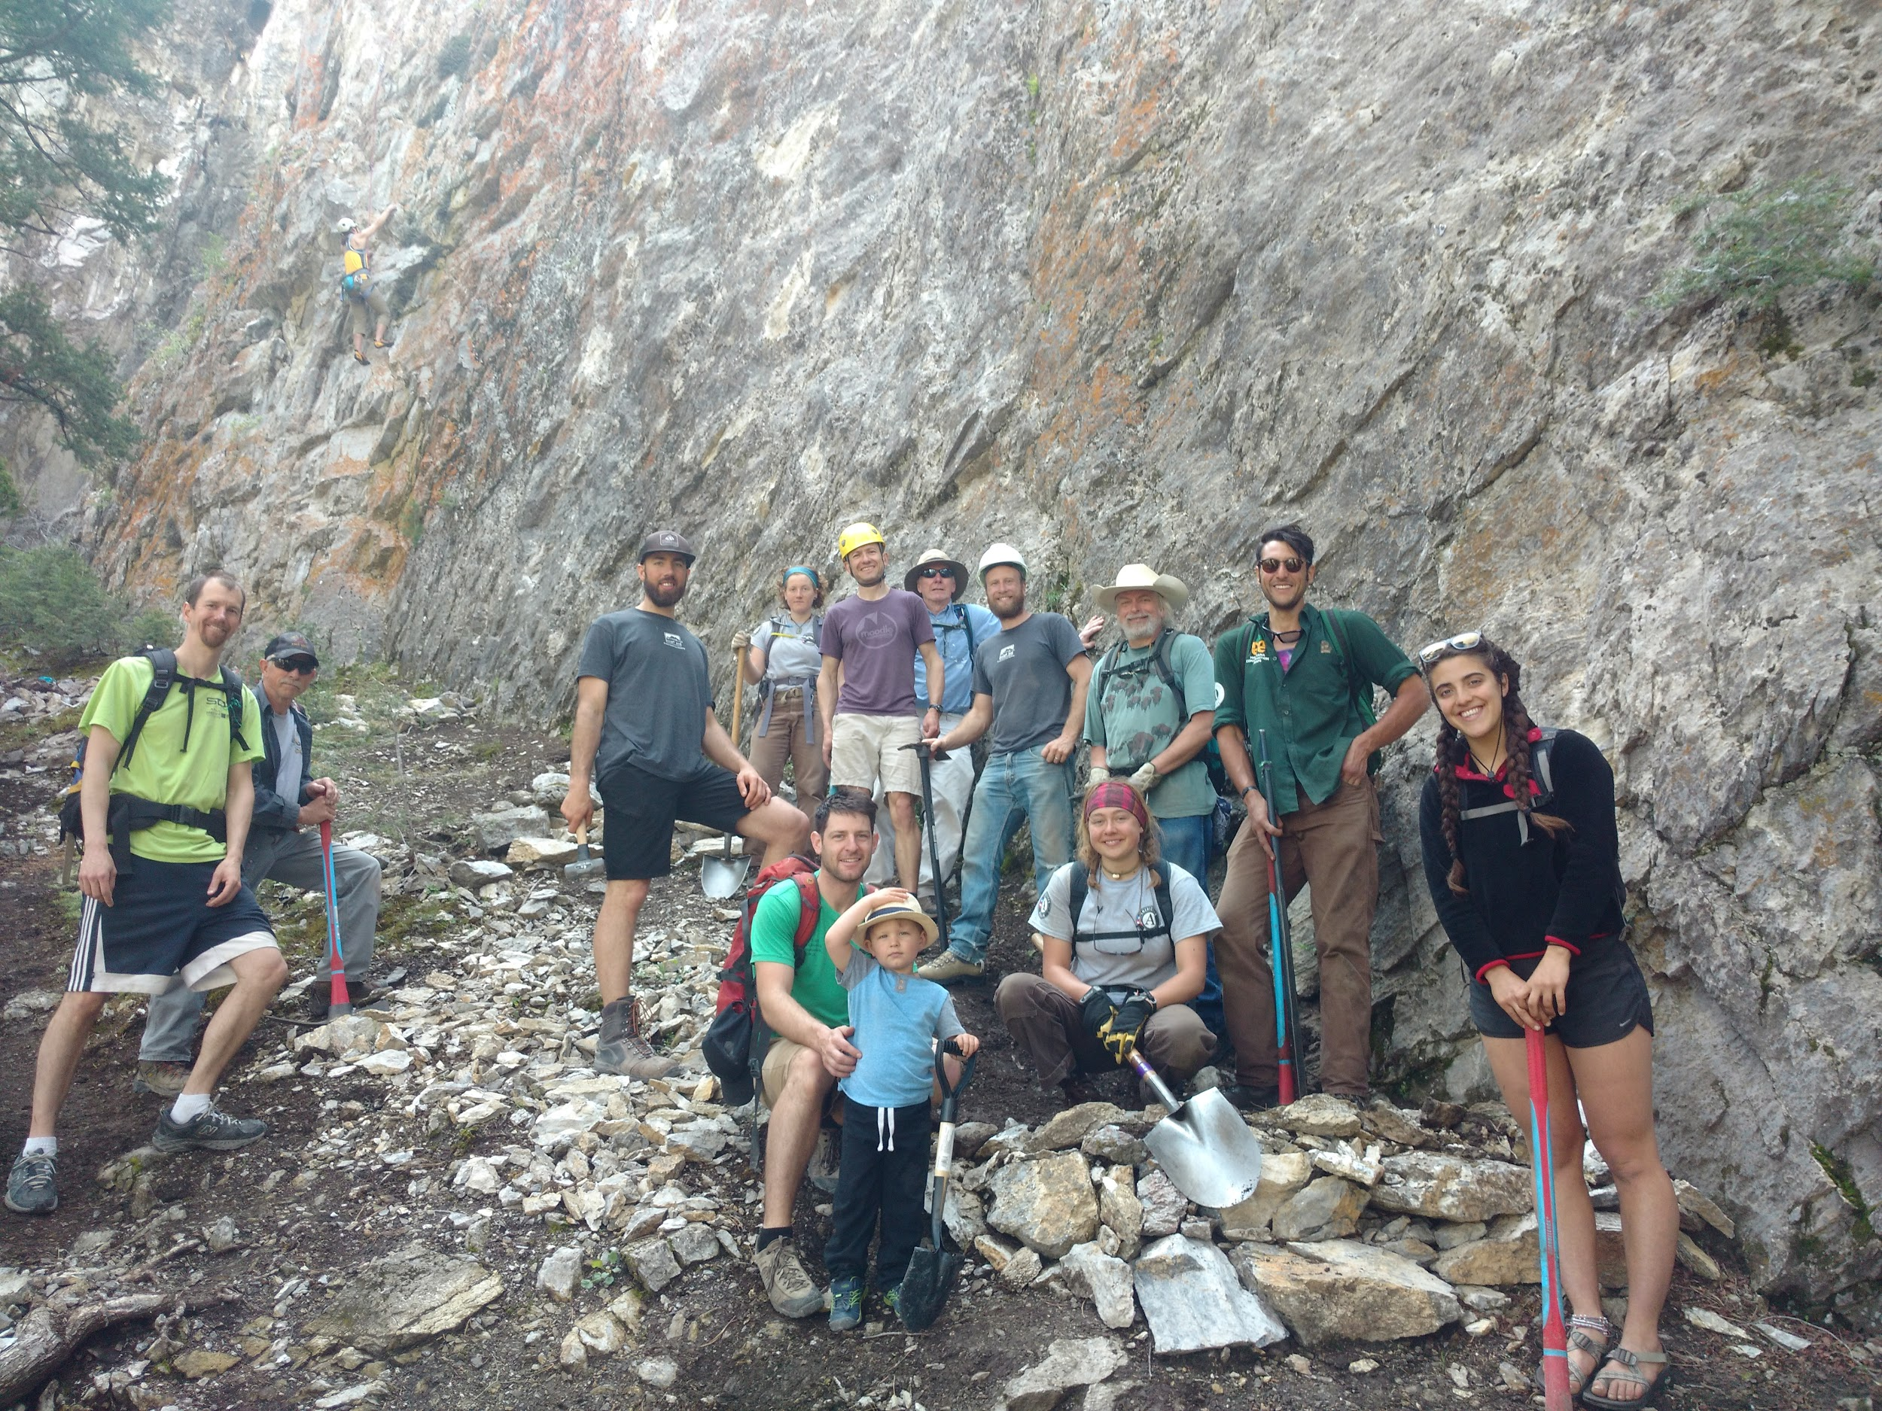

https://helenaclimberscoalition.org

