
HELENA CLIMBERS COALITION
Fall 2020 Newsletter

A message from the Board

Rocktober is here and it has been one of the best fall climbing seasons we can remember in the past few years! We hope that everyone has been staying healthy, safe, and getting tons of days out in the sunshine and amongst golden leaves of fall! Even though we haven't been able to formally gather or work on projects as a climbing community, the HCC board has been hard at work fixing anchors, replacing bad bolts, and getting the ground work done for future stewardship projects when we can gather again as a group safely. We appreciate your support and membership during these crazy times and look forward to gathering with you all again in the future! In the meantime, please check out the opportunities to help the HCC and the greater climbing community below!
-HCC Board

CALL FOR GUIDEBOOK PHOTOS
Want to be famous? HCC is looking for high quality photos and action shots of you and your friends on your favorite routes. We will include your photos (with credits) in the new guidebook. Please submit photos to bradly.maddock@gmail.com with location, route name, climber name, and photographer name. Please not butt shots or TR shots (sorry Top Rope Ninja - you’re insta famous only).
New guidebook anticipated Spring 2021!

HELENA ADOPT A CRAG
Are you and your family or COVID quarantine crew looking for a way to give back to the climbing community!? The HCC has a few projects at our local crags that we would love a crew of excited volunteers to tackle! Please email us at helenaclimberscoalition@gmail.com and we will supply you with the tools and details needed to tackle the project!

BOLT REPORTING TOOL
Finding yourself stuck on the couch and thinking about those bad bolts you clipped the last time you were out? Report them here!
Finding yourself wanting to get off the couch and replace those bolts? Email helenaclimberscoalition@gmail.com and we can teach you how!

Stonetree Climbing Center News
Wednesday nights are $7 for HCC Members.
HCC members and their families get $10 off memberships.
New 20 foot tall tower capable of top roping and lead climbing.

The Access Fund & COVID-19
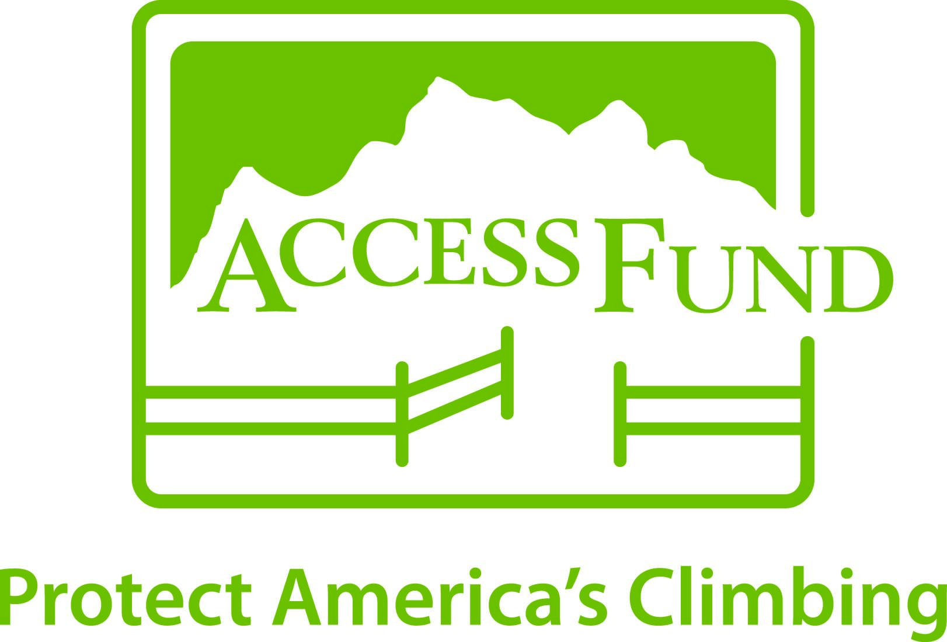
We are sure you are sick of reading more news about the COVID-19 pandemic. Here is the “COVID-19 Resource for Climbers” that the Access Fund has created. It is worth a read if you haven’t stumbled upon it already.

General Comments/ Suggestions
We love hearing from YOU! Please email us at helenaclimberscoalition@gmail.com

STOKE
- STONE LOCALS
- THE ARTIST
- A WORLD LESS TRAVELED Ep. 1

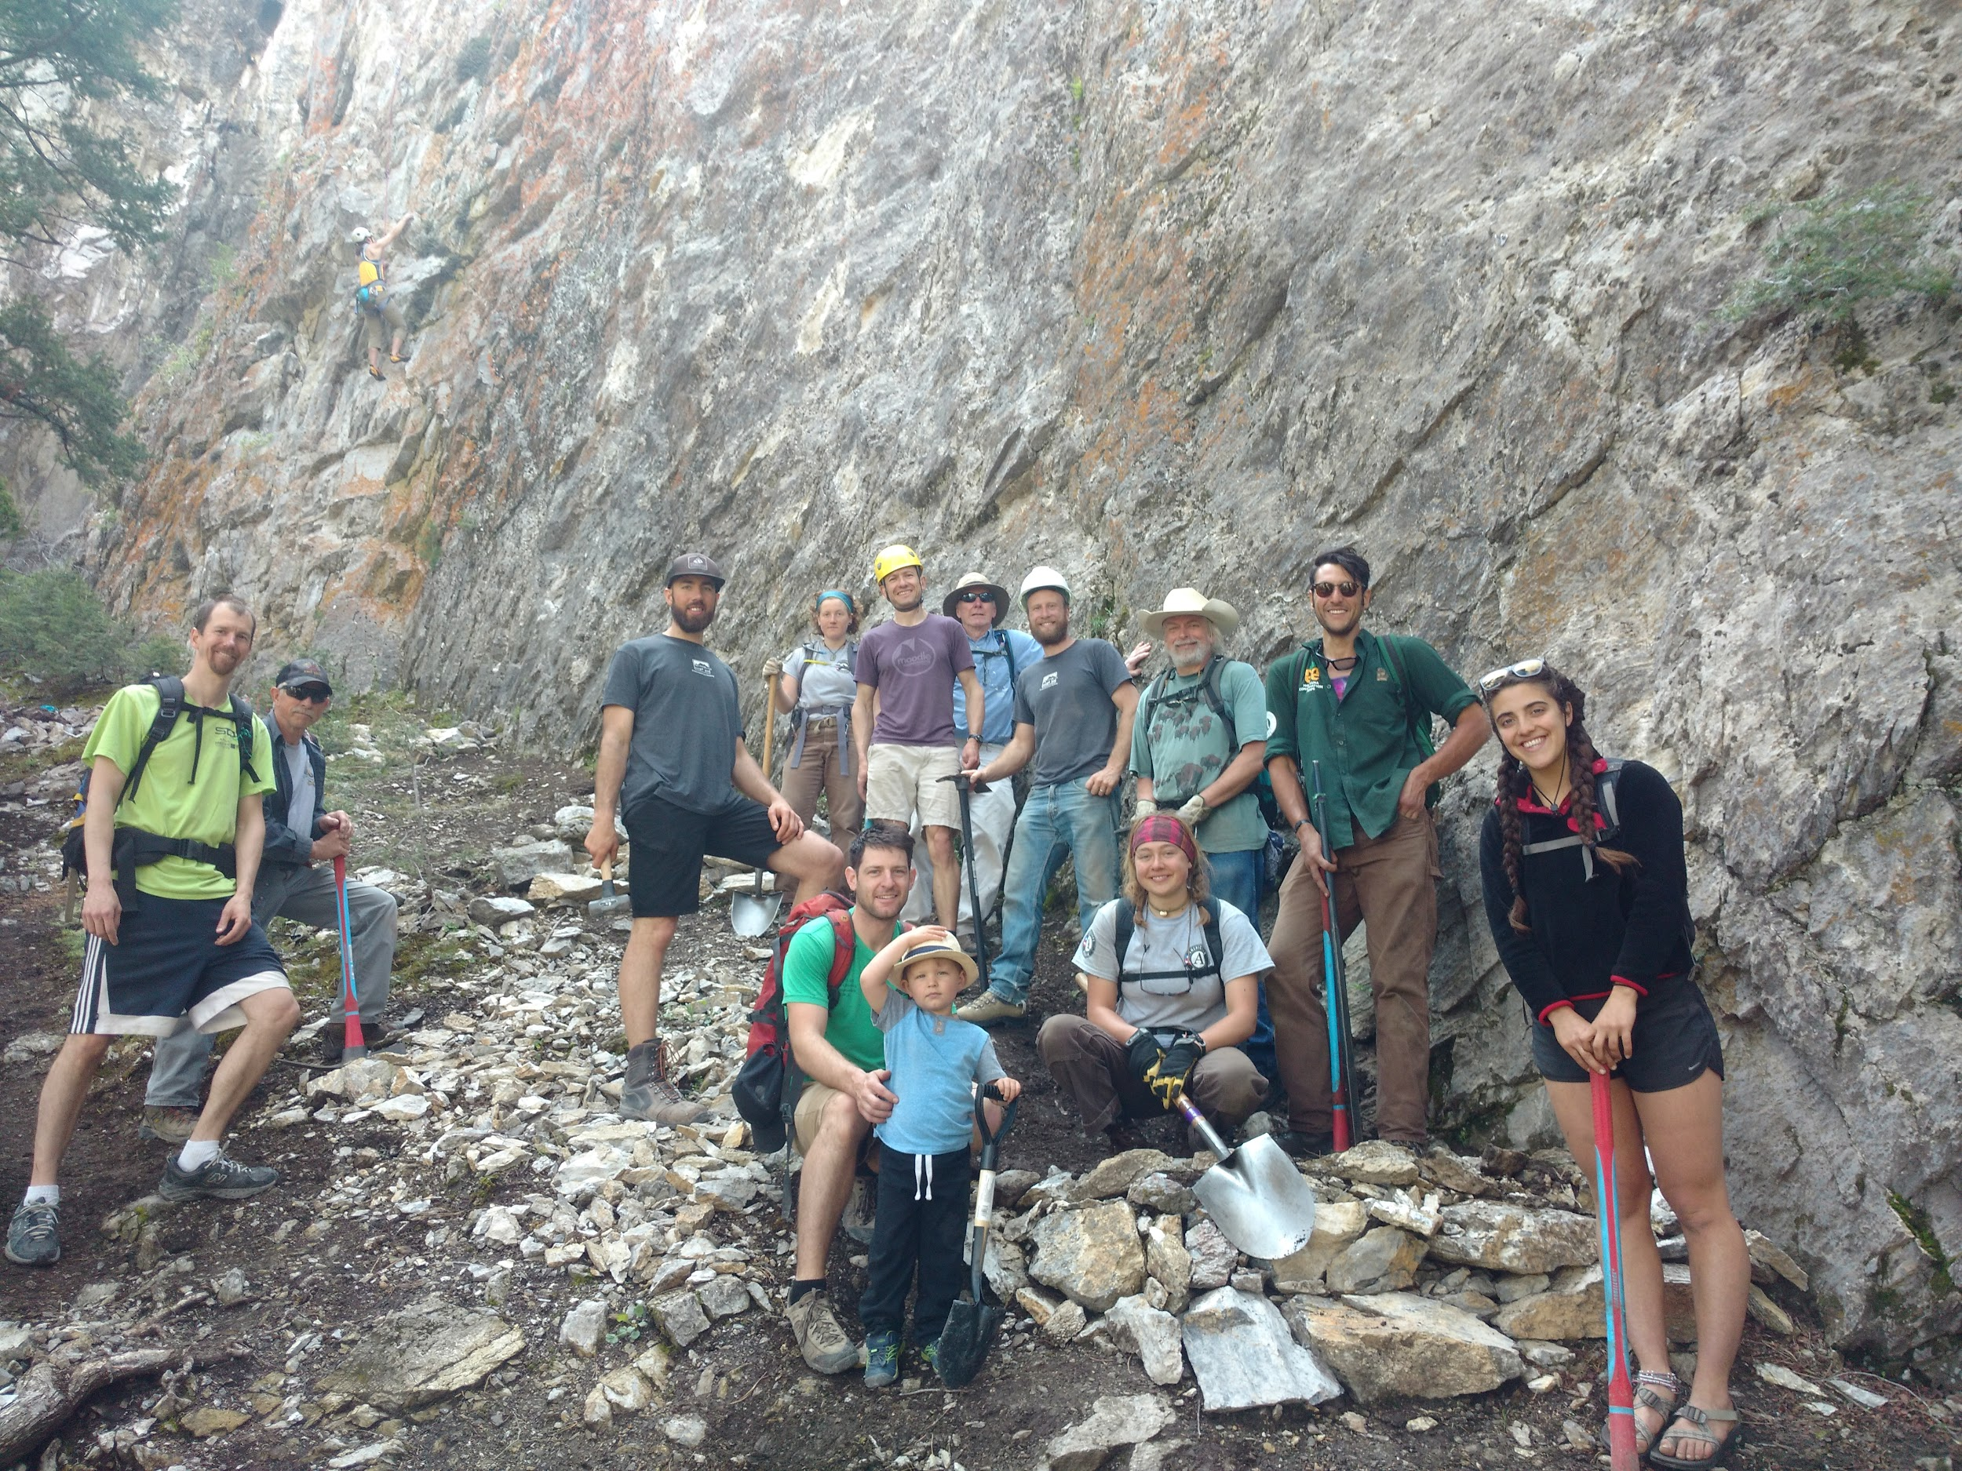

https://helenaclimberscoalition.org

