Helena Climbers Coalition
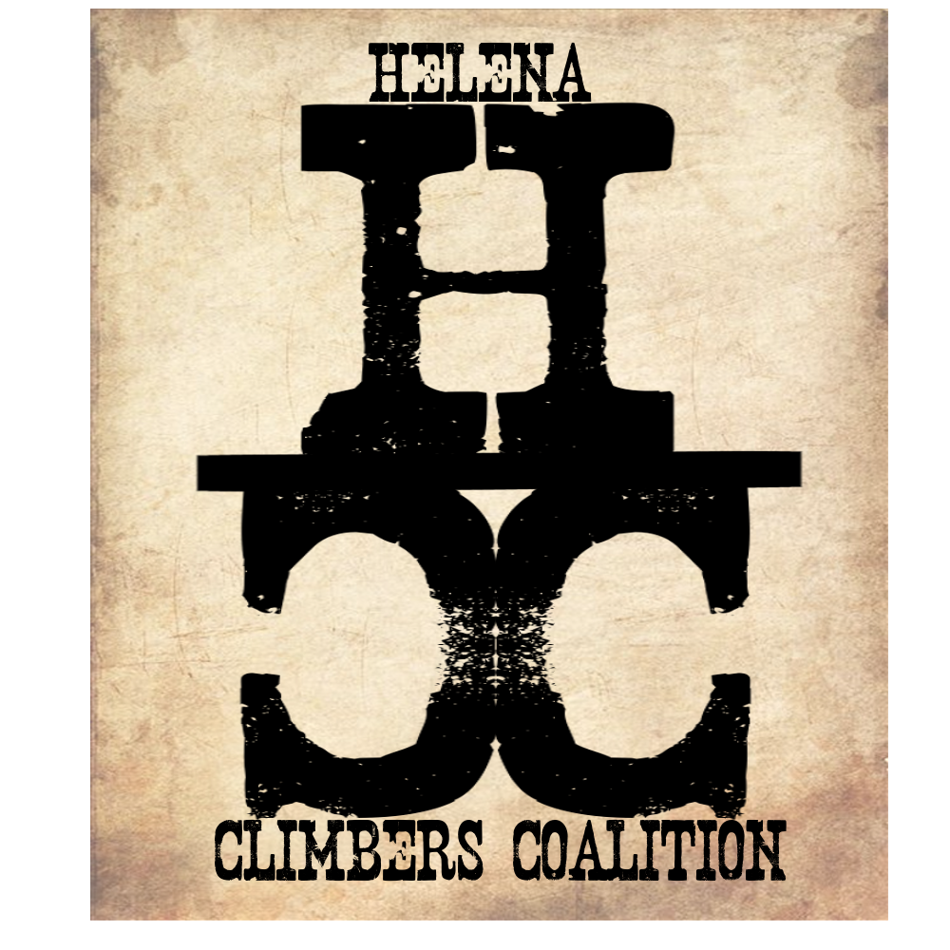
July 8, 2019 / 5:15pm / Carroll College HAC
Attendance
Bob, Megan, Brad, Sarah, Dan, Zach

AGENDA

Meeting Purpose
- Quarterly Board Meeting

Crew Contract: Zach needs text or phone call. Be timely, limit distraction during meetings. Take action. Clear roles and responsibilities. Good listeners.

Meeting Agenda

- Zach is on T-Shirts - Pictures to come!!
  - Put mission on back
  - Get an email out to see about interest, sizes, quantity
  - What is the purpose of the shirts? Fundraising? Just because? Membership?
  - Matching funds for access fund grant. Megan and Sarah will work on this.
- Summer Newsletter-Yes and then Quarterly- Dan and Megan will work on this
- Community climb nights on Mt. Helena
  - Bring stickers!
  - Keep it social
- Follow up from community meeting
  - Committee formation
    - What are the committees? Should we ask for help via email? One board member per committee to keep communication strong? YES
    - Luke Michaelson wants to be on committees
  - Ideas: Respond to each of these ideas in Summer newsletter
    - Improve Mountain Project - It affects our public image outside of Helena. Possible committee idea?? NO
      - If people want to put routes on Mtn Project on their own they can do that.
      - Put a disclaimer on Mountain project? Brad will look into this
    - Aging bolts - Need replacement plan
      - Dan, Bob, Andrew will lead this Committee
      - Grants from Access Fund - Megan and Sarah?
      - Fundraising? T-shirts
      - Bolt puller from Access Fund - Sarah will contact about getting one
        - Dan also has one
    - Incentivise Memberships - Pro deals, Climbing night at Stone tree, T shirts, etc??
      - Contact Yetta, also fundraising!
      - Megan will be a part of this
    - Hardware Fundraising - Grants, Access Fund grants
      - Group with Bolt committee
    - Sheep Mountain - priority due to age of hardware and lack of trails, Improve trails, Update bolts. Possible Adopt a Crag event, work with MCC to do trail work.
      - Create a Stewardship Committee - Trail maintenance, adopt a Crag events, signage
      - Sarah will work on this
    - Kiosks at trailheads/better signage all around
      - Group with stewardship committee
    - HCC possibly Hosting WFA courses
      - Reach out to Molly about making this happen
      - Coordinate with Carroll College?
- Treasury update
  - How is our federal tax status coming?
  - Andrew sent out email about this
- By-laws
  - Review for how to send notes and agendas in the future and to include membership
  - Megan is going to update wording and send out in an email to be approved by the board
  - Still need to notify the community about all board meetings - get better at this!
- Blue Cloud update and action plan
  - July/August - signs, stile, graffiti removal, trail maintenance
  - What is our Date for this??
  - Where are we on this? Troy is okay with this and would like 2 weeks notice to do some of this work
    - No drive signs - should we look into FWP/Block management for these? Dan will look into this.
    - Climbing signs
    - Trail maintenance
    - Graffiti removal okay
  - Talk with FS and BLM about doing all this - Brad
  - Bob follow up about stile and specific dates and send update email
- Mt. Helena Update
  - No Bolting right now
  - Technically illegal according to Helena Open Lands Rec Plan Chapter 7.1.3 https://www.helenamt.gov/fileadmin/user_upload/City_Parks/Open_Lands/Documents/Helena_Open_Lands_Management_Plan.pdf
  - 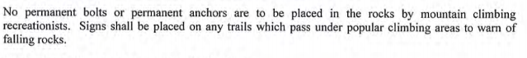
  - Brad has been asked to represent the Helena Climbers Coalition at the stakeholder meetings. He will work to keep everyone informed on how to comment on the process and what the plan is moving forward.
  - No ban on climbing or future bolting is expected, but we do need to get the language changed in the new Helena Open Lands Plan.
- Raptor’s at Helena Climbing areas. What to do?
  - Formally close? Or tell people not to climb if they see/hear a raptor? Hard to know where they are always.
  - Dan talked about regulations. The concern is nesting raptors. He hasn’t seen any direct concerns about nesting.
  - Don’t formally address this but keep our ears out for additional sightings or issues.
- Website
  - Future events need to move to top of event page
  - Put board bio’s and pictures on web page
  - Add access fund logo to all our stuff - Sarah will send out logos to use
- Membership Drive
  - Group Climb
  - Community Events
- Other projects/Ideas?
  - Avy Trails/ belay pads
  - Sheep Trails and Anchor Replacement
    - Can we get a bolt remover from Access Fund? Sarah will send follow up email
  - Community Guide Book Idea from Brad
    - Talk to Jake about this - Brad
    - Distribute load to community members?
- Set meeting times in advance

**Megan will let Board know how much we owe for StoneTree climb night
Meeting Minutes Taken By: Sarah Maddock
Meeting Adjourned: 650pm

