Helena Climbers Coalition
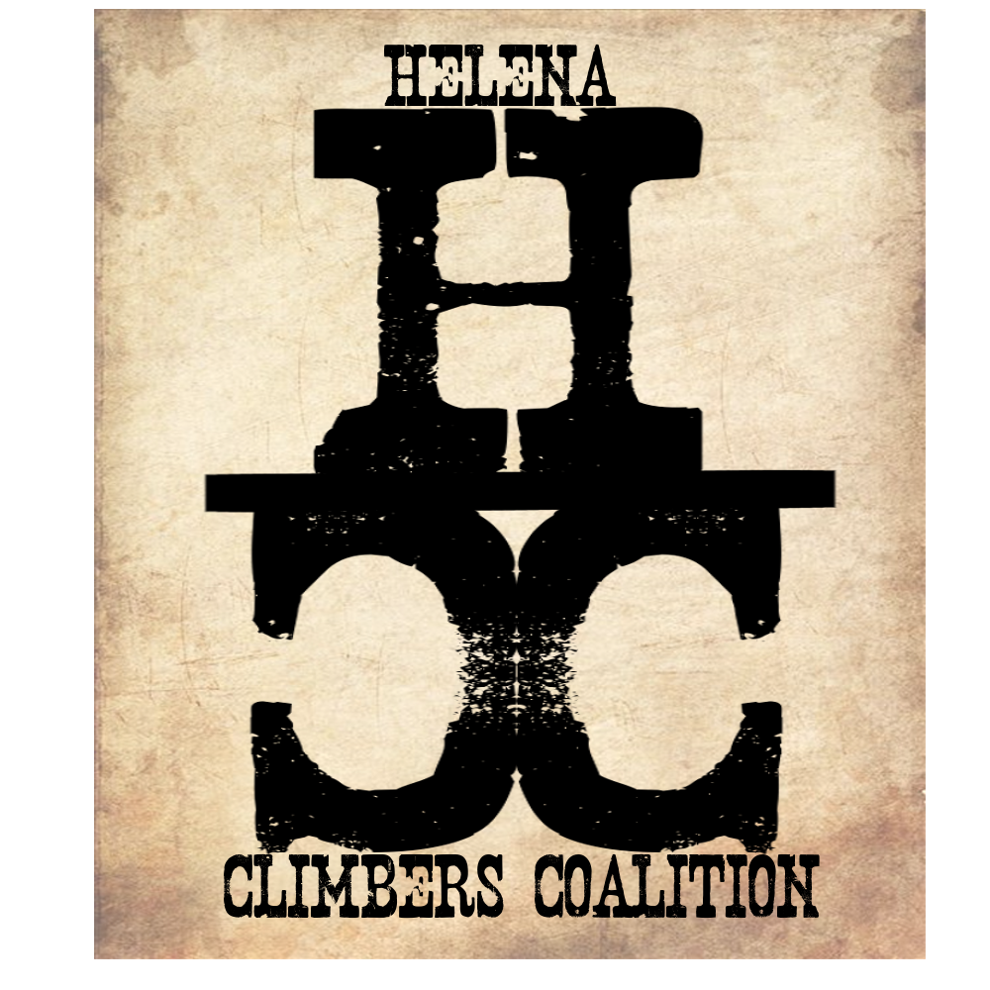
June 24, 2020 / 5:15pm / Carroll College
Attendance
Megan, Brad, Sarah, Zach, Andrew, Dan

AGENDA

Meeting Purpose
- Quarterly Board Meeting

Crew Contract: Zach needs text or phone call. Be timely, limit distraction during meetings. Take action. Clear roles and responsibilities. Good listeners.

Meeting Agenda

- Postponed Events. Can we re-plan any?
  - Board decided that we should do a few outdoor stewardship and community events. People can decide to come or not to come, there will be ample opportunity for social distancing.
  - Sheep trail work night
    - July 15th 5:30pm Meet at Climbers Trailhead
  - Community Night at Avalanche
    - July 29 5:30pm
    - Climbing, camping, and social distancing
  - National Public Lands Day
    - September 26th
    - Avalanche or Hellgate crag work day (waiting to hear from Mandy)
- Committee Updates:
  - Bolts/anchors
    - Dan, Bob, Andrew
    - Dan got us deals from Climb Tech for bolt replacements!
      - Can we spend $ on this
      - $600-700 budget approved by the board (6 yes 0 no)
  - Guide for area
    - Under contract with Sharp End
    - Dan - Beaver Creek and Trout Creek
    - Andrew? - Indian Creek
    - Martin - Blue Cloud
    - Zach/Dillon/Schmeck/Brad - Bouldering areas
    - Jake - Avalanche, Hellgate, Blackleaf, Refrigerator
    - Bob/Megan - Sheep
    - Brad- Mt. Helena
      - Ask companies about maps.
  - Fundraising
    - Bob, Dillon, (Yetta is gone :(
    - Community Comp March 28--- CANCELED
    - Reel Rock in the Fall for community event--- Can we do this? Is there even going to be films!?!?
      - Look into climbing films for fundraiser in fall.
- Blue Cloud
  - Martin cleared trail
  - Ask about putting up signage at road and gate and ability to drive to gate when not hunting season.
    - We can put up signage, no driving to gate :(
  - Contact ranchers to talk about easement/land use permit

- Treasury Update
  - Federal application for 501c3. $275 one time fee.
- Summer newsletter
  - Megan will write up
  - Dan will write intro
  - We will send out July 10th!

Meeting Minutes Taken By: Brad Maddock

Meeting Adjourned: 6:45pm

