Helena Climbers Coalition
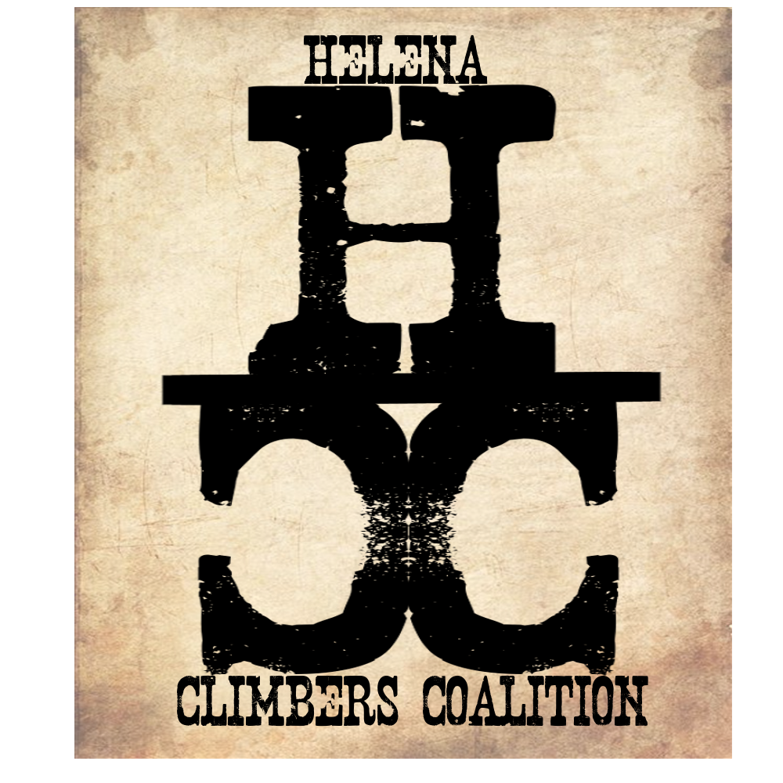
January 15, 2020 / 5:15pm / Carroll College
Attendance
Bob, Brad, Sarah, Dan, Zach, Andrew.

AGENDA

Meeting Purpose
- Quarterly Board Meeting

Crew Contract: Zach needs text or phone call. Be timely, limit distraction during meetings. Take action. Clear roles and responsibilities. Good listeners.

Meeting Agenda

- Last meeting action items follow up:
  - Dan and Andrew contact climbtech for deals? Andrew will aslo contact SWMCC about joint deals.
  - Contact Blackfoot about Community Monday waitlist. Contact TenMile and Western bar about pint nights
    - Bob contacted them all except Western Bar.
    - Bob will fill out apps for BF and TenMile for dates in March-May and again in Sept-Nov.
    - Western for another event
  - Monthly Happy Hour through the winter for community aspect - Megan
  - Bylaws change approved at community meeting, have we actually updated them? Check with Megan
  - T-Shirt Update
    - We are waiting for an order
    - $10 per shirt to make $20 for retail
    - Have T shirts for sale at Pint Nights
    - Update Paypal to make line item for Tshirts- Brad or Sarah
  - Blue Cloud Signage- Check with Troy before we install.
    - Can climbers drive to gate and park after hunting season? Bob, check on dates that Troy would prefer. and How to make this successful
      - Propose Jan 1st - Oct 15th first. Then Jan 1- Sept 1 if not successful.
    - Does Troy want Parking area improvements if parking by the gate?
  - Brad will submit proposal to FS so we are GTG in the spring. Also include Hellgate trail work.
    - Done. We are on hold until Mandy gets back from DC in April :(
  - Improve/Create relationship with BLM - Brad
    - Done. He just got back this week from vacation and we are going to chat soon hopefully.
- Committee updates
  - Stewardship
    - Sarah, Megan
      - Climb nights,
      - Climb and camp out
      - National Trails Day June 6th
      - National Public Lands Day
  - Bolts/anchors
    - Dan, Bob, Andrew
  - Guide for area
    - Brad
      - Planning on going with SharpEnd Publishing
      - Dan - Beaver Creek- contact Luke, Henry, Bozeman guys (Magro)
      - Andrew - Indian Creek
      - Martin - Blue Cloud
      - Zach/Dillon/Schmeck - Bouldering areas
      - Jake - Avalanche, Hellgate, Blackleaf, Refrigerator
      - Bob - Sheep
  - Fundraising
    - Bob, Dillon, Yetta
    - Social Events - Reel Rock (Fall),
- Treasury Update
  - Will need $15 for state annual report
  - Federal application for 501c3. $275 one time fee. Andrew talk to Tony if we really need to do this.
- Next community Meeting on Feb 12th - Bob has been planning
  - T-shirt deal - $10 shirt, $20 if not interested in Membership
  - Food and Drinks - Figure out beer (is it okay?), NO food
  - Free Climbing at Stonetree - how will we pay for this? HCC pays?, Stonetree waives fee?
  - Starts at 6pm
  - Present Committees and have sign up sheets
  - Need to Print a poster - Brad
- Next quarterly newsletter needs to go out between now and the end of March. Date to shoot for? Mid March - Include Member meeting update, pint nights, spring/summer events.
  - Brad is happy to take this on if Megan no longer has time to
- Christmas tree burning/bouldering event - Weekend prior to Community Meeting

Update HCC Google Calendar to include $7 Wednesday nights
Send out HCC email and password to Board - Sarah
Email participating members about Tshirt Deal for Member meeting - Sarah

Meeting Minutes Taken By: Sarah Maddock
Meeting Adjourned: 615pm

