Helena Climbers Coalition
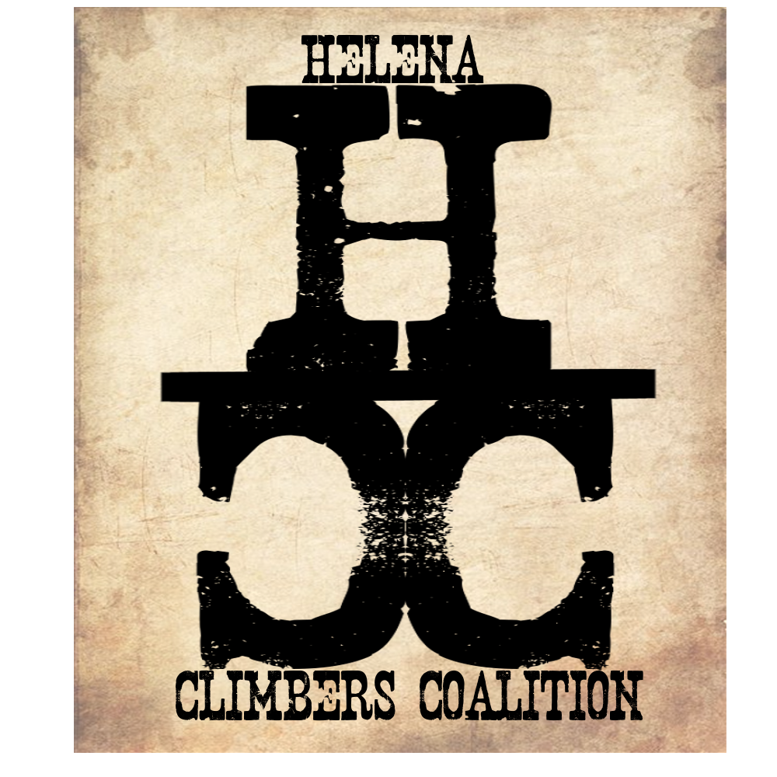
November 19, 2019 / 7:00pm / Carroll College
Attendance
Bob, Megan, Brad, Sarah, Dan, Zach, Andrew

AGENDA

Meeting Purpose
- Quarterly Board Meeting

Crew Contract: Zach needs text or phone call. Be timely, limit distraction during meetings. Take action. Clear roles and responsibilities. Good listeners.

Meeting Agenda

- Committee formation
  - Stewardship - Sarah
    - National Trails Day
    - What does this mean for everyone? Bolts/Anchors, trails, access, trail maintenance.
    - How does this look? Do we need a specific committee for this? Stewardship should encompass all of our committees.
  - Bolts/anchors
    - Dan, Bob, Andrew
  - Guide for area
    - Brad
  - Fundraising - Bob
- Bolts/Anchors
  - Sarah go the Hurley Jr from Access Fund and turned in the reporting tool.
  - Brad and Dan did some work at Sheep
  - Indian creek needs help
    - Brad talked to Ronny B and okay to replace necessary hardware
    - Email Ron for list of routes that may need replacing? Brad

  - Has anyone used/submitted on form Dan created?
  - Avy might need more attention than Indian creek due to volume of climbers
    - Cratering of the rock is an issue that needs to be looked at in limestone
  - Fixed anchor replacement plan for Helena Climbing - Awesome work Dan!!
    - Good start for grant applications, working with land managers
  - Jake mentioned he wants to go all stainless here soon. He is starting to feel the pressure.
    - Subsidize Jake? Look into some deals.
    - Ask Climbtech for deals? Apparently SWMTCC gets good deals from them.
    - Share bolt orders with SWMTCC and/or WMTCC.
    - Call Climbtech and SWMTCC - Andrew, Dan
    - Dan had ideas for getting cheaper materials from Global Industrial supplies and other random spots. Keep it on our radar for the future.
  - Fundraising for Bolts and Anchors
- Membership Drive/Fundraising! - Bob
  - Pint night - Blackfoot, TenMile, Western Bar! Contact Blackfoot about Community Monday waitlist. Contact TenMile and Western bar about pint nights
  - Chris Alke - touch base with him?
  - Monthly Happy Hour through the winter for community aspect - Megan
  - Need to have Fall/Winter Community meeting
    - Purpose - renew memberships, goals for 2020, Events for 2020 (National Trails Day, Bolts/Anchor).
    - Locations - Base Camp, L&C brewery meeting room, Capital? La Pa, Oddfellow, MCC, Red Atlas
    - Date - Dec 10th or 17th?
    - What you can get out of this? - T-shirts! - Zach
    - Bob will work on outline for the meeting - let us know what you need from us!
      - Group people into committees at the meeting
      - Layout specifics for how much stuff costs and money/resources spent - Megan
      - Where do you want to see your money used - Place your name in bowls/topics
  - Lets go!
- Treasury update
  - $430 available today
    - Spent $150 this summer - $100 on lumber for the stile at Blue Cloud, $50 for graffiti removal snot
  - What do we want to do with this money? Bolts/Anchors ($100 per route), tools/supplies, trail supplies, signage, website, guidebook,
  - Money from Reel Rock? Carroll paid for RR and all profits go to HCC
    - Use Reel Rock as a fundraiser for next year
- T-Shirt Update- Zach :)
- Quarterly newsletter- Megan
  - Sarah - overview of season, etc
  - Summary of events
  - Membership
  - Bolts
  - Community meeting and agenda
- By-laws
  - Megan is going to update wording and send out in an email to be approved by the board
  - ^^ that’s not how we can change by-laws.
  - I’d like to go over by-laws, why they exist, and that we need to pay attention to them!
  - We need to change wording of bylaws regarding notification of board meetings and meeting agendas.
  - Notify the community of future meetings and a call to agenda items in the Quarterly newsletter. Ask community to participate in discussion at this time for input about future meetings.
    - Megan motioned this and Brad, Dan, Andrew, Bob, Zach, and Sarah seconded.
  - Megan will update Bylaws!!
- Blue Cloud update and action plan
  - Summer work day was a success!
  - Next steps:
    - Signage-Check with Troy before we install.
    - Can climbers drive to gate and park after hunting season? Bob, check on dates that Troy would prefer and How to make this successful
    - When do we want to approach landowner about legal access
      - Lease Agreement, Access Agreement (temporary but long term) vs Easement
        - The Access Fund is ready to help when we are!
        - Lets address at next meeting
- City Rec Plan Chapter 7 Revision/Mt. Helena Update
  - Climbing should not be specifically addressed in new Ch 7
  - Draft plan should come out in November for comment.
- Website - Dan will do it!!
Needs updated meeting notes
Can we make a board tab to clean up the homepage?
- Other projects/Ideas?
  - Avy Trails/ belay pads
    - Brad will submit proposal to FS so we are GTG in the spring. Also include Hellgate trail work.
  - Sheep Trails and Anchor Replacement, Graffiti removal
    - Ask BLM for funds for Elephant snot
    - Improve/Create relationship with BLM - Brad
- Community Guide Book Idea
  - Committee - Megan, Brad, Sarah
    - Jake is 100% in on this. He does not want to make a guide book right now.
    - Form committee? Yes - advertise at Community meeting
    - Contact publishing companies? (Sick Proj Publishing-SW MT Blocks) (Wolverine Publishing-COR and Tetons) (Sharp End Publishing- Moab/Indian Creek) (Mountaineers Books) Or Publish on our own, or Amazon publishing? Falcon Guides? Call Randall?
- Consider having 6 board meetings per year. Next meeting to be held in January sometime. Date TBD
- Thoughts on Kootenai Canyon Craziness!
  - Address at next meeting?

Meeting Minutes Taken By: Sarah Maddock
Meeting Adjourned: 9:25pm

