Helena Climbers Coalition
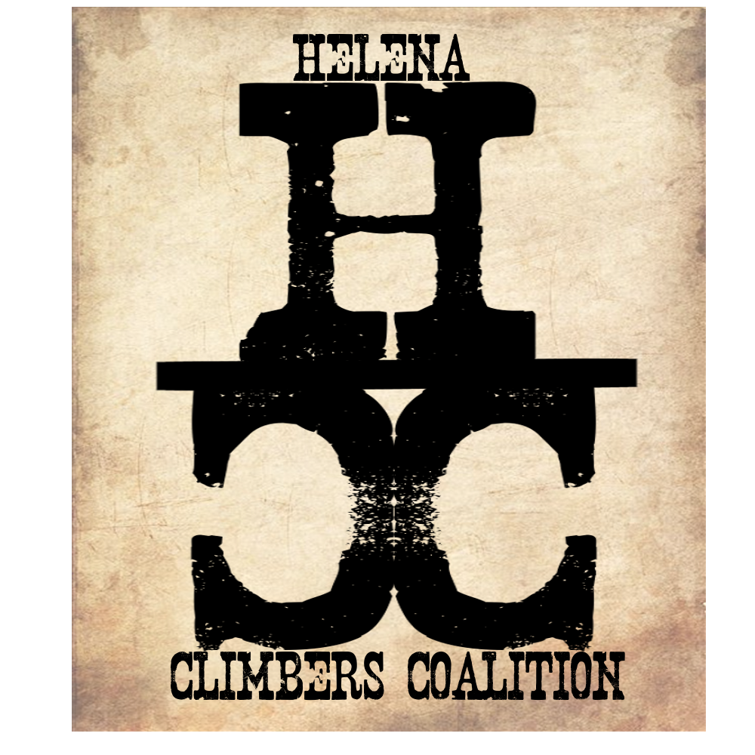
December 17, 2019 / 6:00pm / 326 Fuller Ave
Attendance

AGENDA

Meeting Agenda

- (10 min) Bob’s Intro
  - Meeting Purpose
  - Meeting Contract

- (5 min) Overview of the year

- (5 Min) Where do you want your money to go?

- ( 5 Min) What’s coming next year?

- (5 Min) By-laws change

- (10 min) New Guidebook

- (20 Min) Committee Meetings
  - Stewardship & Trails - Sarah, Megan
  - Bolts/anchors - Dan, Andrew
  - Memberships & Fundraising - Bob

- (2 min) Thanks for Coming!/Meeting Adjourned - Bob

Meeting Minutes Taken By:
Meeting Adjourned:

