Helena Climbers Coalition
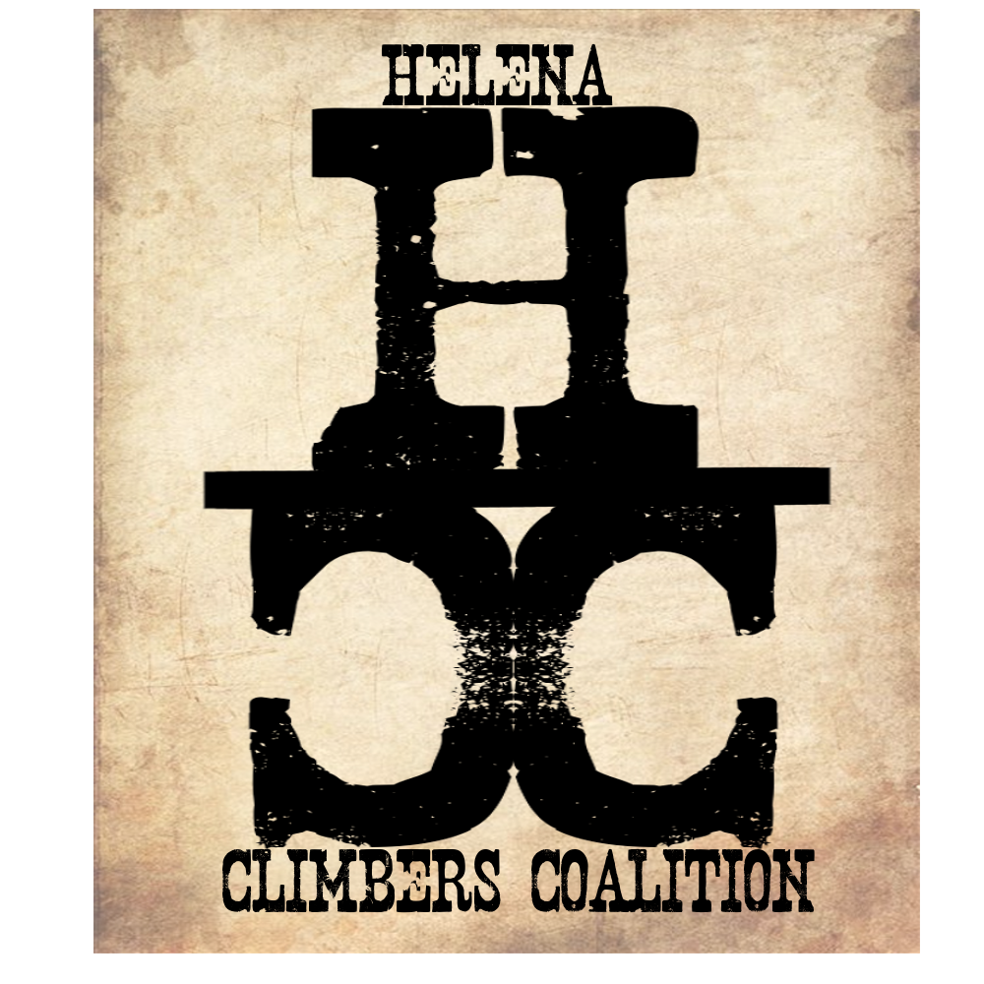
November 18, 2020 / 8pm / Google Meet
Attendance
Megan, Brad, Sarah, Bob, Dan, Andrew

AGENDA

Meeting Purpose
- Quarterly Board Meeting

Crew Contract: Zach needs text or phone call. Be timely, limit distraction during meetings. Take action. Clear roles and responsibilities. Good listeners.

Meeting Agenda

- Membership renewals - Sarah sends out an email asking folks to renew - DONE
- Board Elections- Brad will create Google forms for nominations and voting. New Board members will start in January
- Jake Mergenthaler and bolts after guidebook - Andrew will talk with Jake about quantities he feels he should be reimbursed for and create a formal agreement
- Committee Updates:
  - Bolts/anchors -none
  - Guidebook
    - How is everyone doing
    - Is Megan still interested in reading and editing? YES
    - Megan is interested in writing a LNT/climbing etiquette section for the beginning of book
    - Thanksgiving deadline for info to Brad. Dec 20th deadline to Publisher
  - Fundraising - none
  - Stewardship -none
- Blue Cloud
  - Ask about putting up signage at road and gate and ability to drive to gate when not hunting season.
    - We can put up signage, no driving to gate :(
  - Contact ranchers to talk about easement/land use permit
    - Andrew will talk with some landowners he knows to discuss how to approach someone about this issue
    - Brad will look up template and begin working on it for possible submission this spring
    - ‘What’s in it for the rancher?’ We can provide labor and maintaining equipment, etc?
- Treasury Update - Sarah transferred Paypal money to the bank.
  - Discussed fundraising ideas - possibly a discount for guidebook-See below
- Winter newsletter - Megan will do this. Highlight Stonetree deal. Megan requests some more info on membership incentives related to the guidebook. Possible incentive: $60 for membership + Guidebook ( $30 membership + $35 book - $5 discount)
- Other Items: Anchor replacement on Winterwall

Meeting Minutes Taken By: Sarah Maddock
Meeting Adjourned: 915pm

